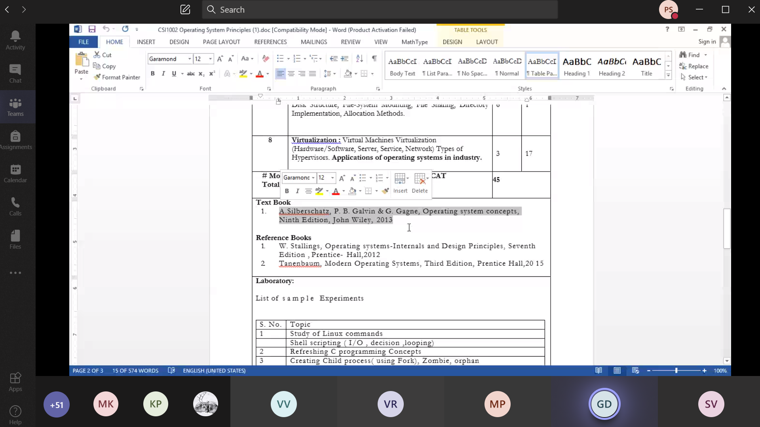

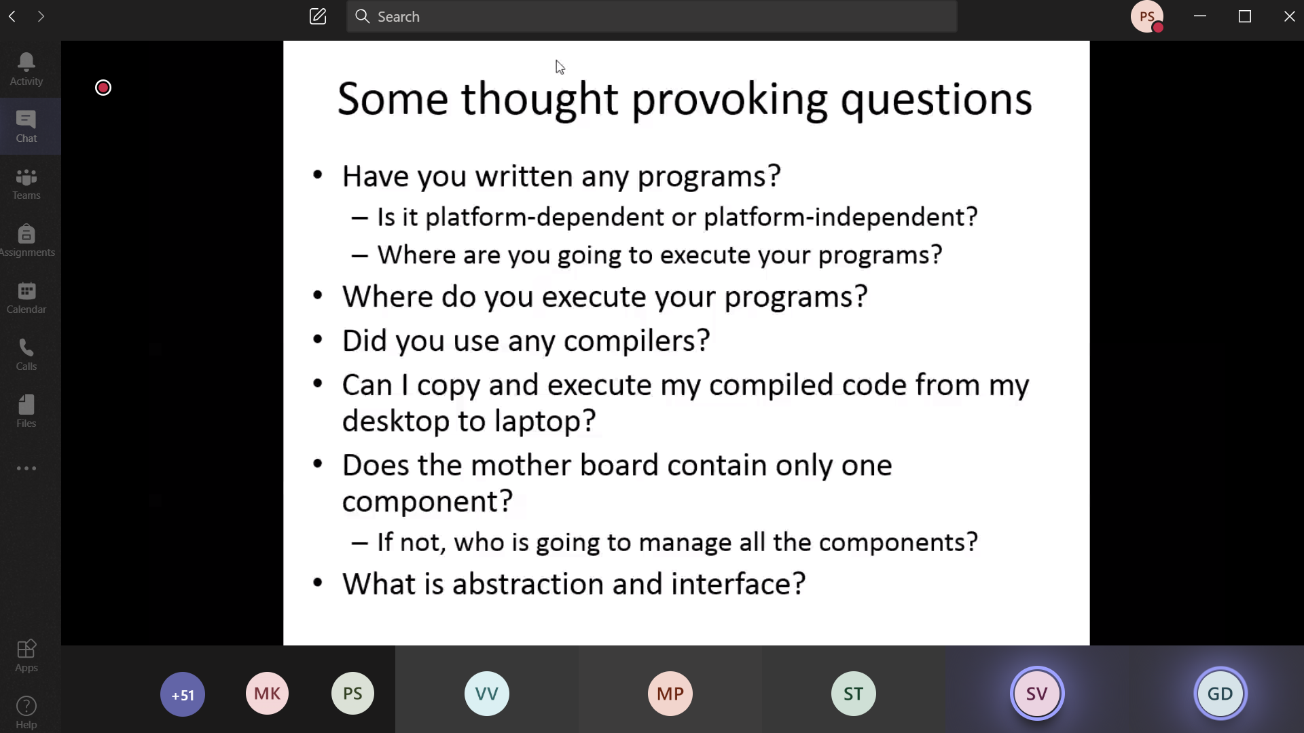

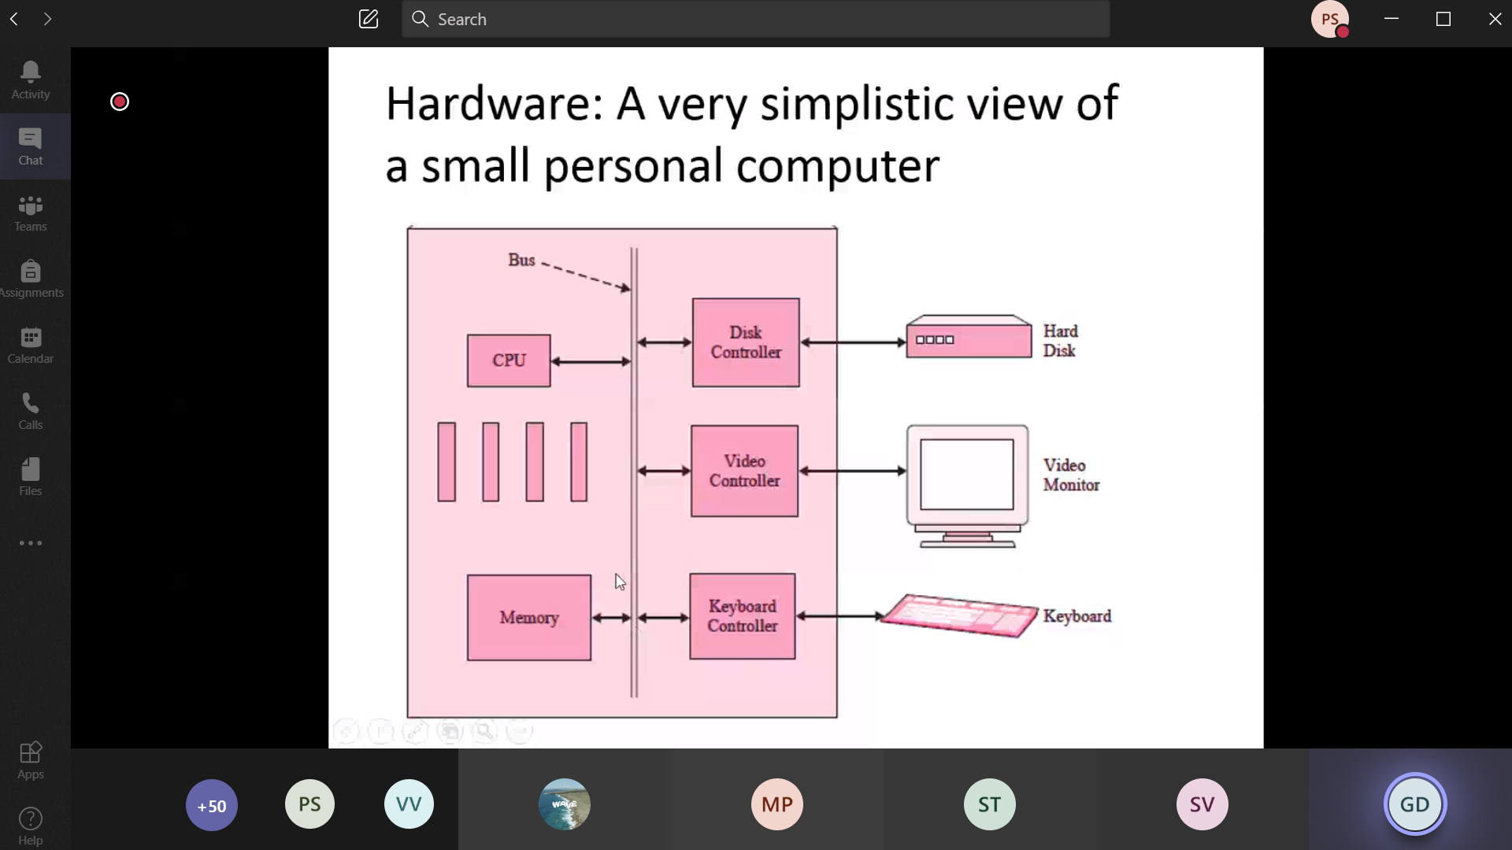

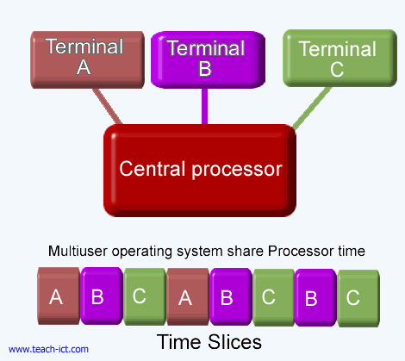

**Single-user OS**

* Windows 95
* MS-Dos
* Windows NT Workstation
* Windows 2000 professional

**Multi-user OS**

* Ubuntu
* macOS
* All linux based OS
* Unix
* IBM AS400
* Windows 10

Computer System Architecture

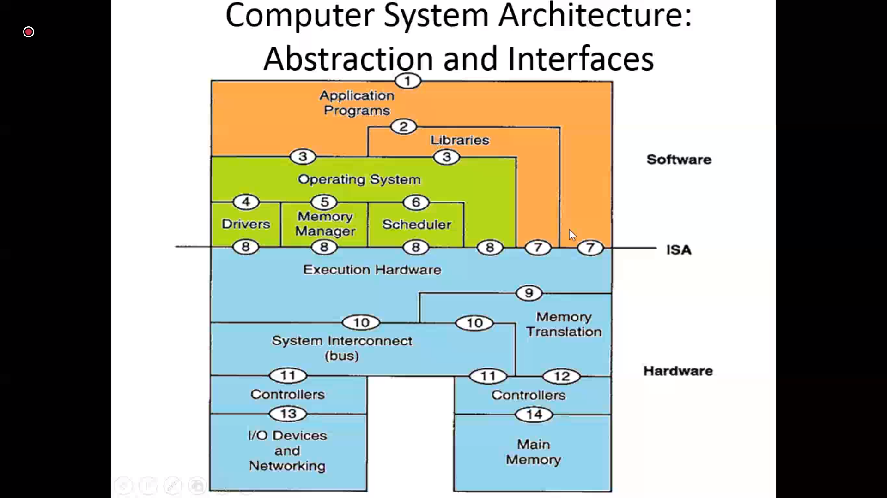

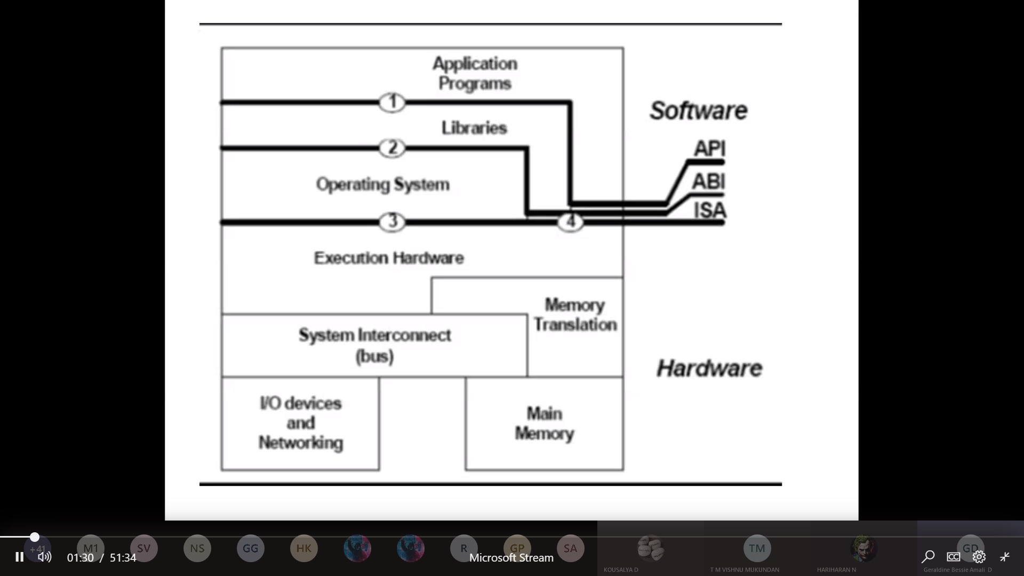

API 🡪 Application Programming Interface

ABI 🡪 Application Binary Interface

ISA 🡪 Industry Standard Architecture

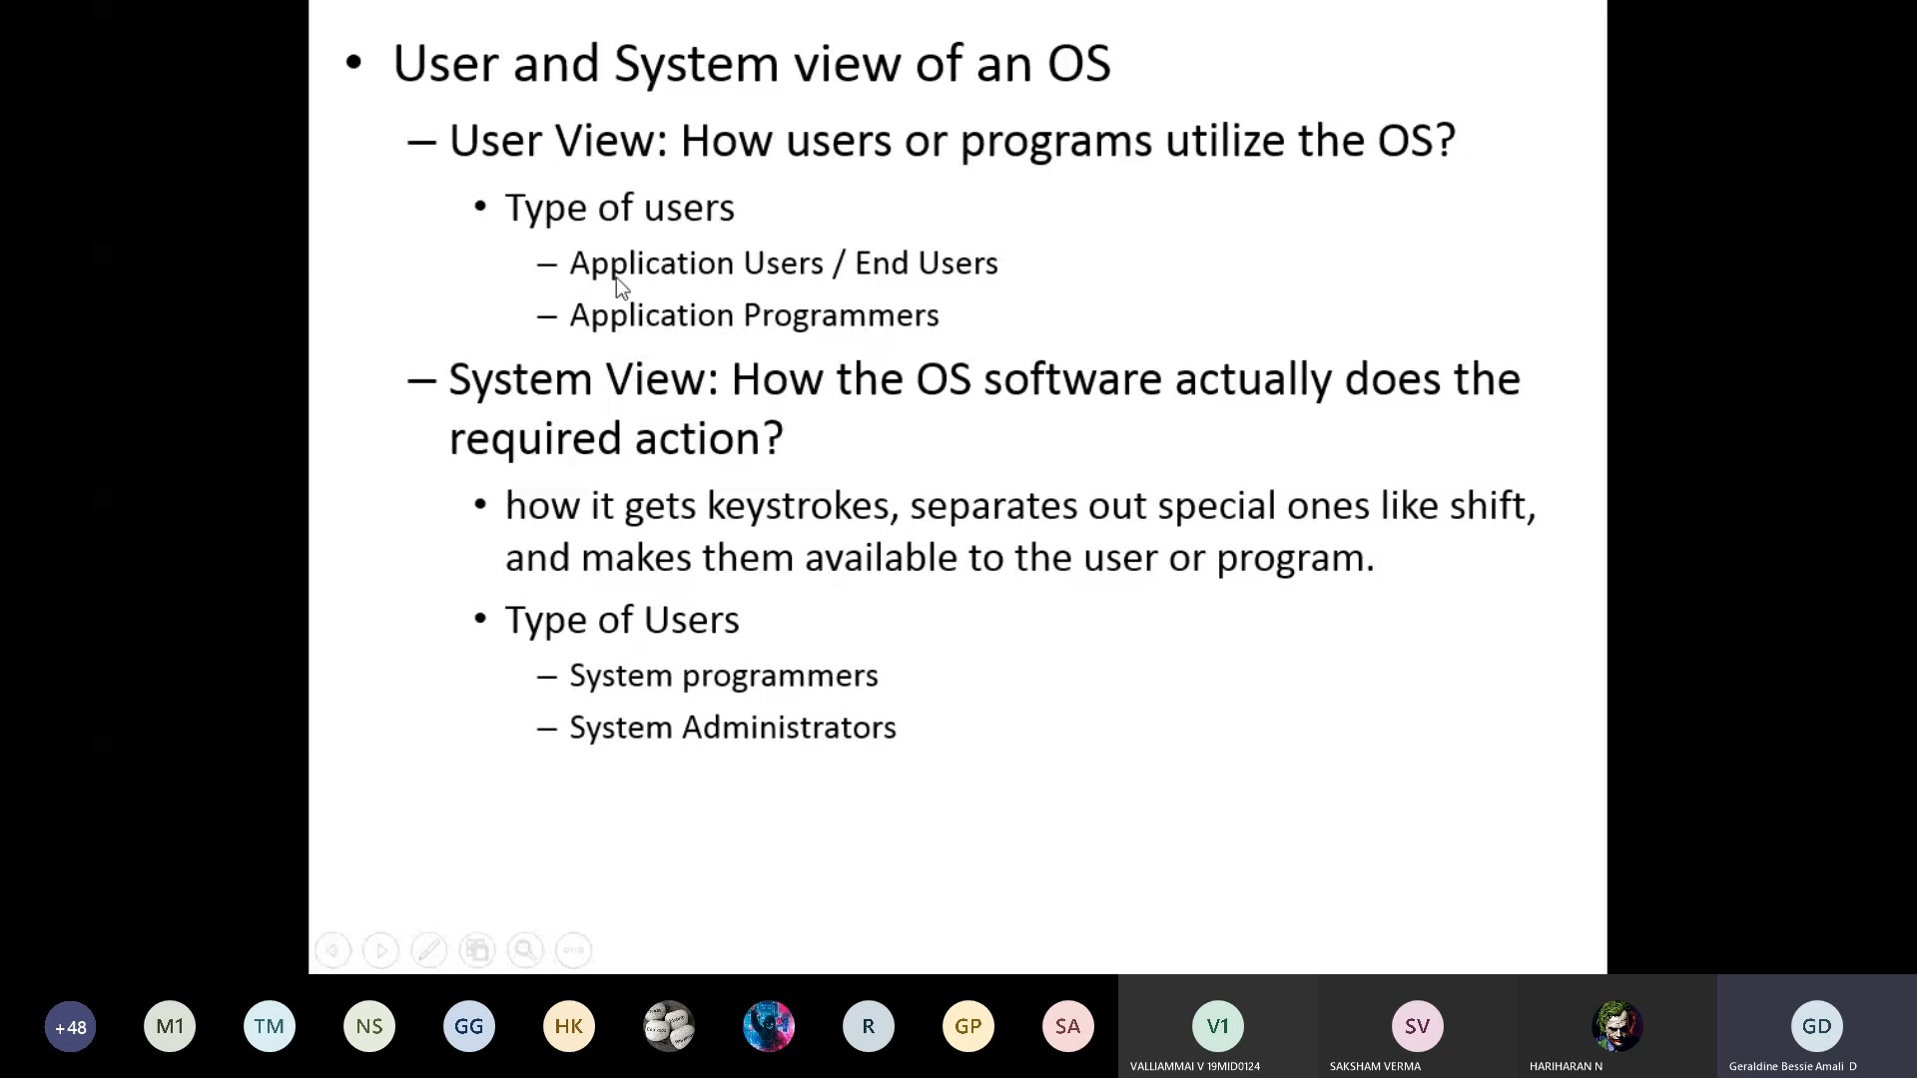

User:

* 1. Application Users/end users
  2. Application programmers
  3. System Programmers
  4. System Administrators

**Application users/ end user:**

These are the common people who a software to do their specific tasks . Eg: In a shop a biller uses an excel in-order to do bill the amount, look into available stocks, employ details, customer details. The biller doesn’t the know the backend process (i.e) how the calculations are performed , how the data’s are organized etc.

**Application Programmers:**

These are the persons who develop this application for the end-user, He take cares of the internal algorithms running in-order to provide an efficient and a useful application for the end-user. Eg: PUBG game developer, the game developer knows everything about designing, architecture, algorithm, CPU performance , GPU performance, touch sampling rate, screen refresh rate etc about the game. But as a end-user I know only to play the game rather than the back-ground process.

**System Programmers:**

These people develop programs closely related to OS.Eg: Device drivers, Compliers , SHELL it is command line interface 🡪 This directly access the OS

**System Administrators:**

These people directly deals with hardware device

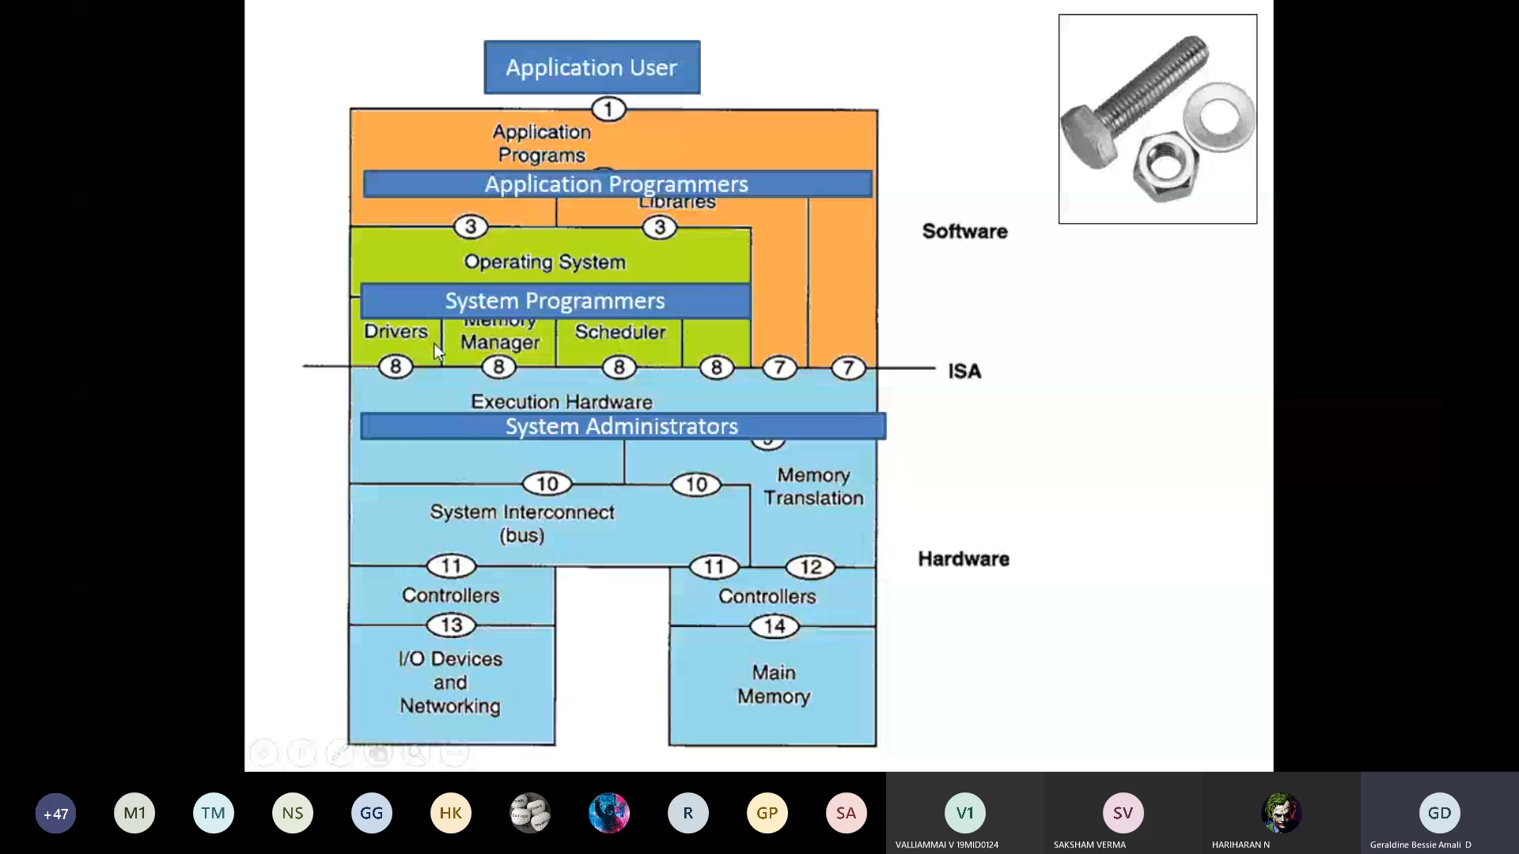

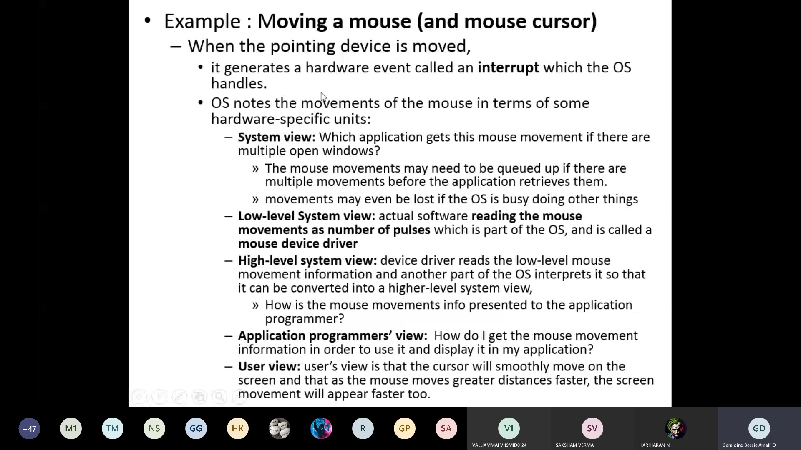

**System View:**

When several applications are running RAM and we are in a situation to select the required apps with mouse.

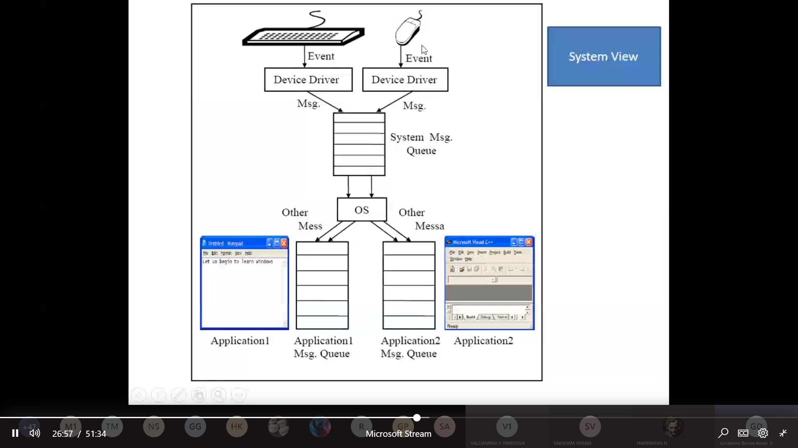

**High level system view**

**Application Programmer view**

**User view**

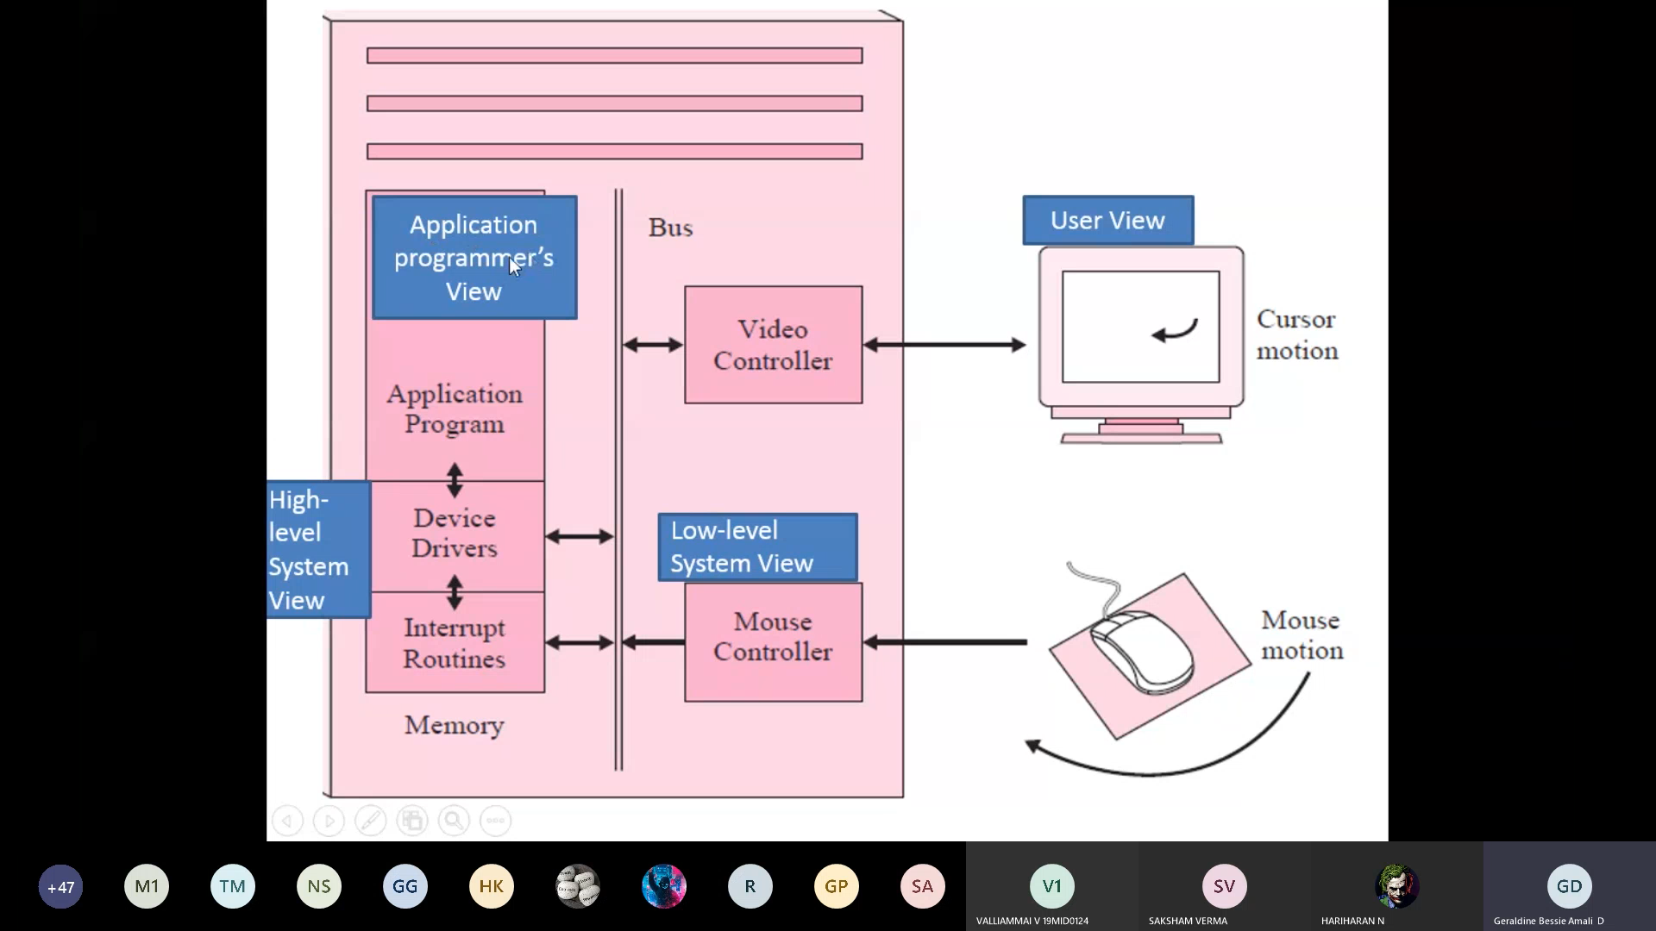

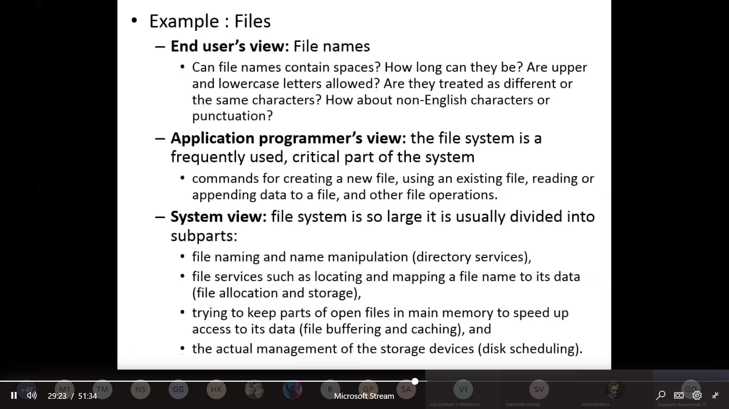

***Simple Batch System:***

When a program is bought into a main memory , then it becomes the process.

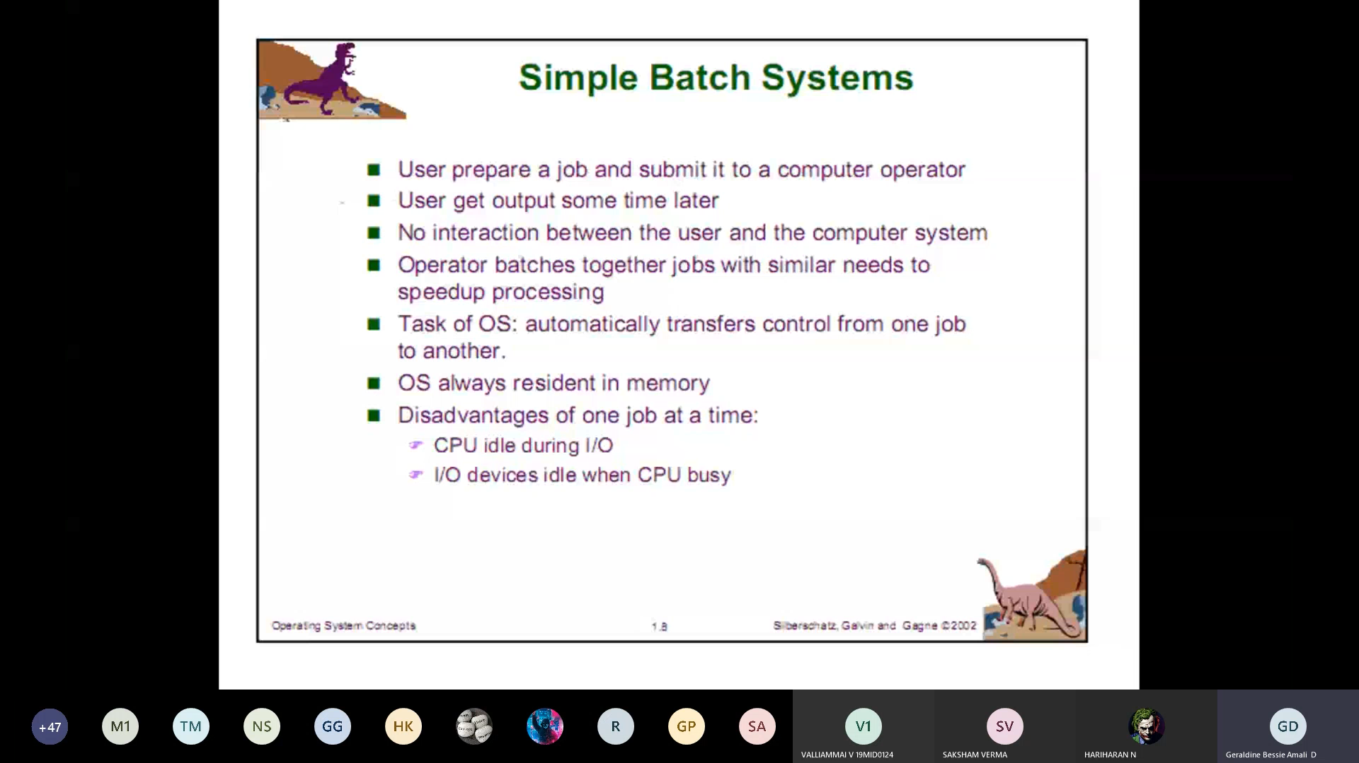

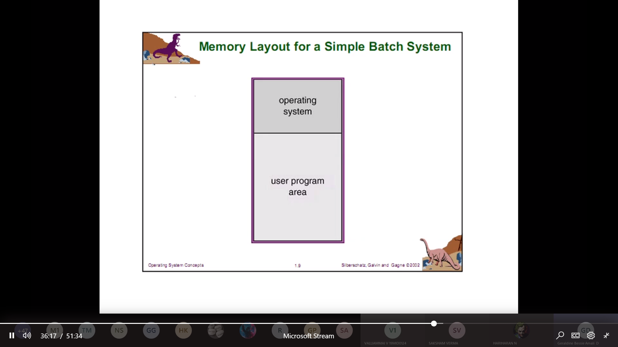

During booting OS will be in the main-memory (will occupy some space)

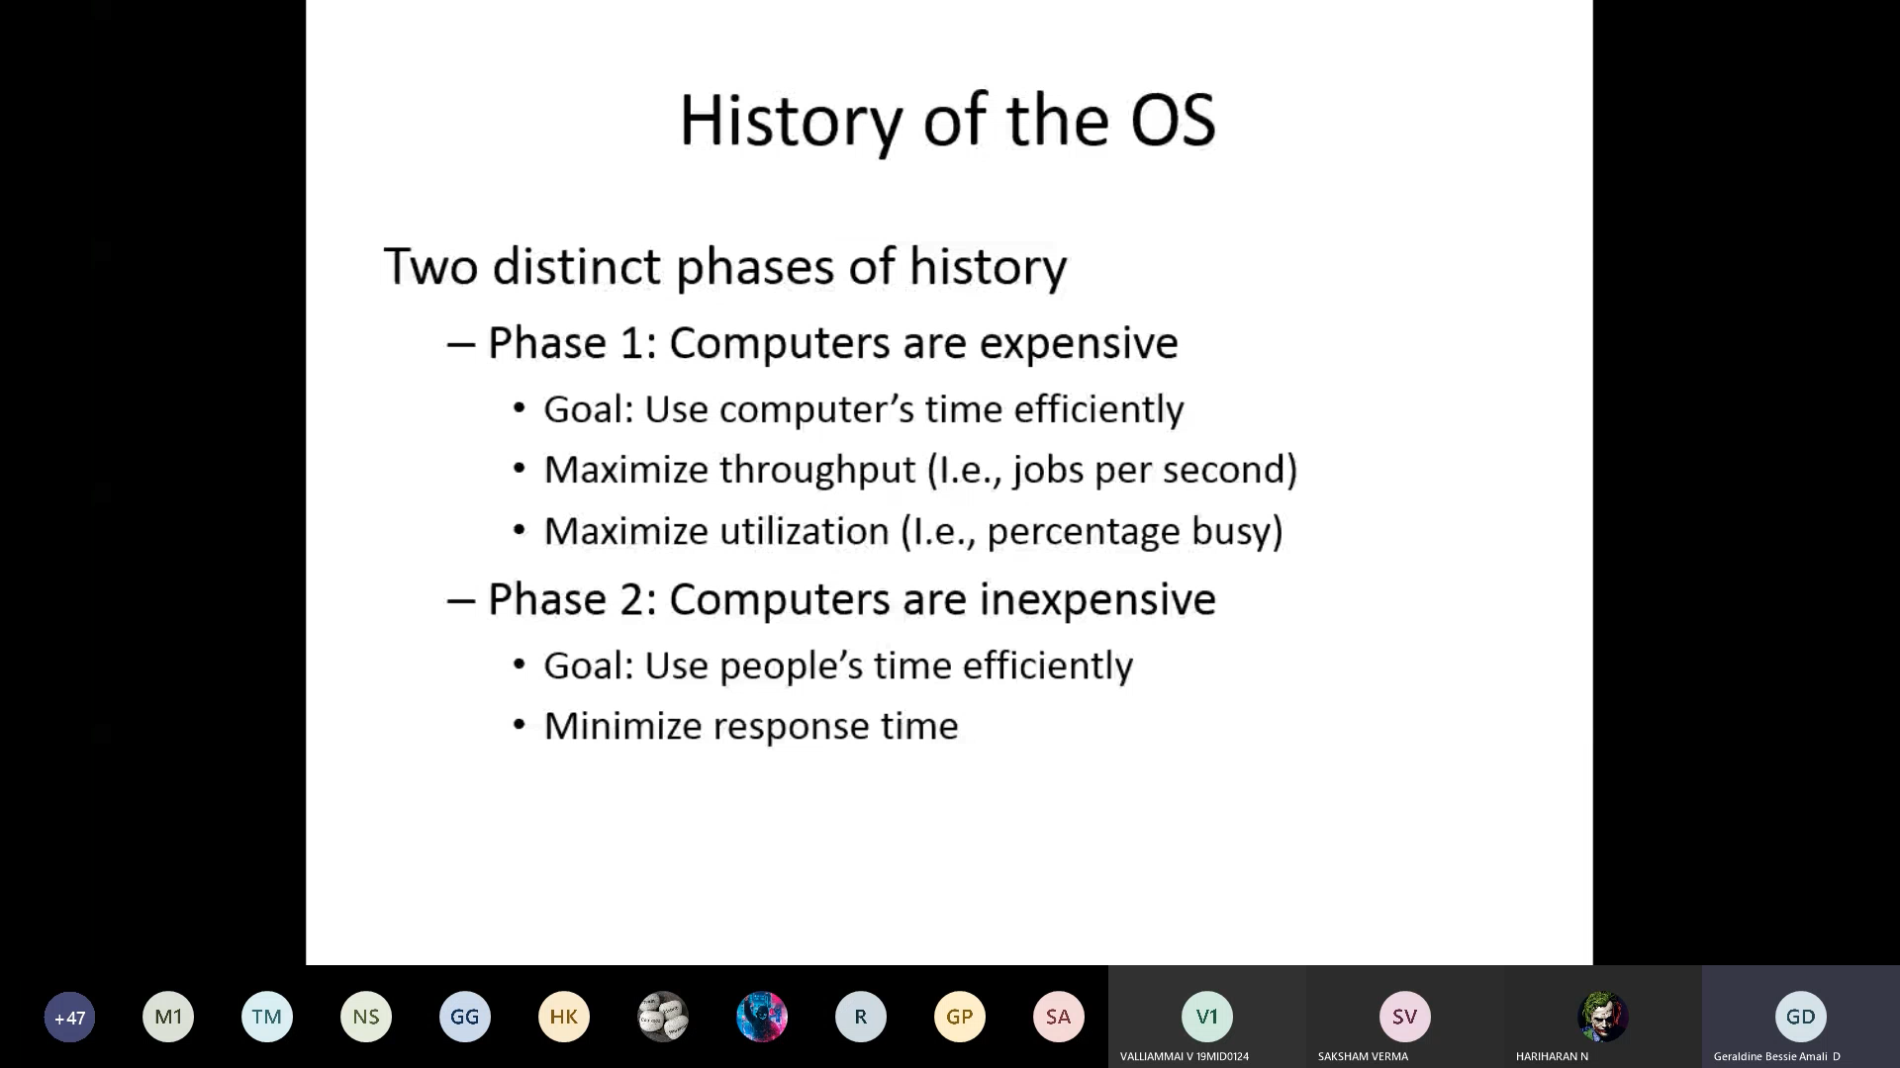

CPU burst

IO burst

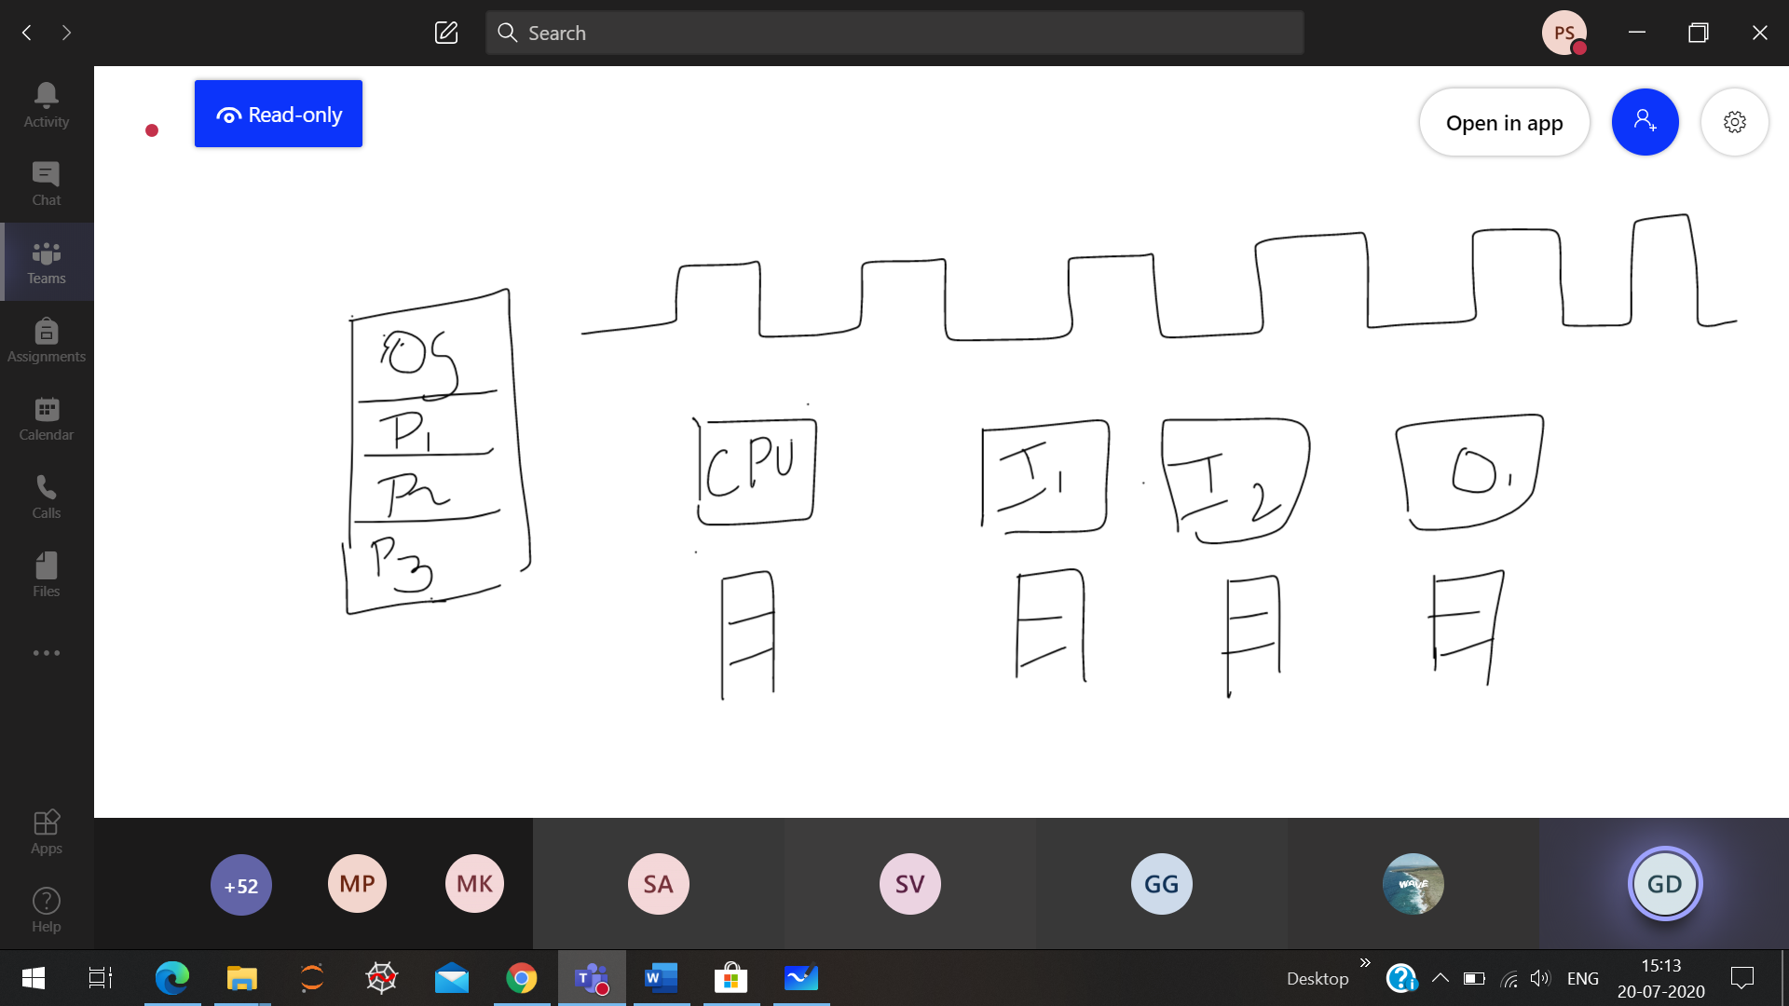

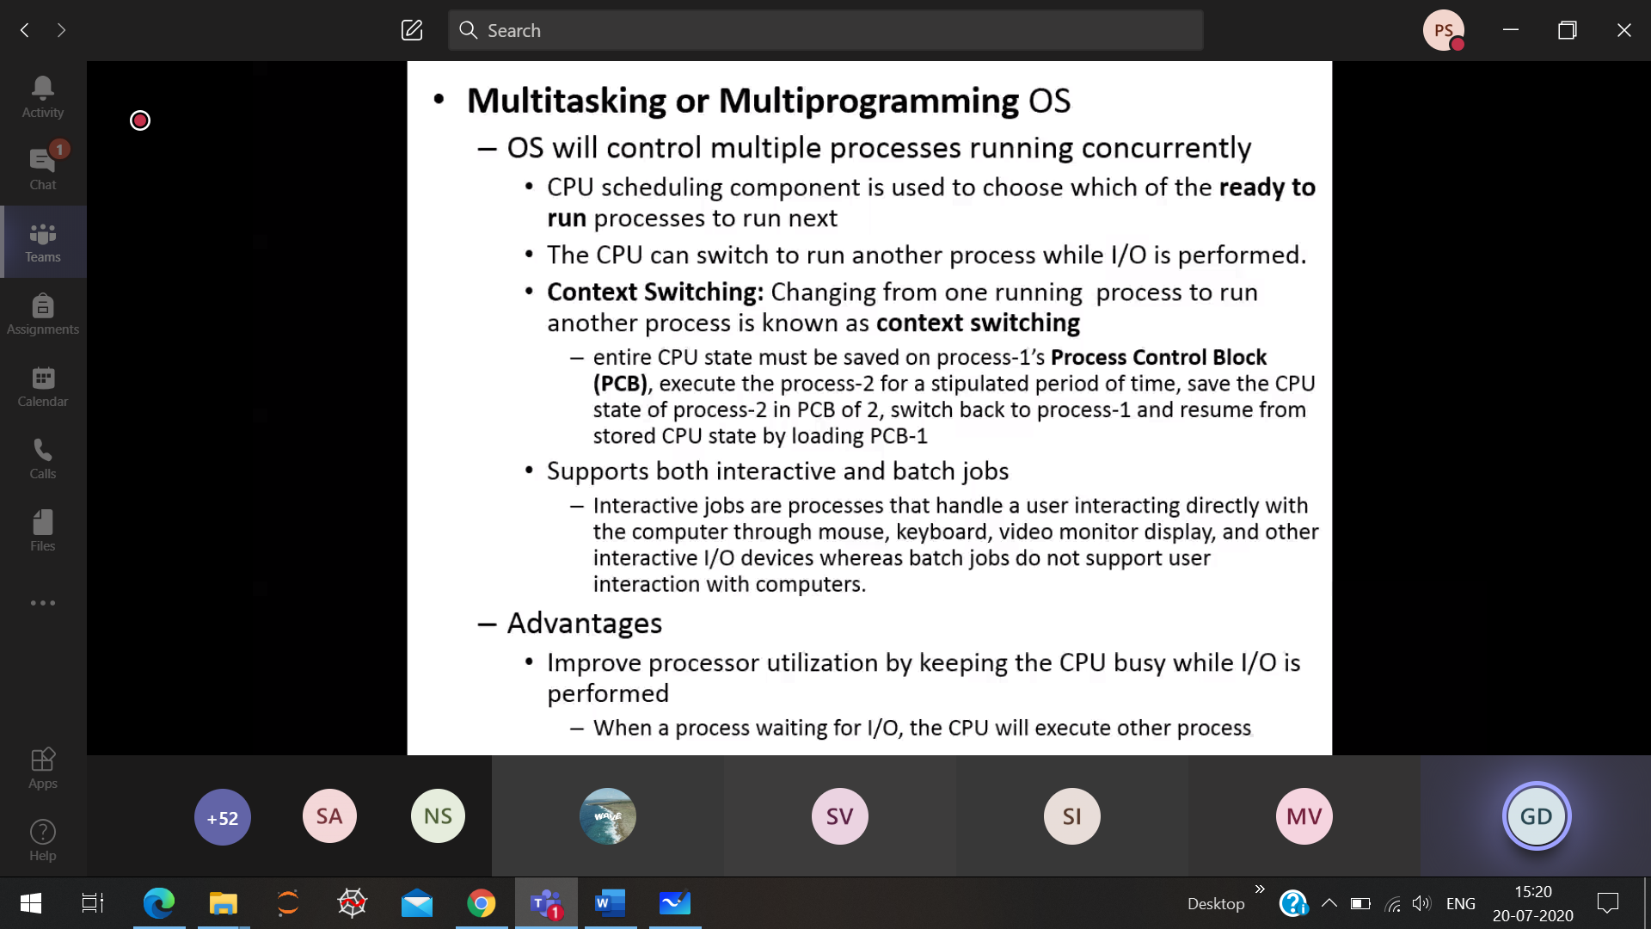

(3+2) + 6 🡪 11

Process-1 (3+2)

Process-2 5 + 6

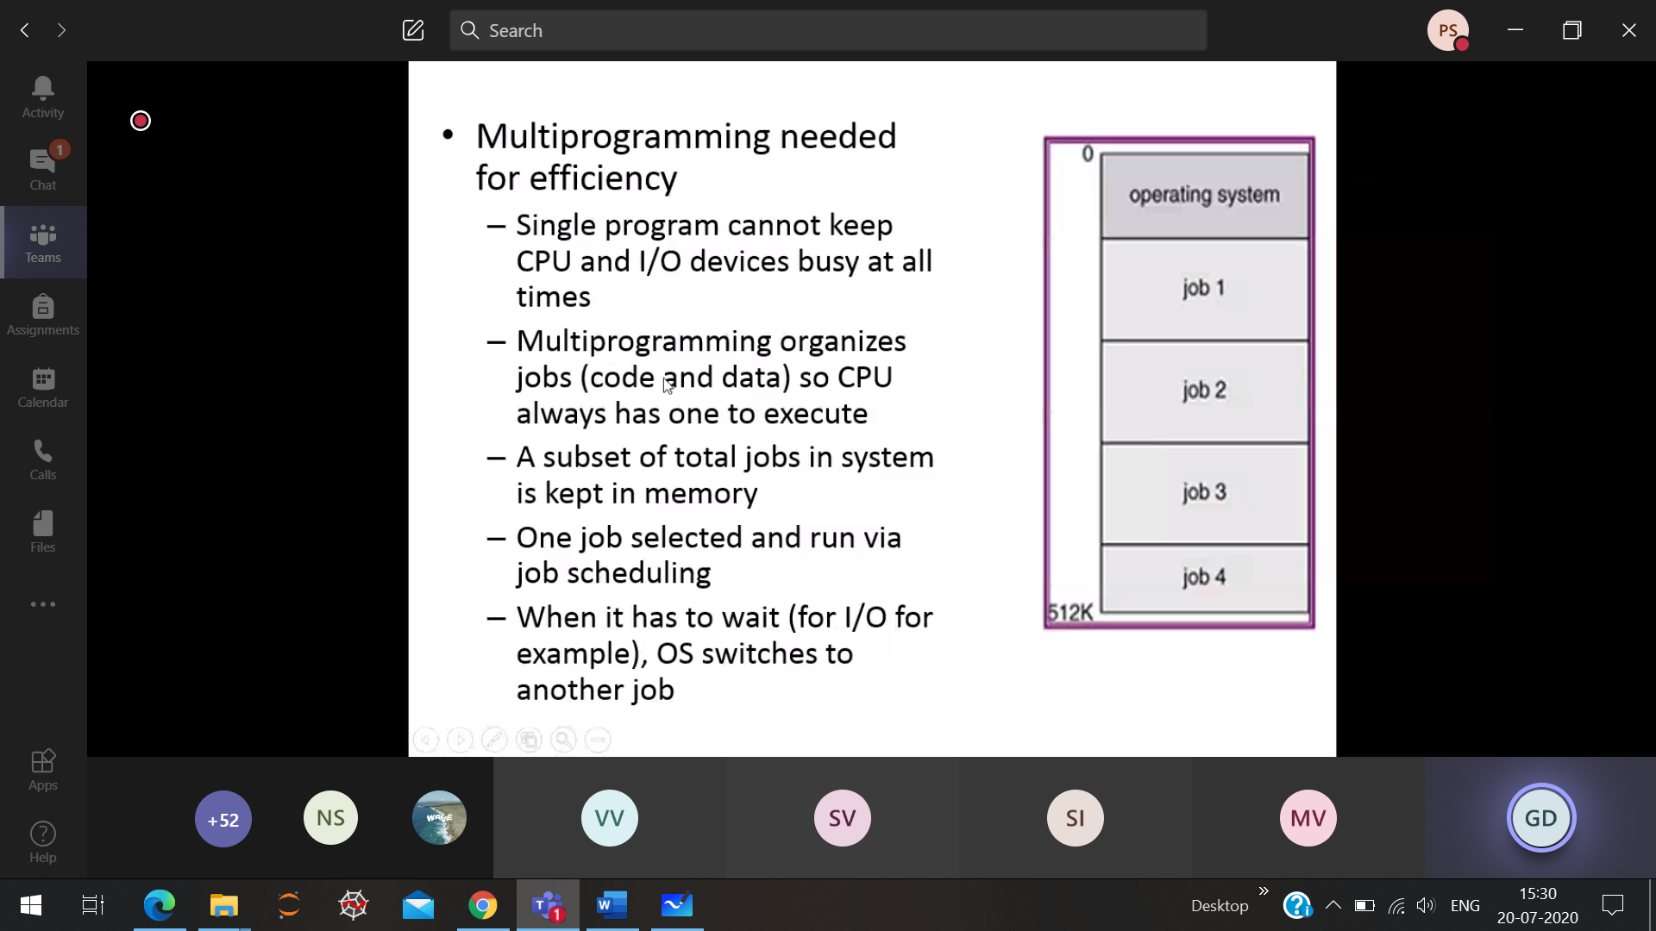

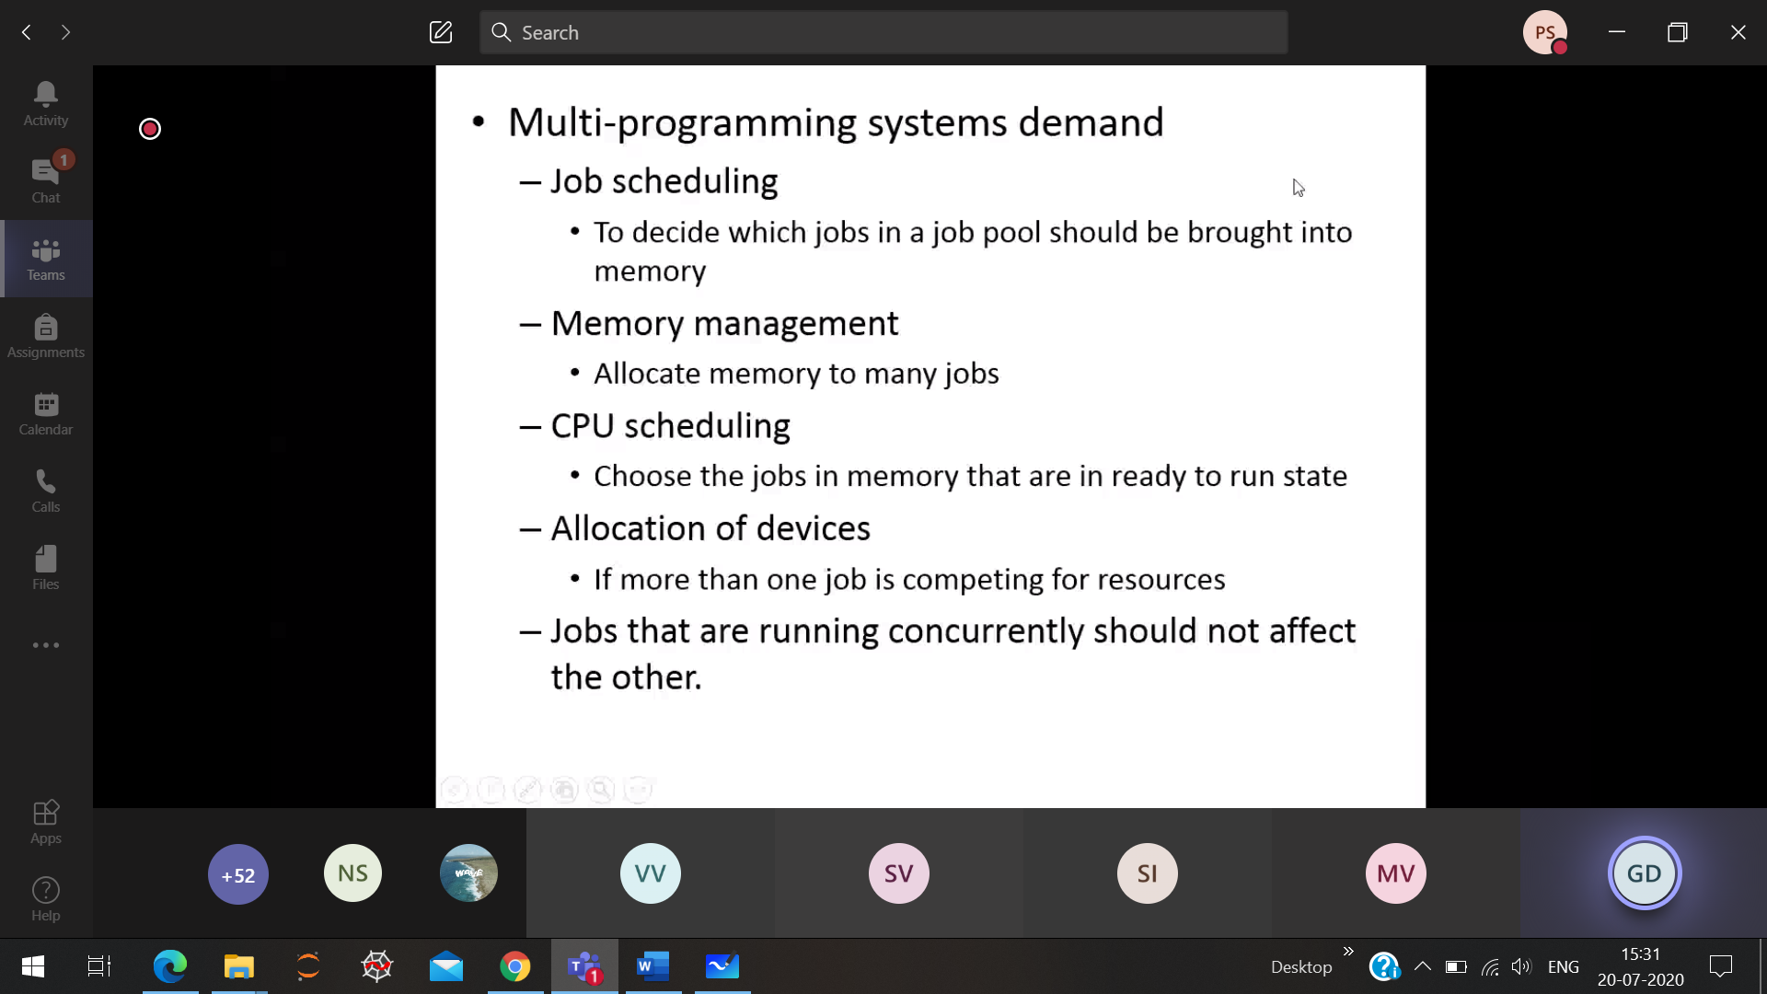

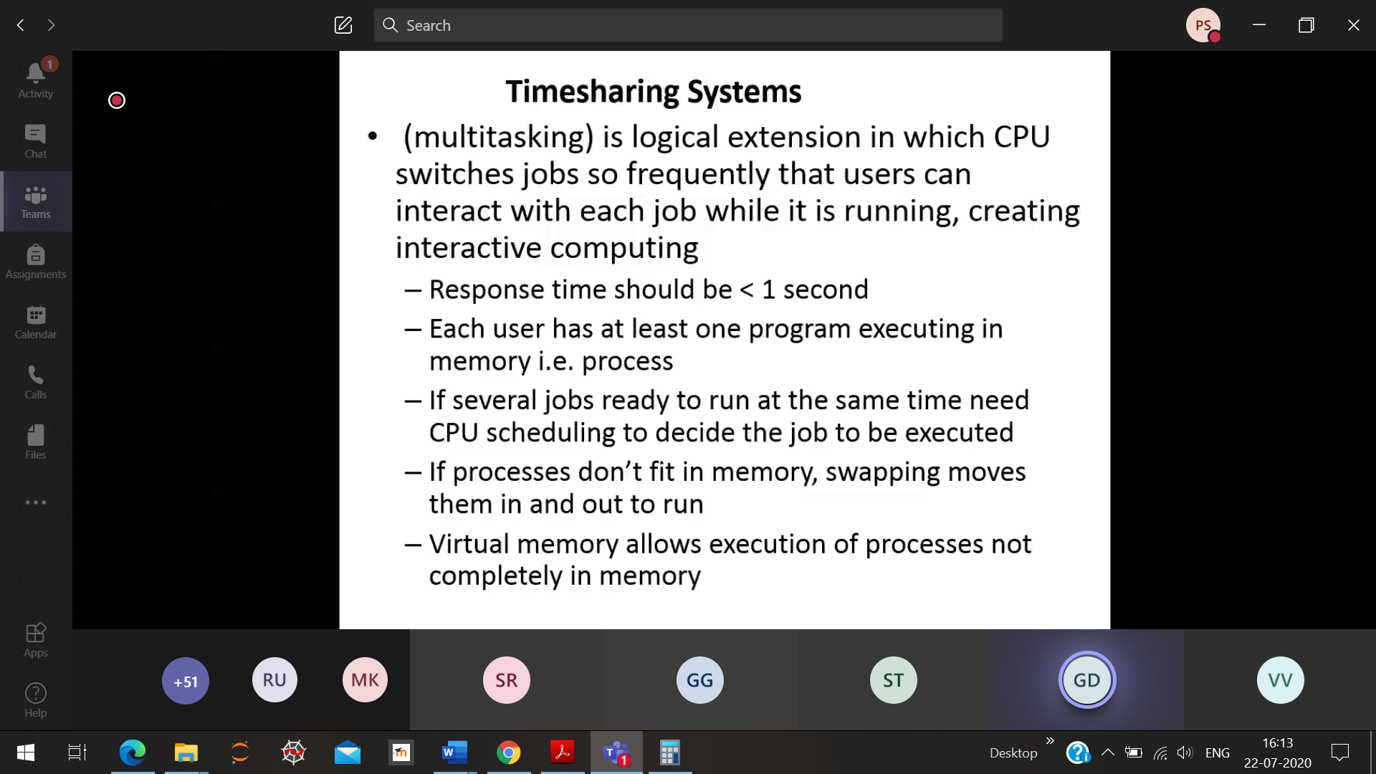

More space required than RAM, then it takes place at virtual memory.

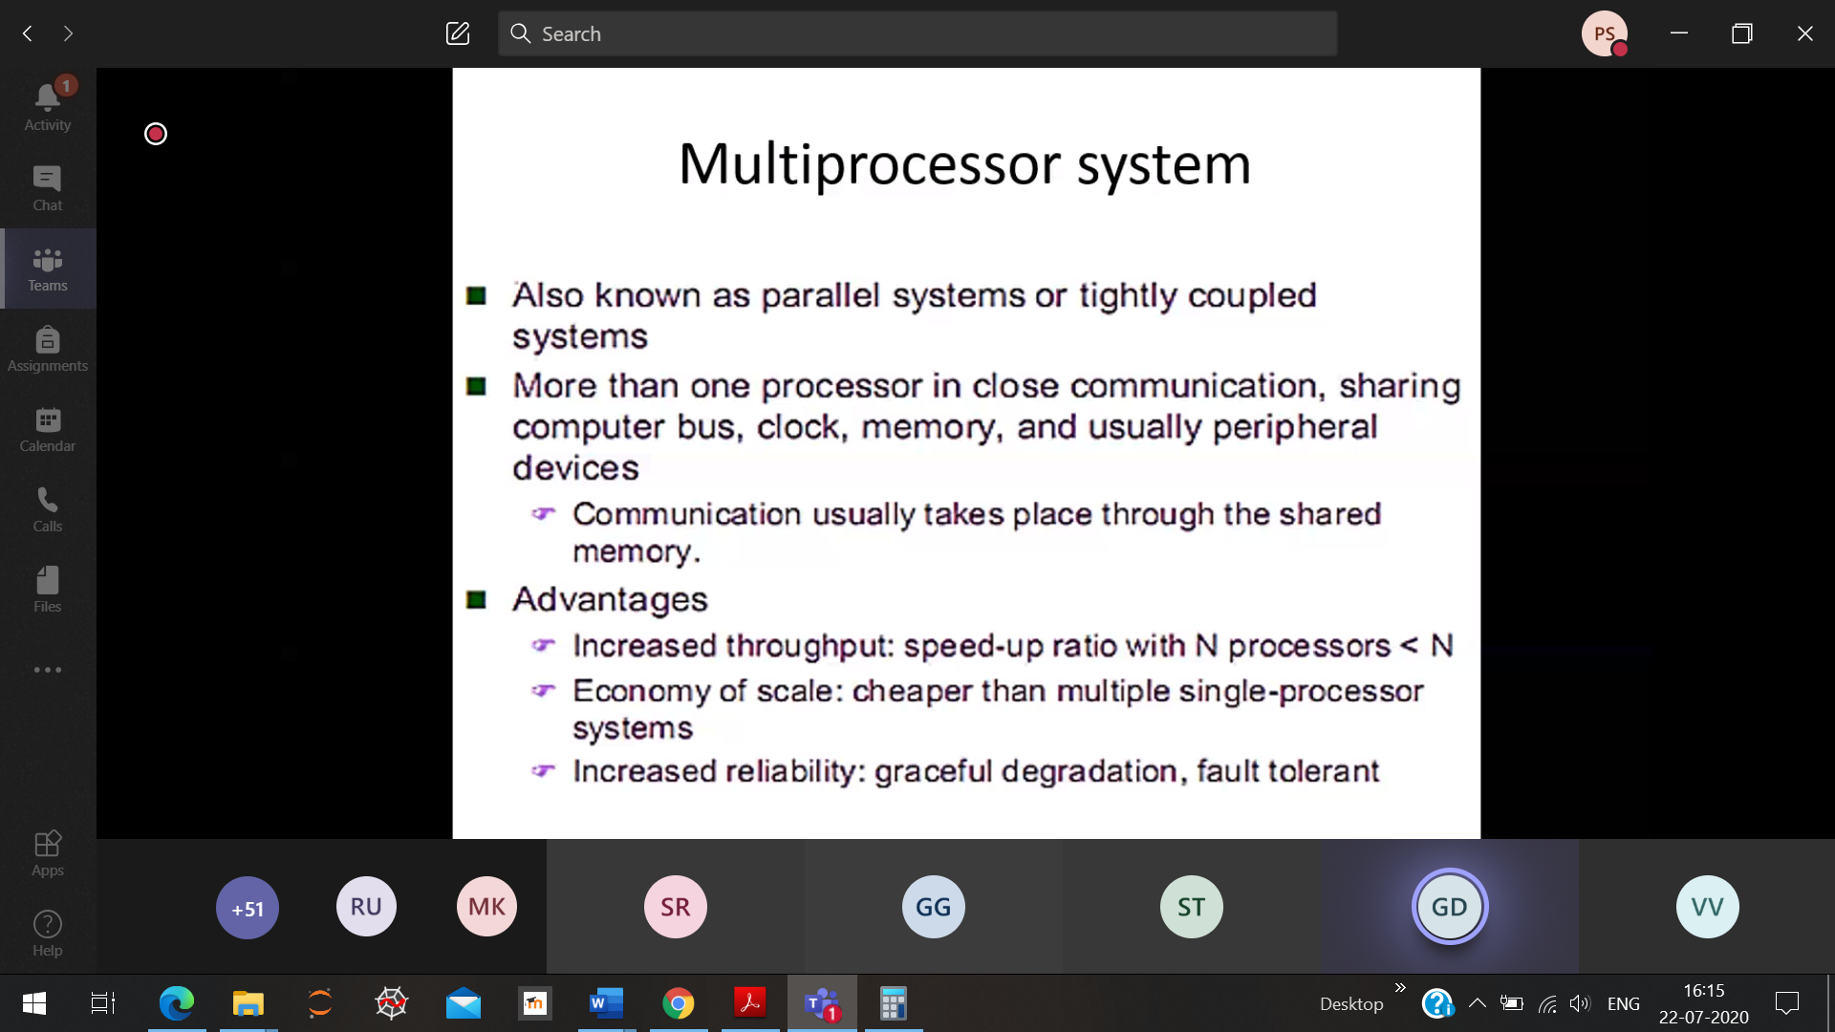

through put

graceful degradation 🡪 out of 4 processor if 1 is faulty, then the remaining 3 processor will do the job of 4 processor

**Symmetric:**

Processor-1 : 10 min

Processor-2 : 5 min

After Processor-2 finishes it does not sit idle, it takes the work from Processor-1 and do that work. No head for scheduling the processor to do 🡪 Present technology

**As-symmetric :**

Processor-1 : 10 min

Processor-2 : 5 min

A head will be there to schedule the processor.

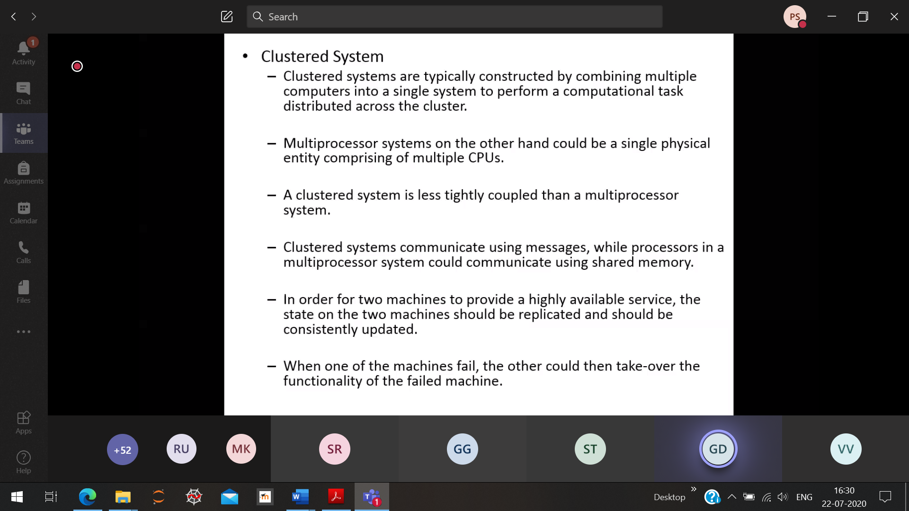

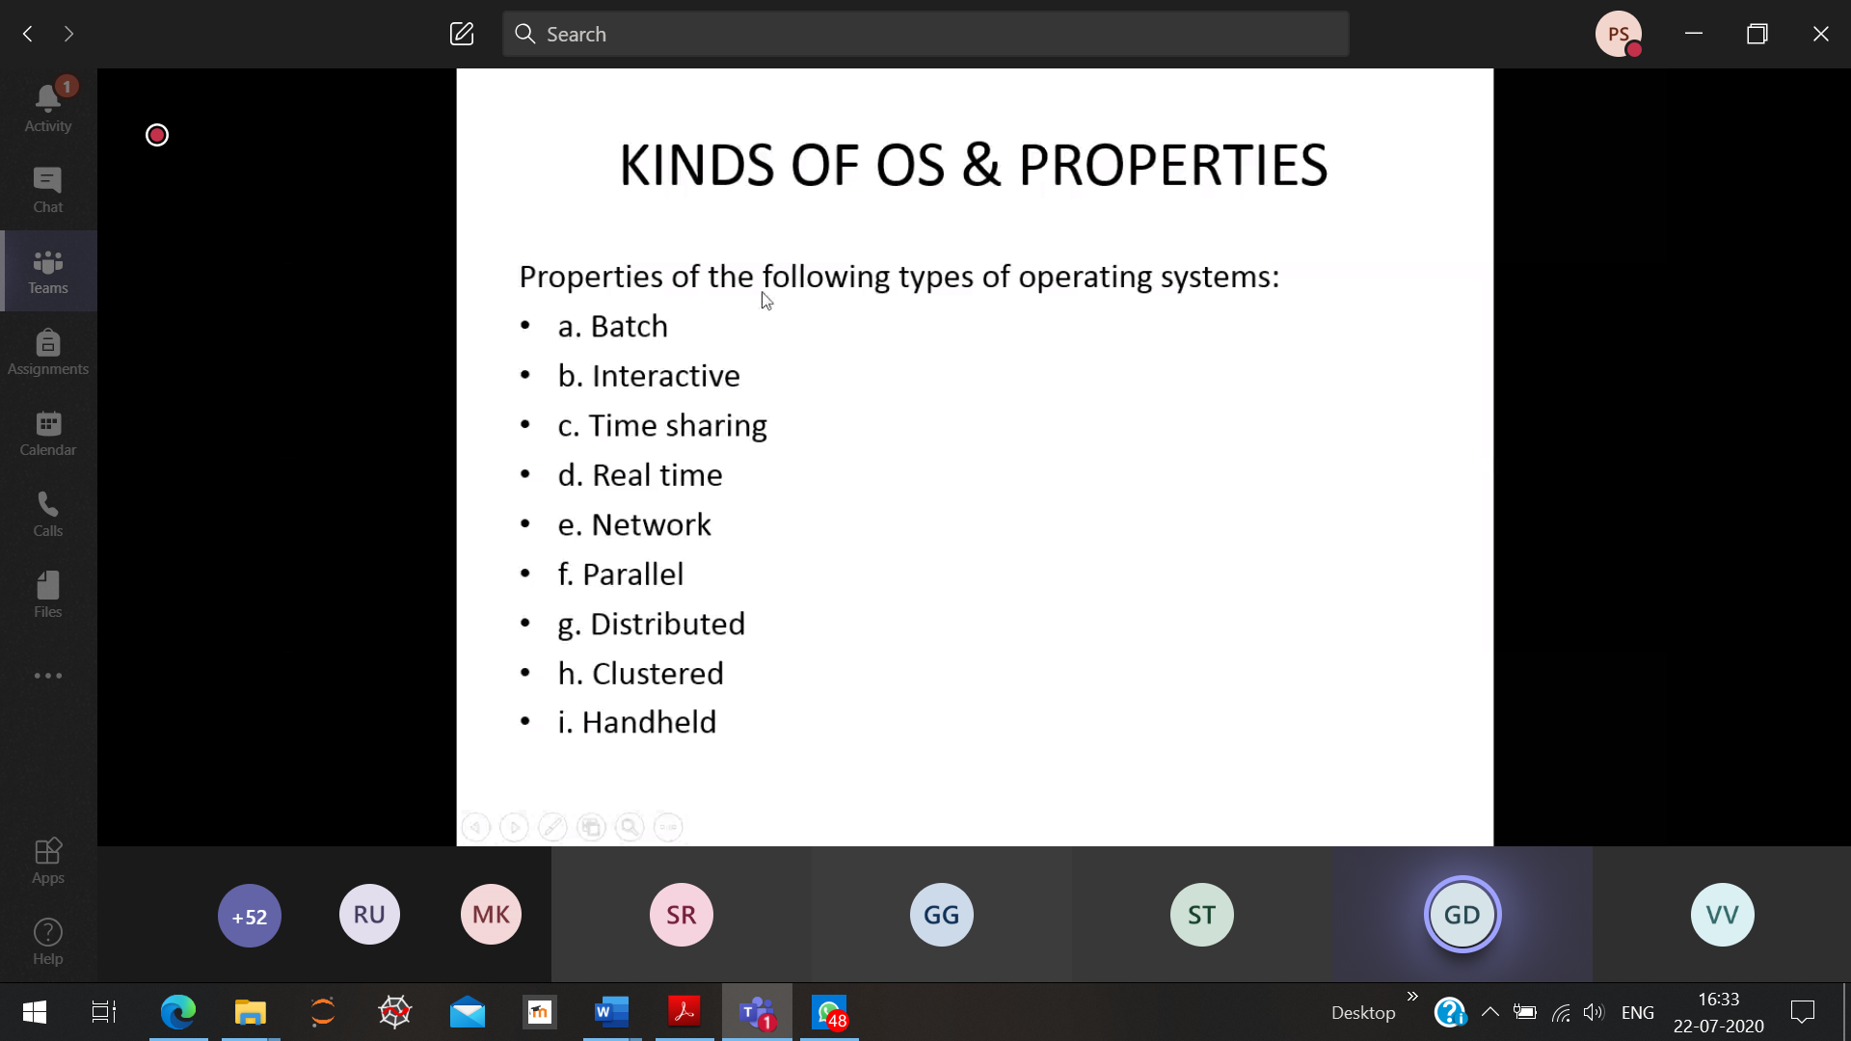

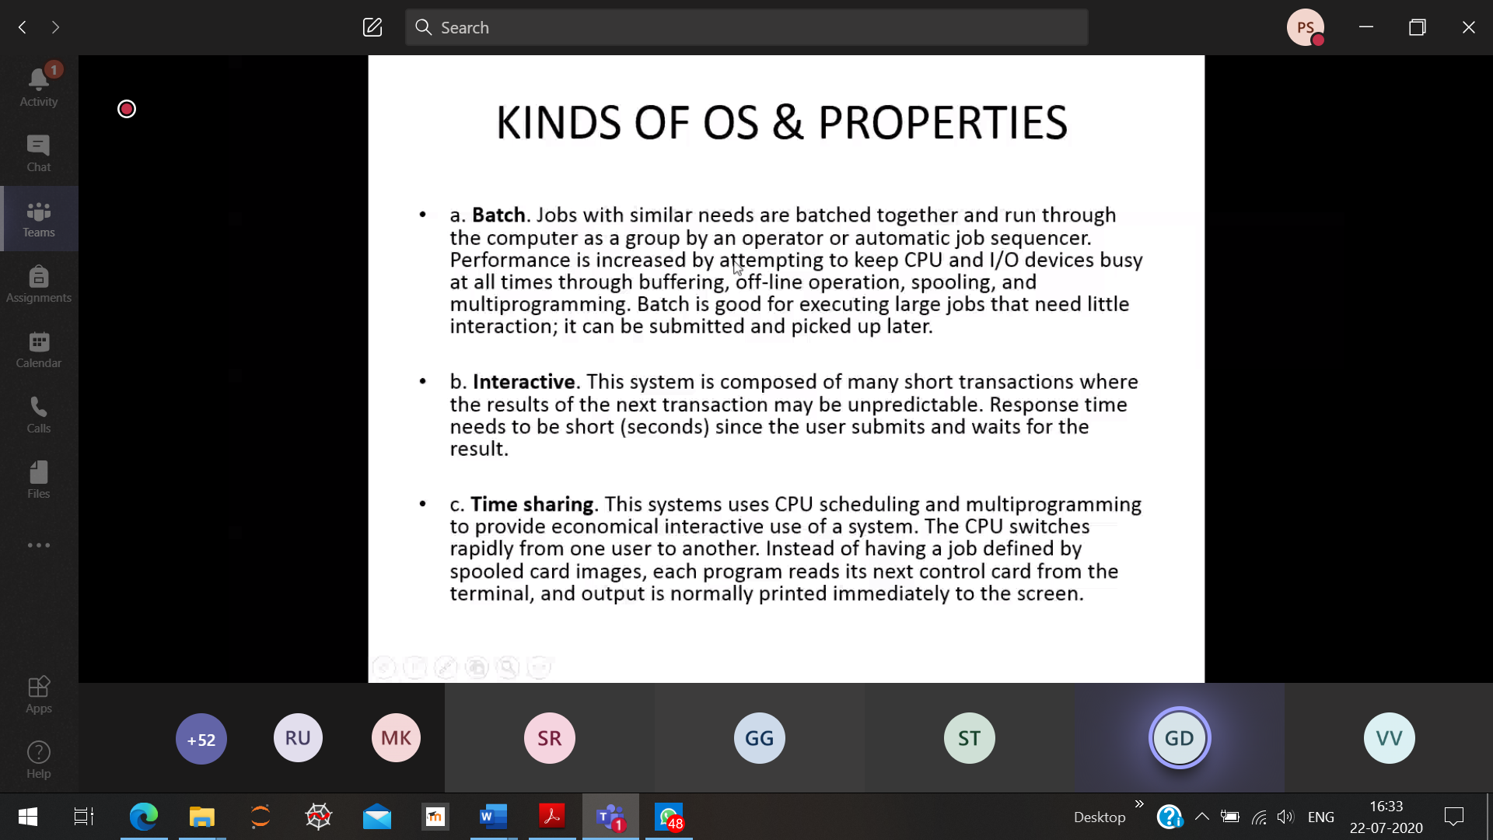

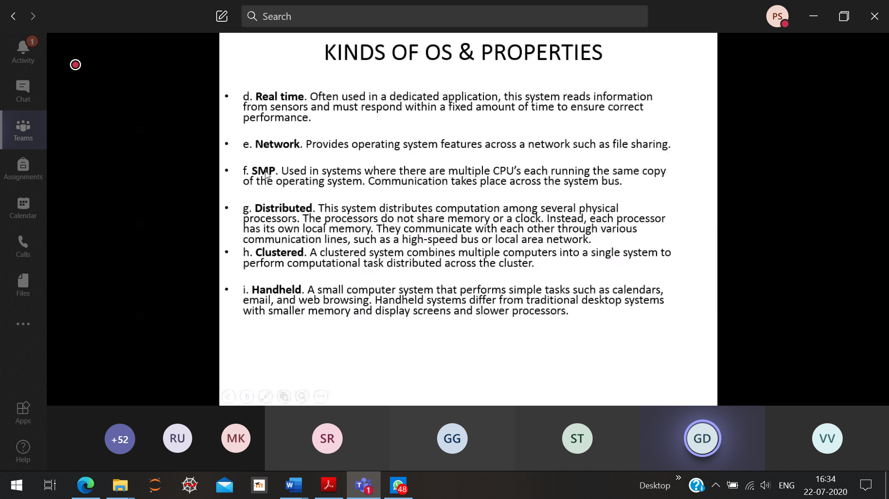

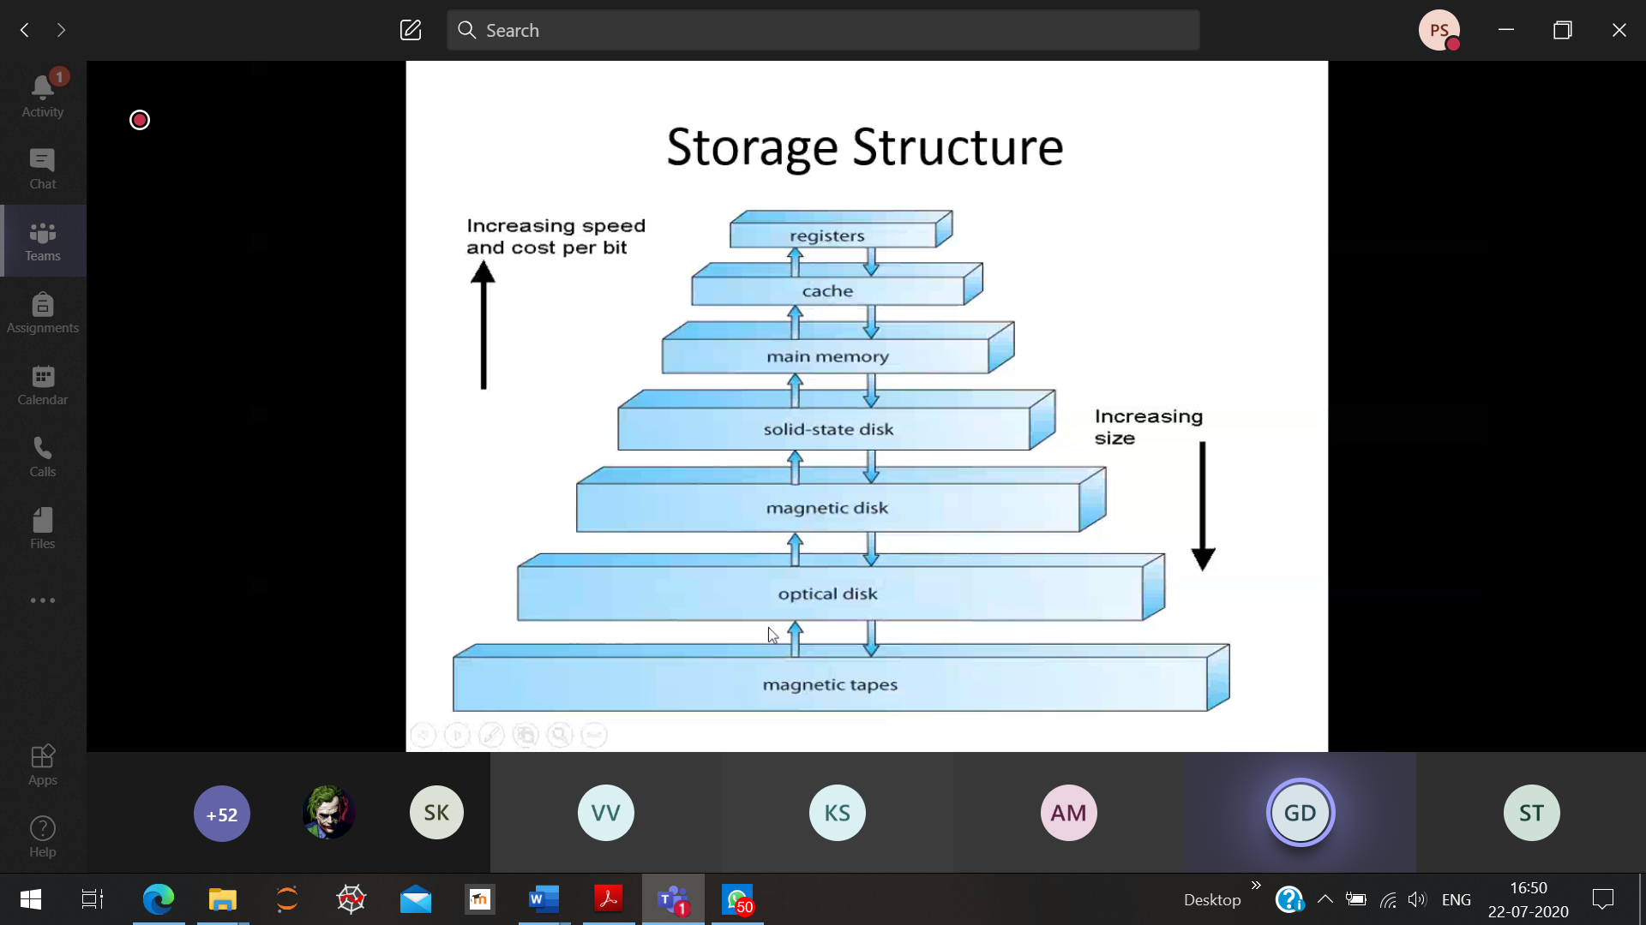

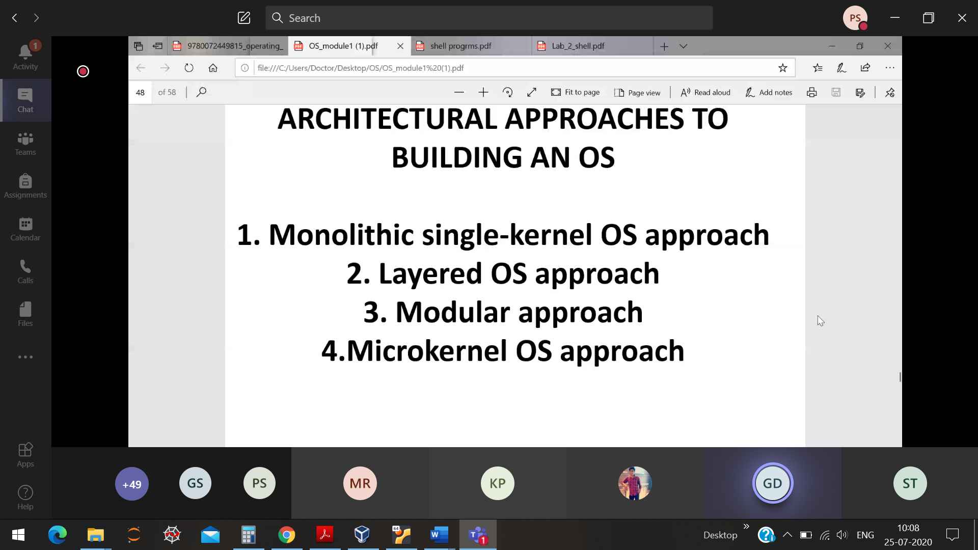

**Kernel 🡪** Only contains the most important function of the OS

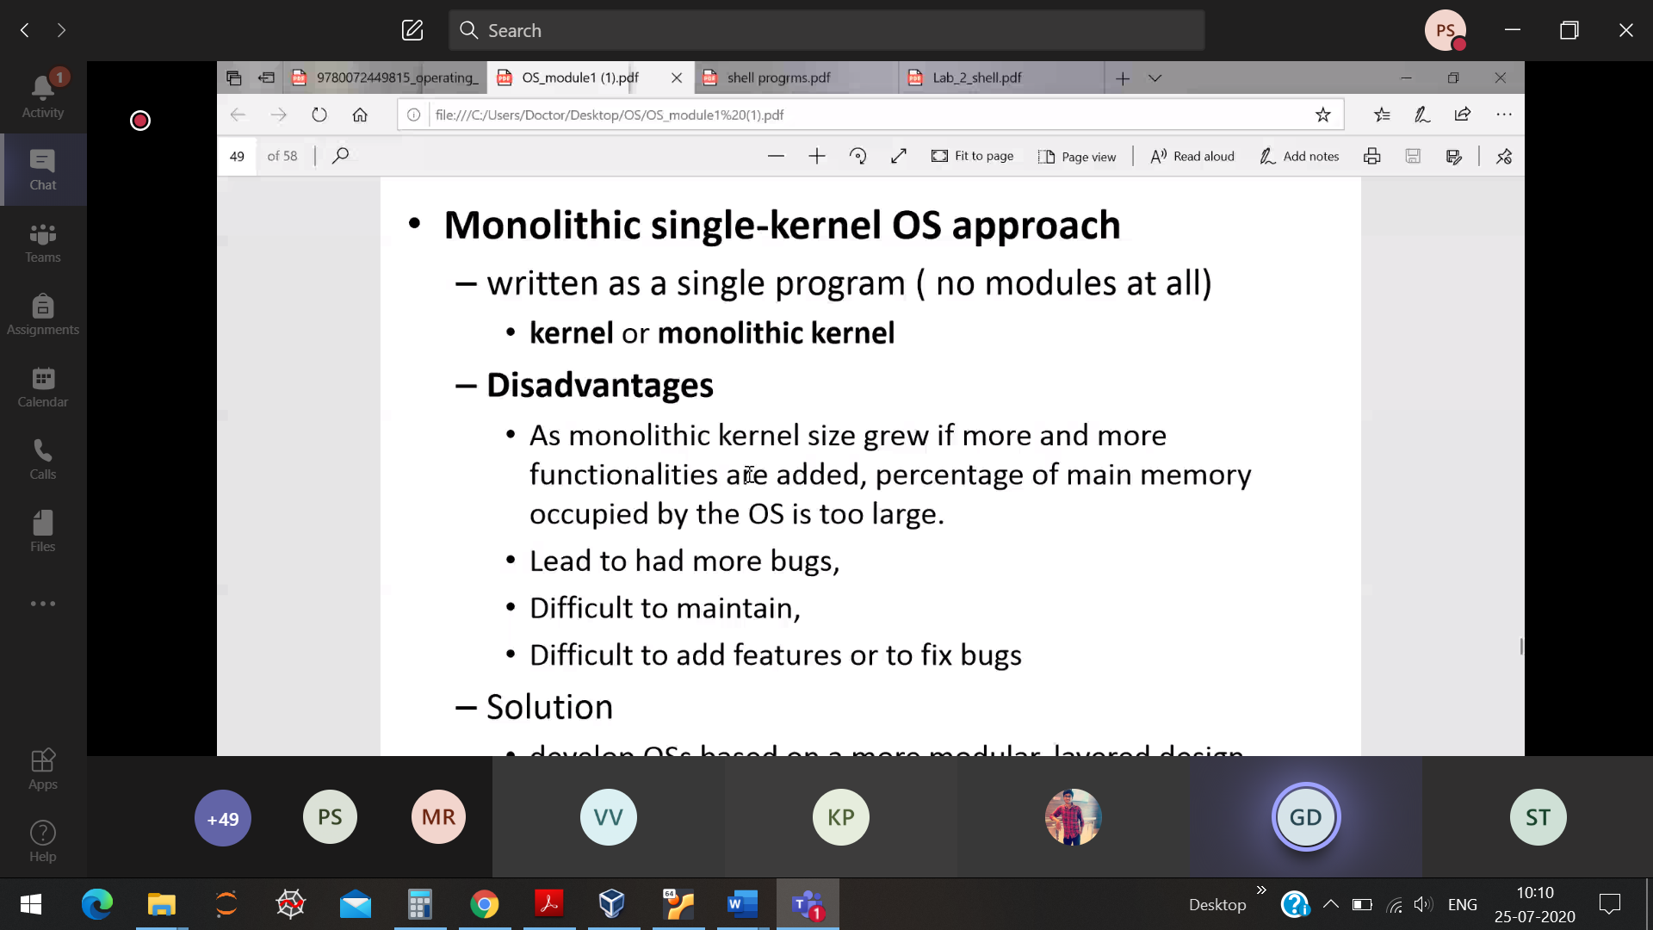

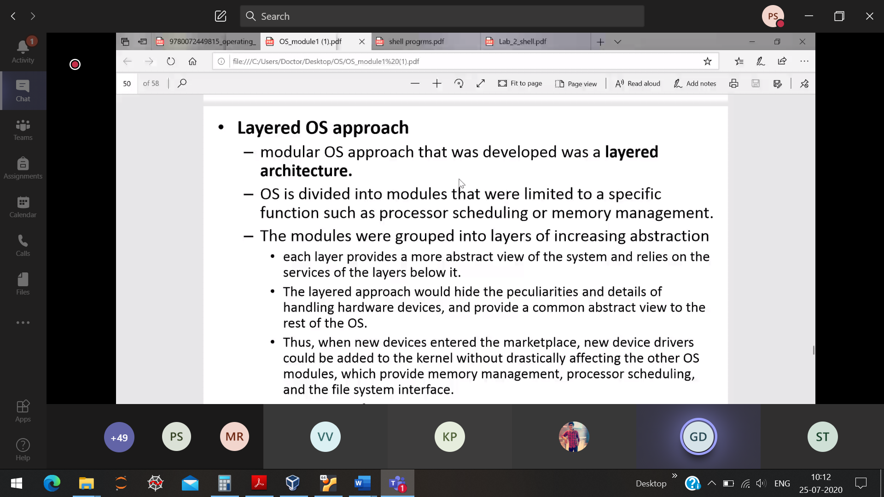

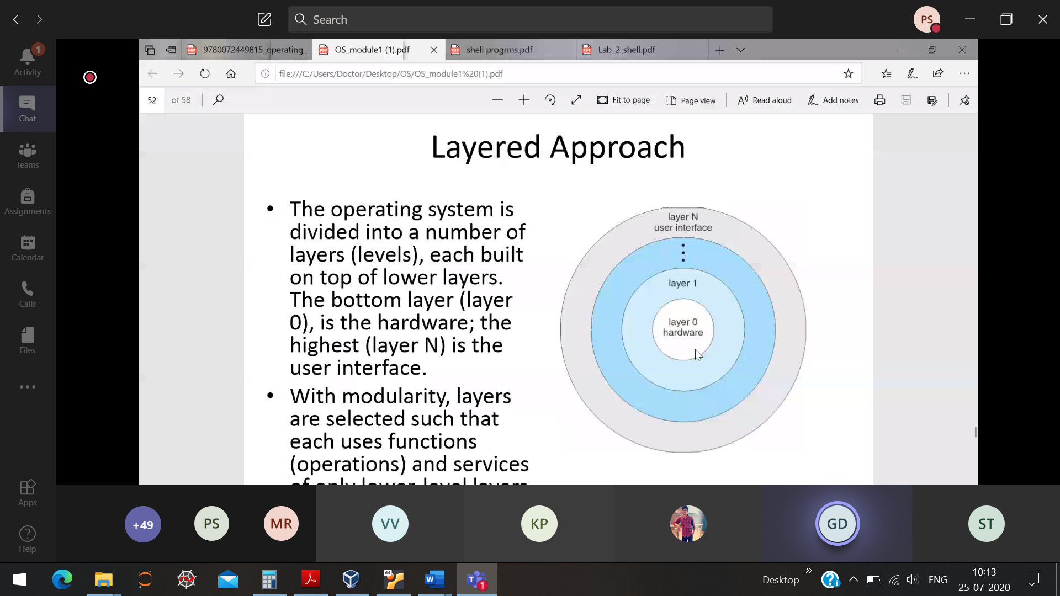

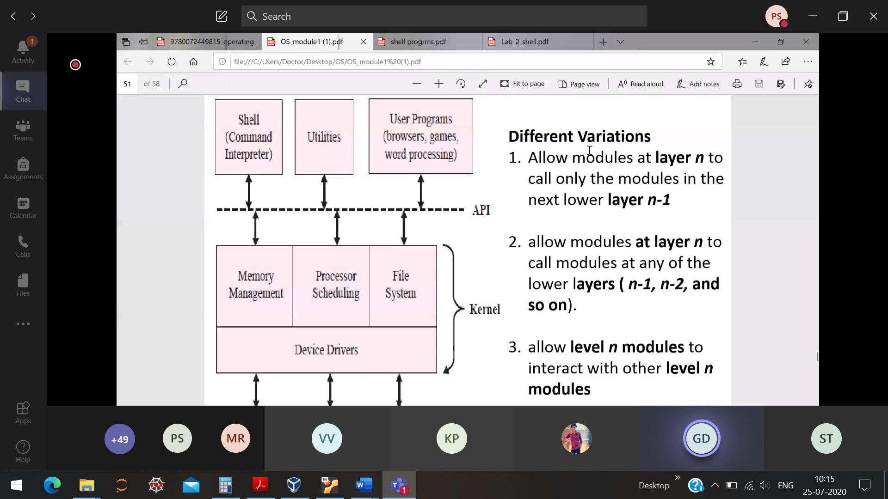

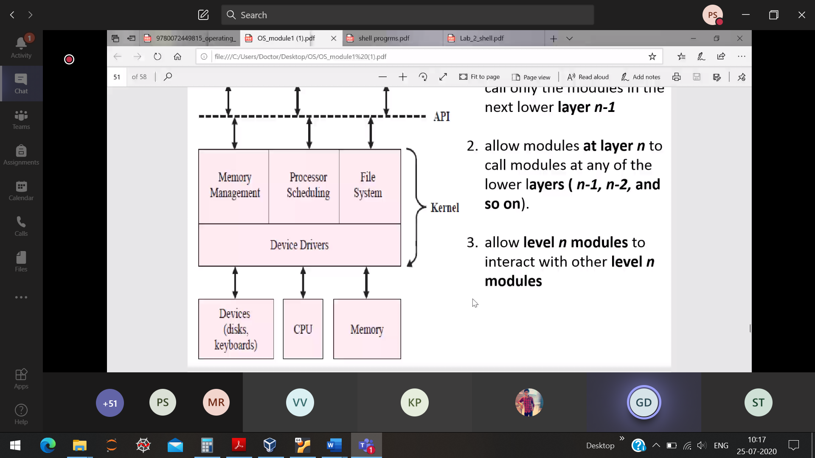

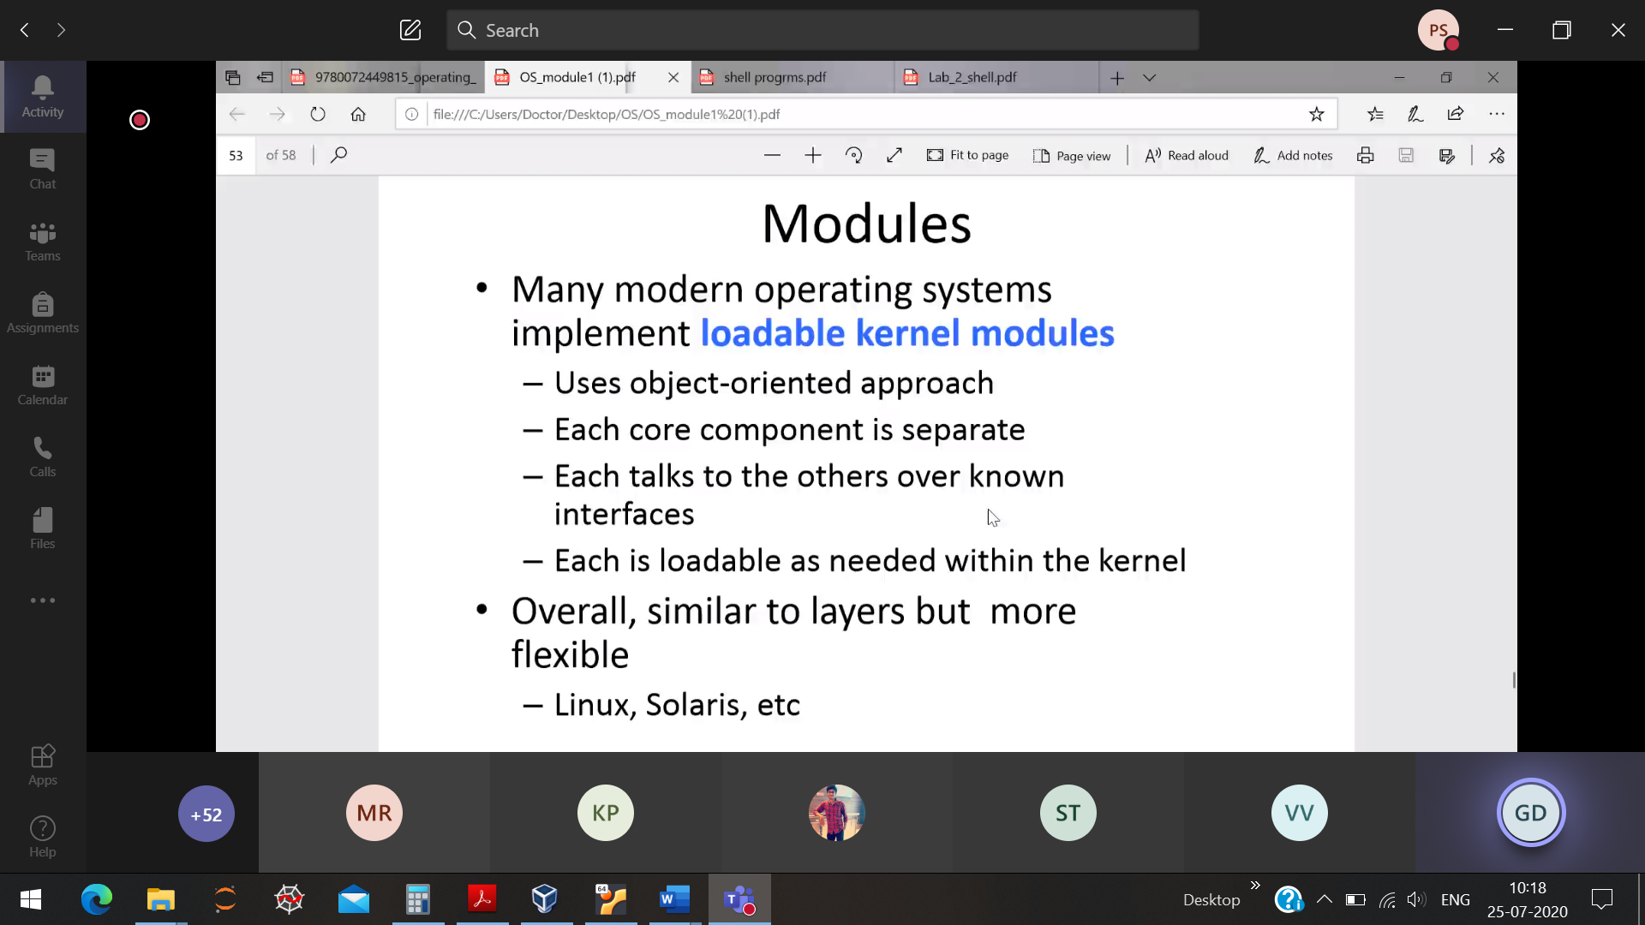

Layer approach uses stack to approach the kernel . But in modular approach

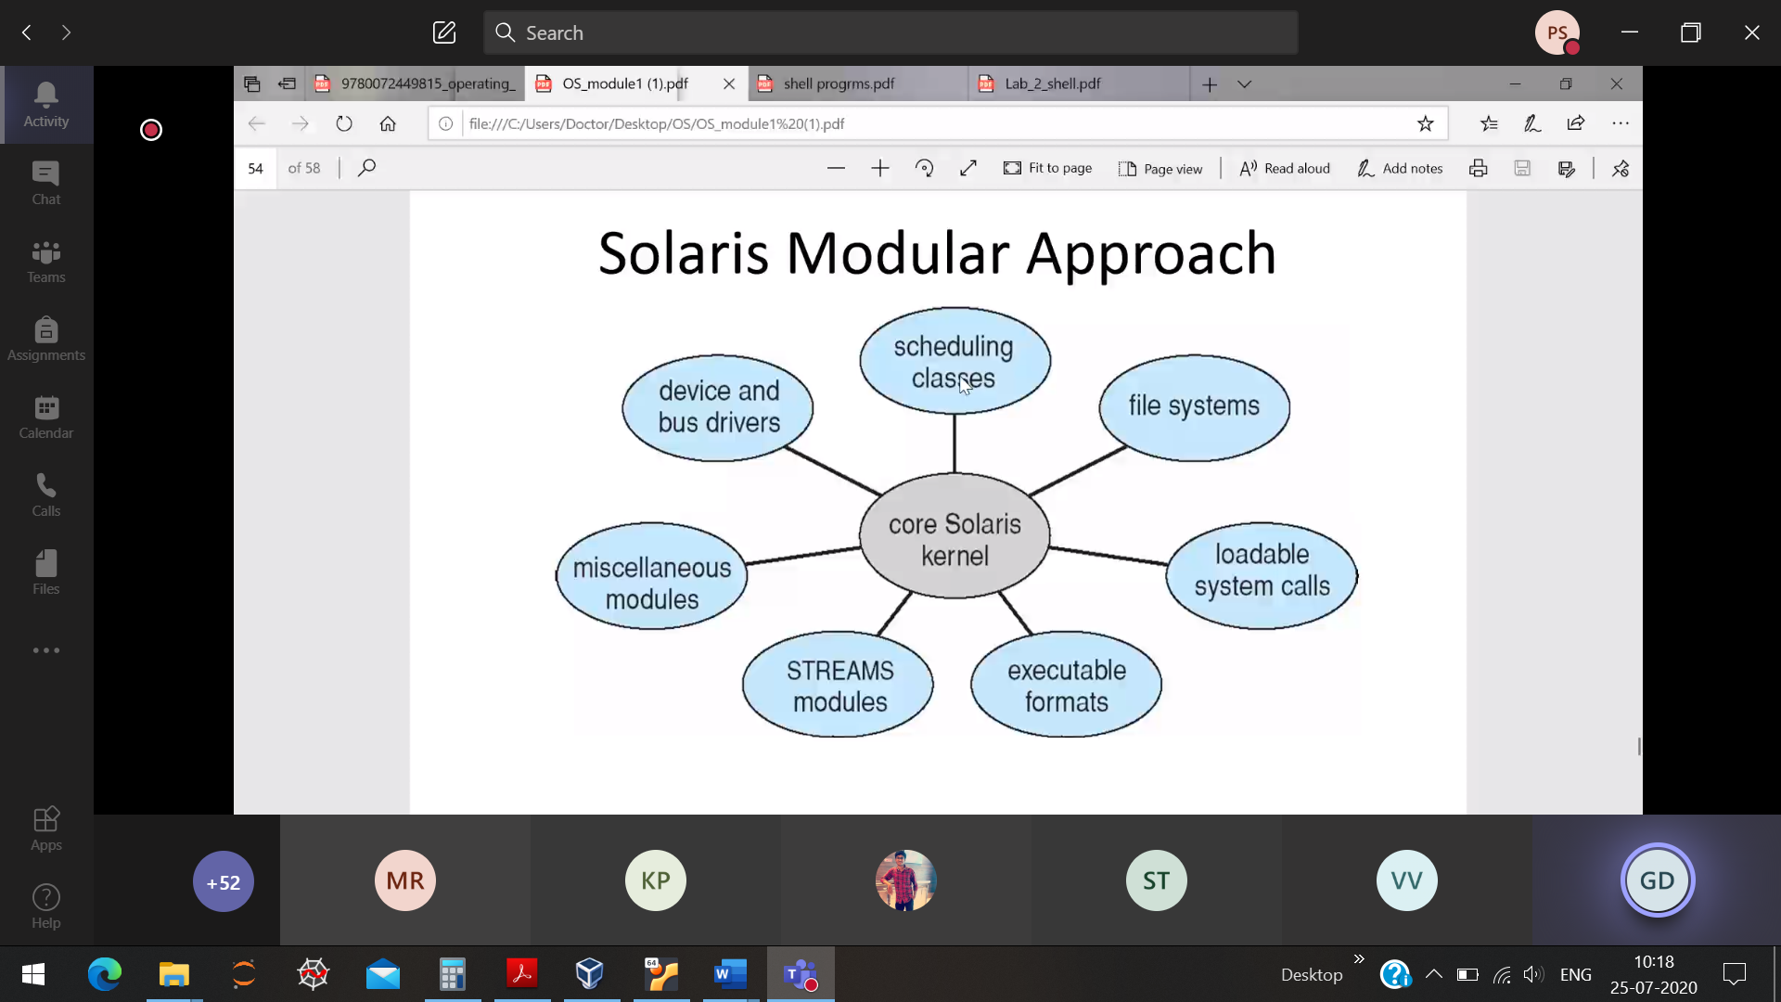

Each and every module will communicate with the kernel.

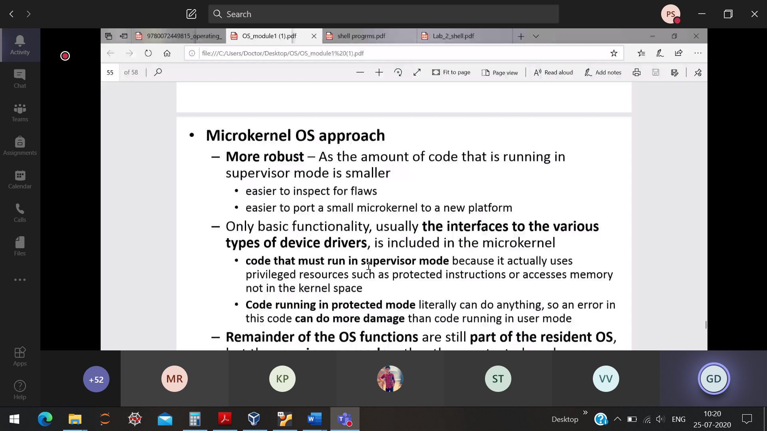

CPU 🡪 user mode

* Kernel mode(hardware is exposed directly)

Invoking into the kernel approach is reduced, user mode(majority)

So many apps running on OS, so Context switching is done often

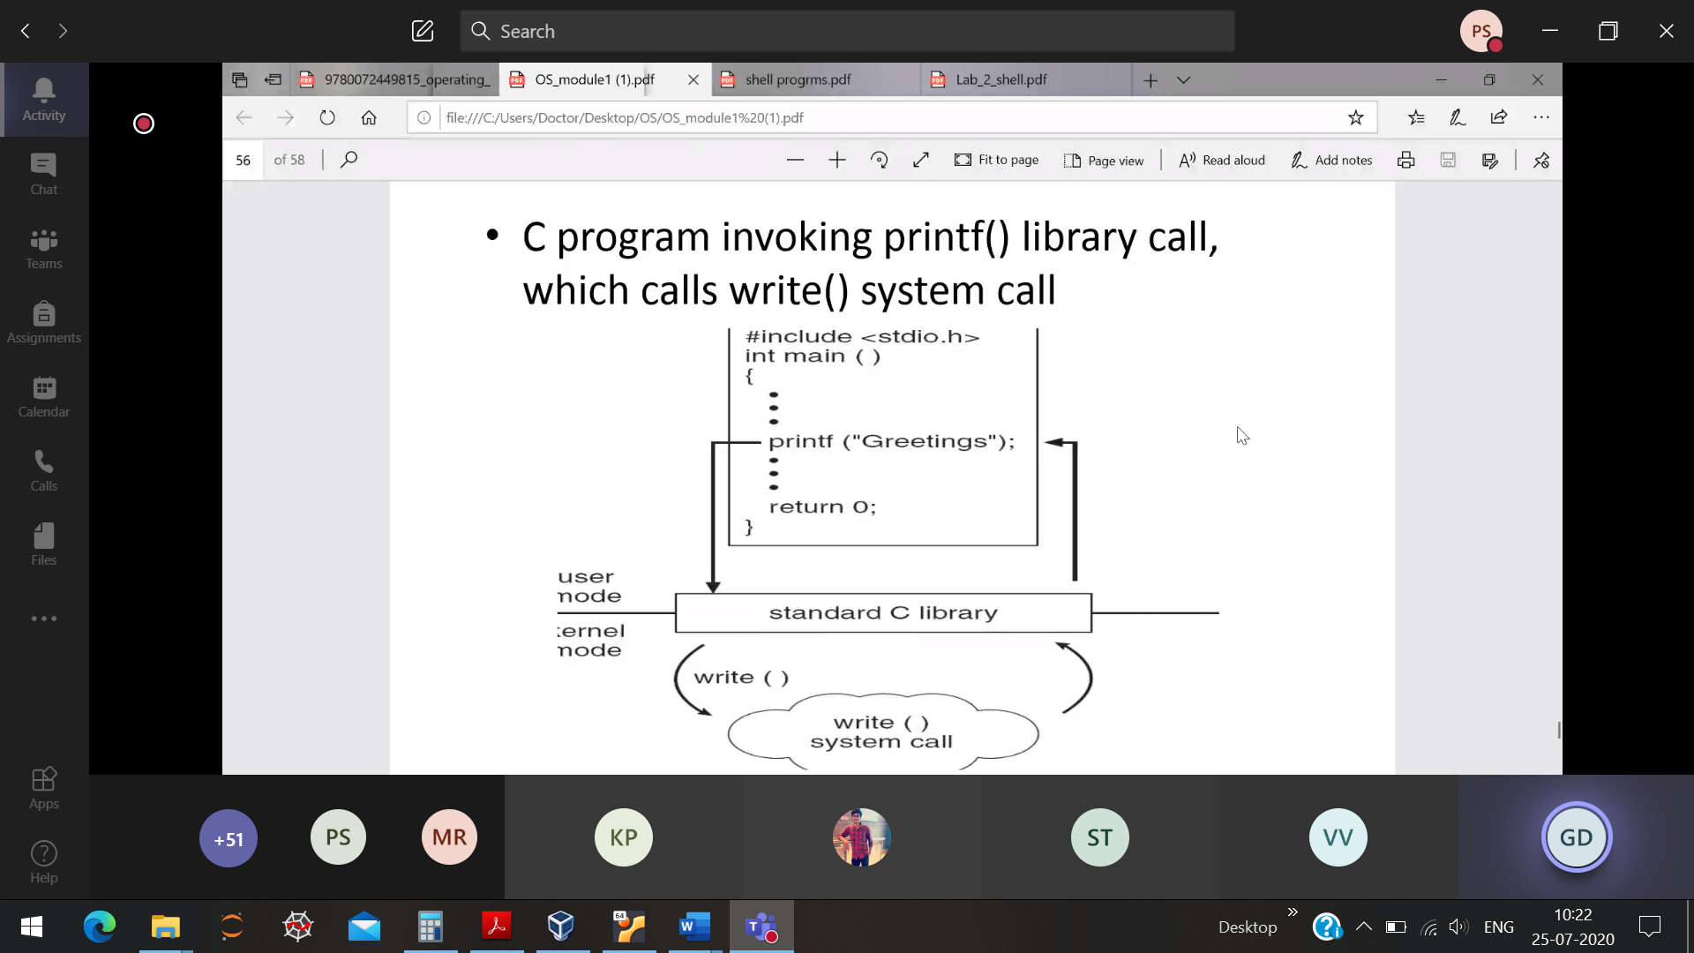

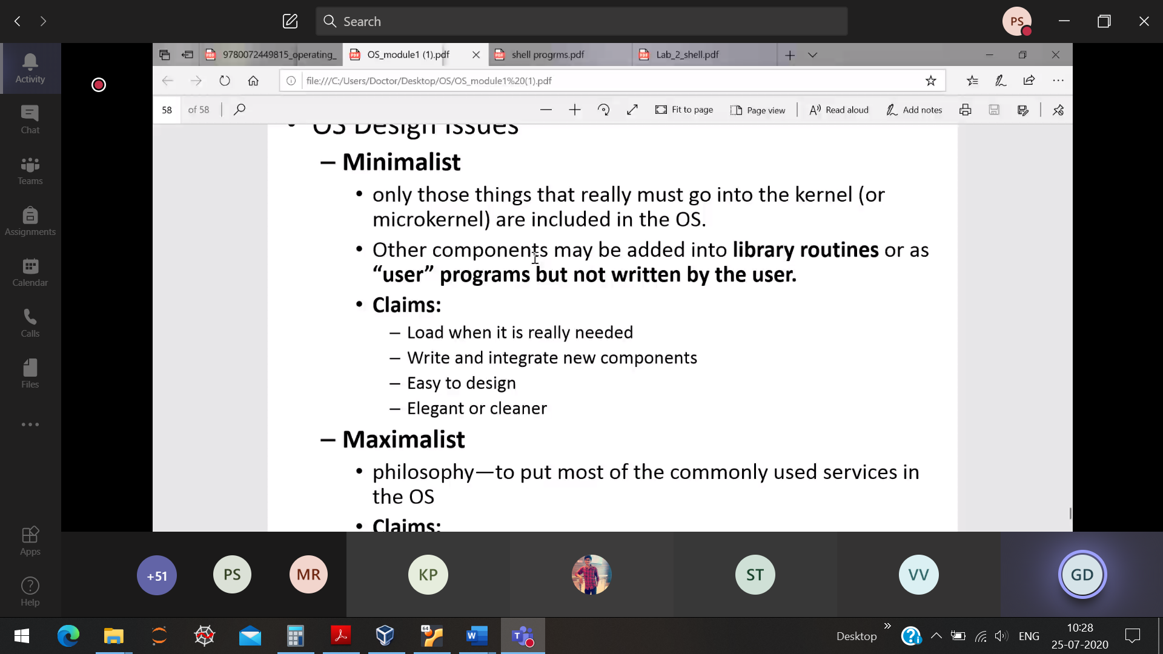

Chapter-2 System call (helps to interact with OS)

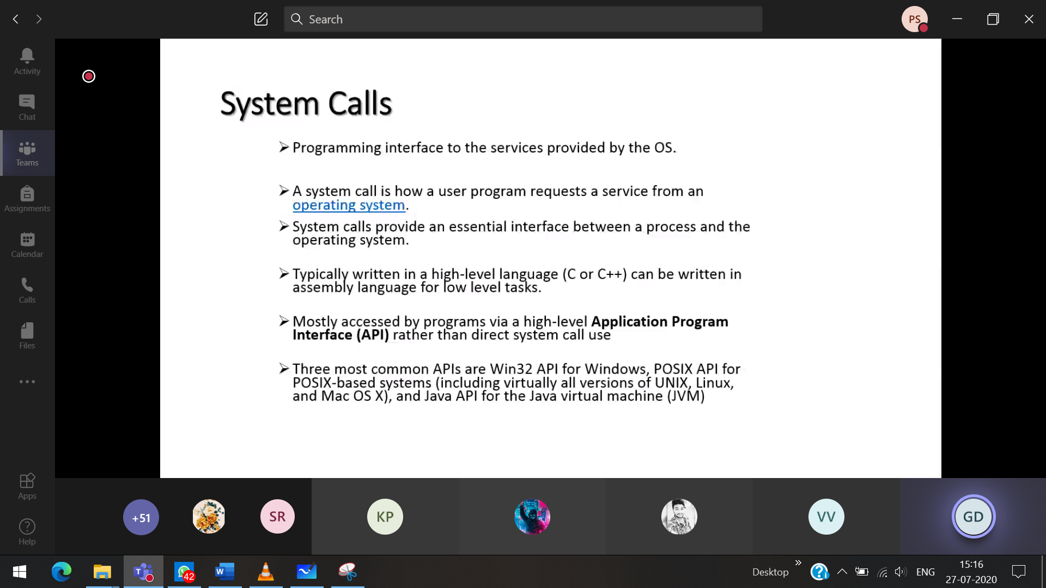

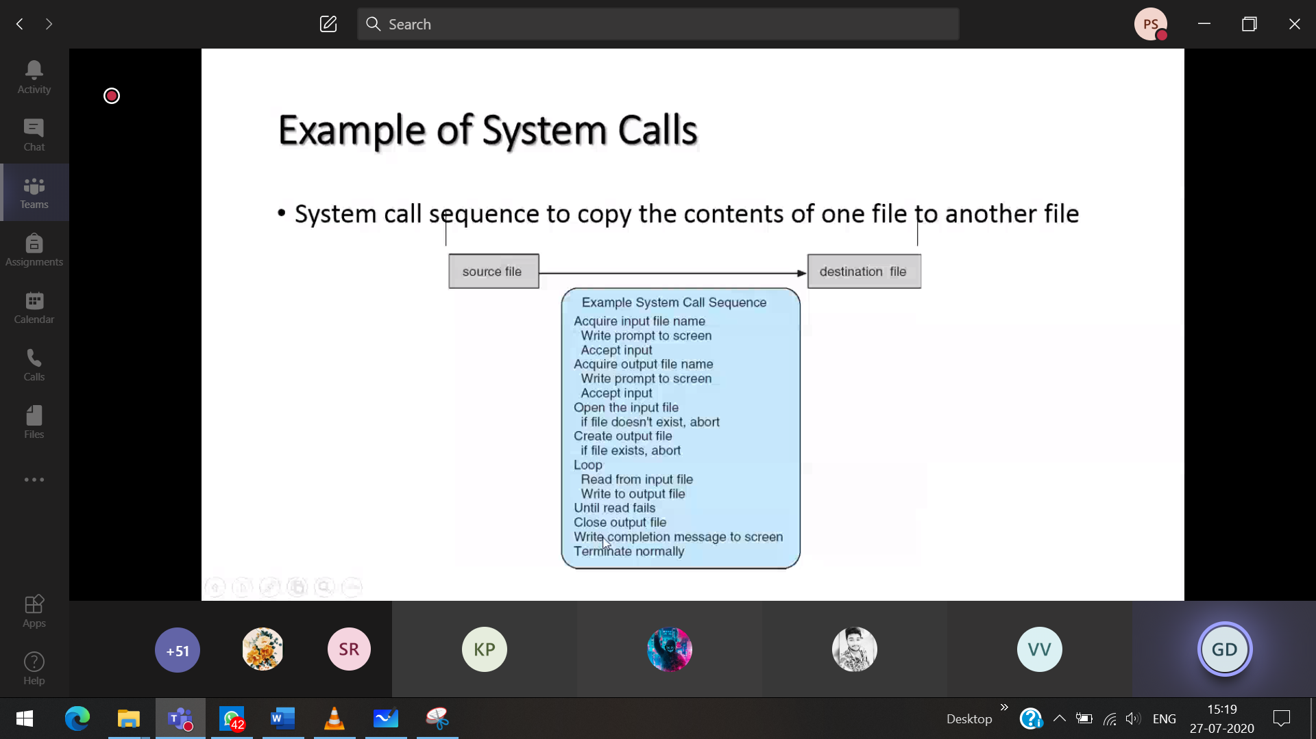

Each and every operation requires a system call ( with keyboard, monitor)

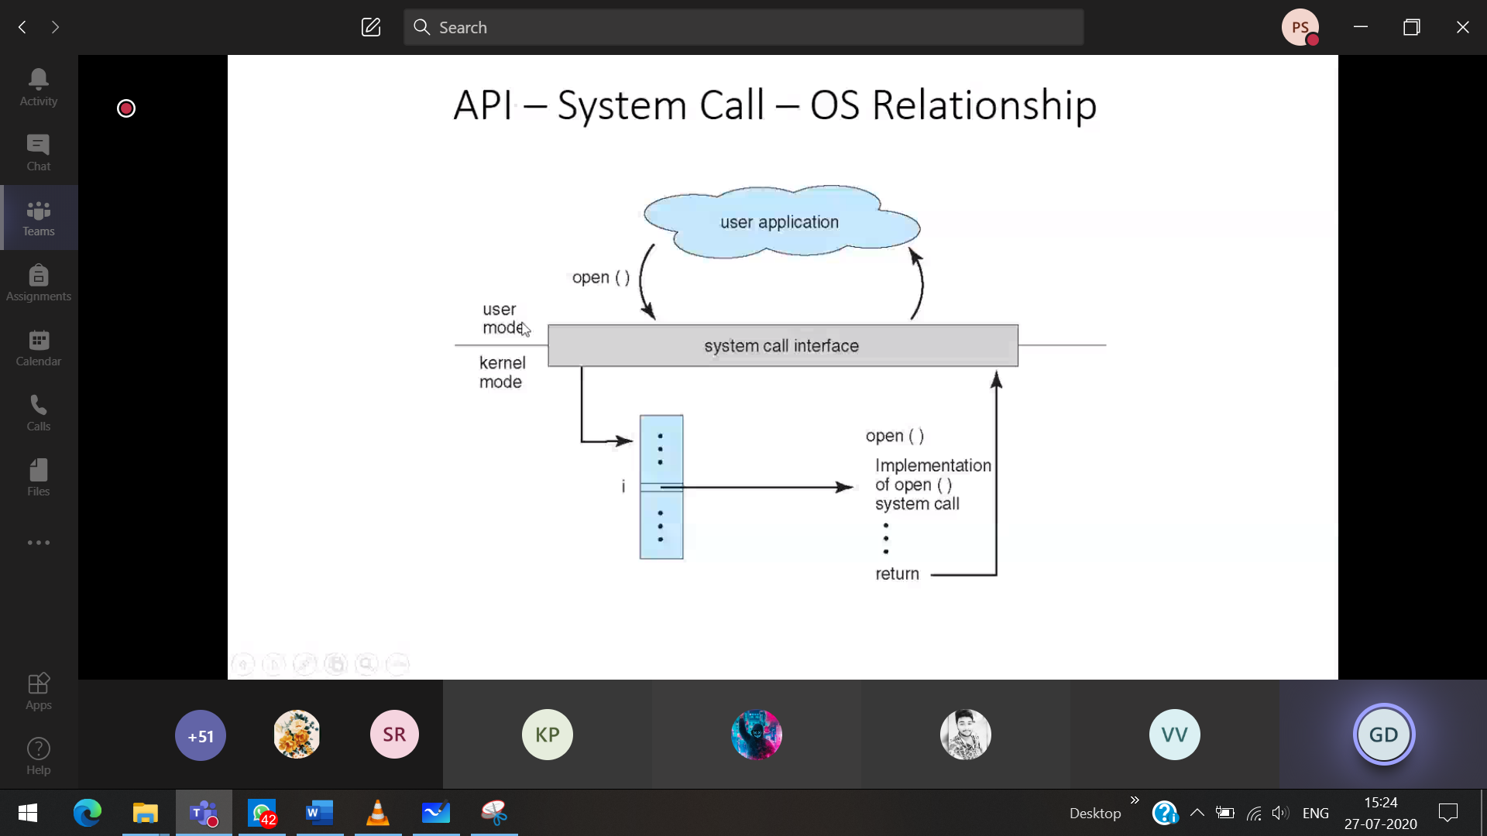

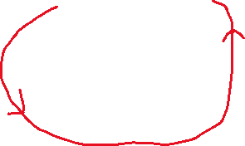

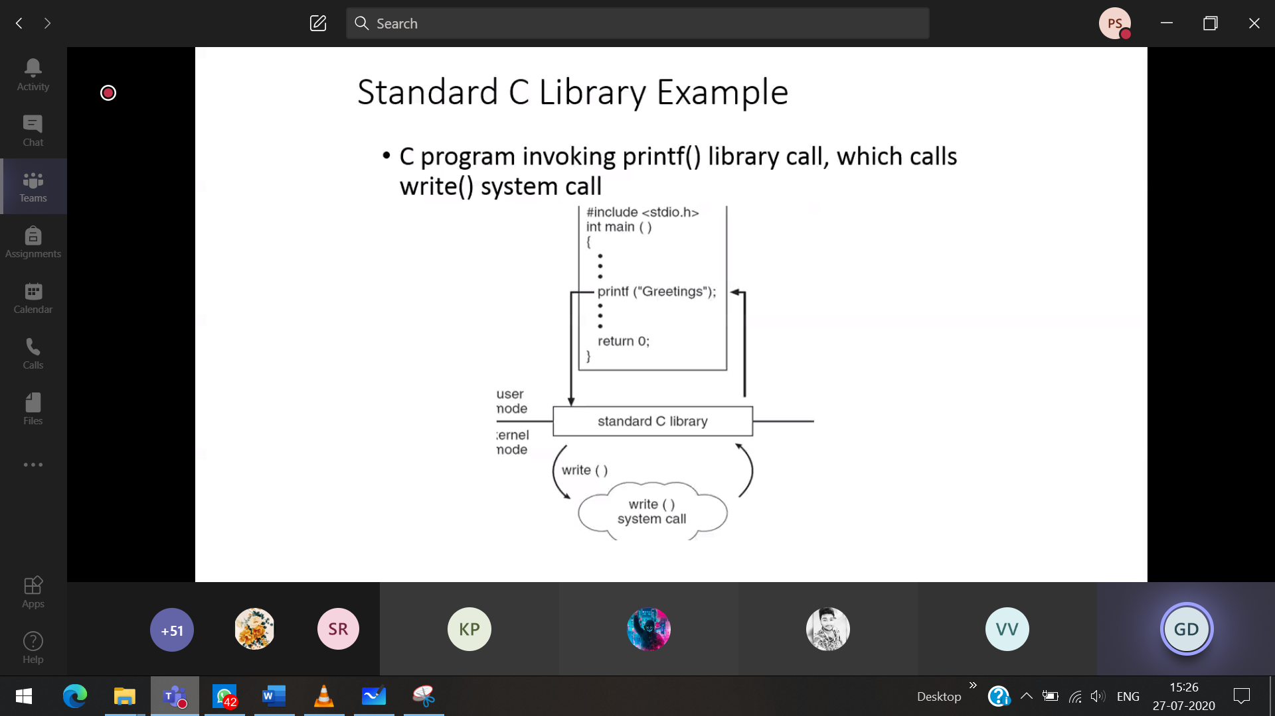

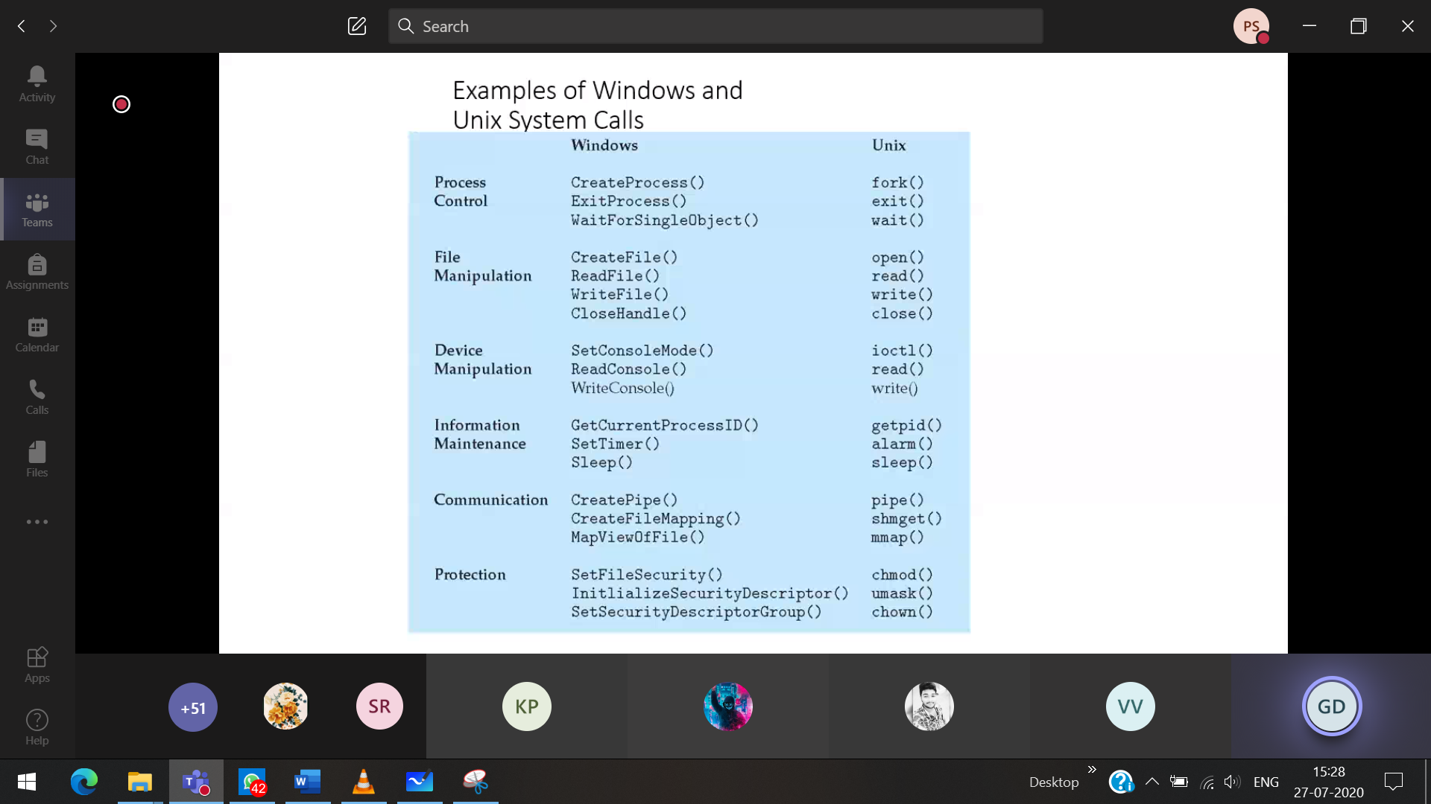

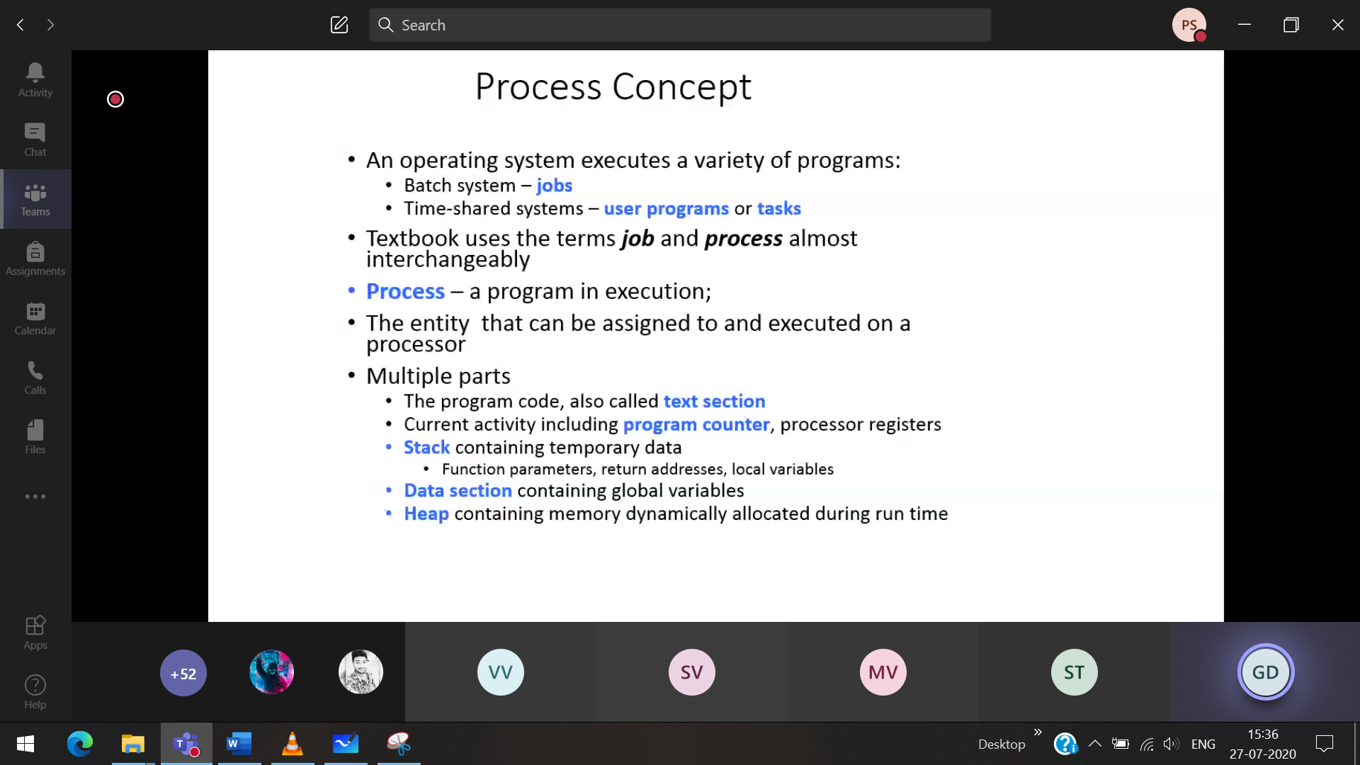

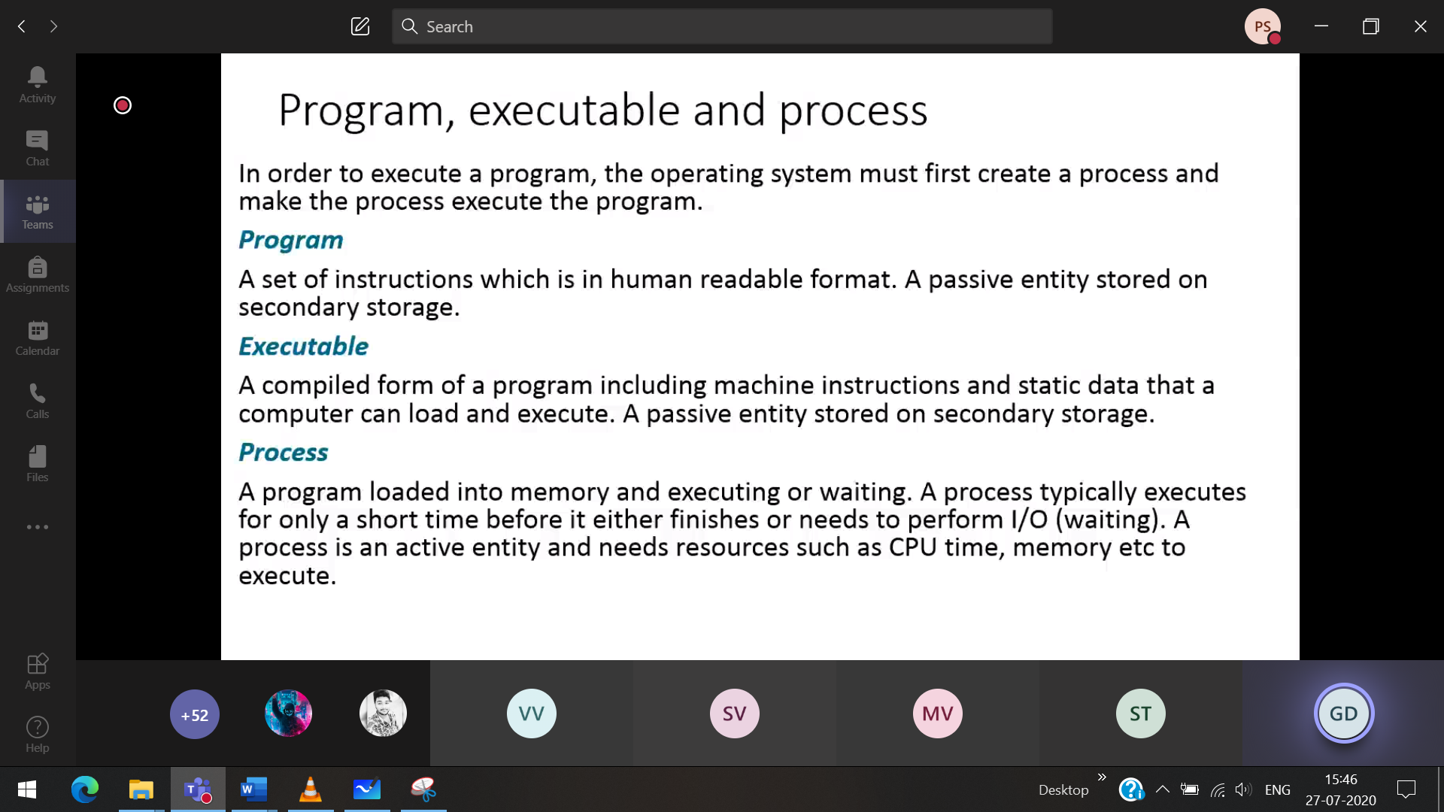

OS distinguishes various process via process ID

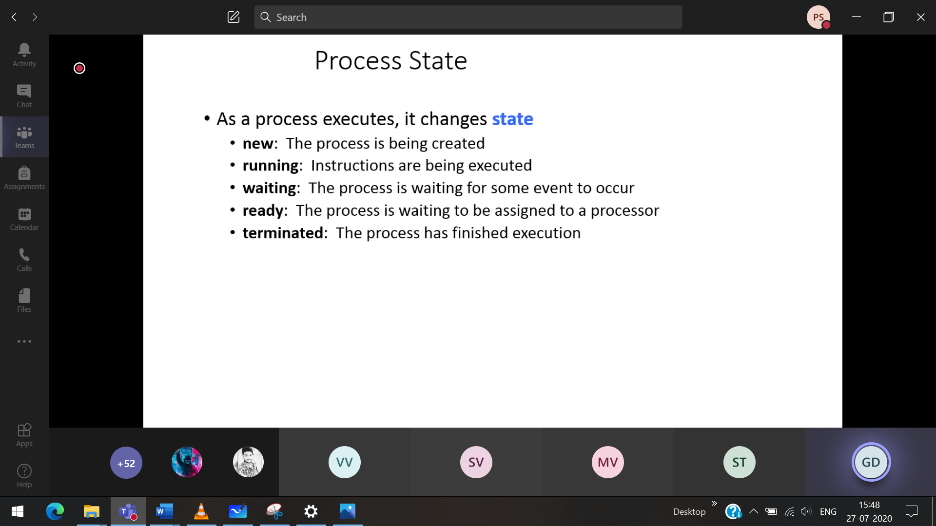



Waiting 🡪 Waiting for the I/O access

Process transistion state

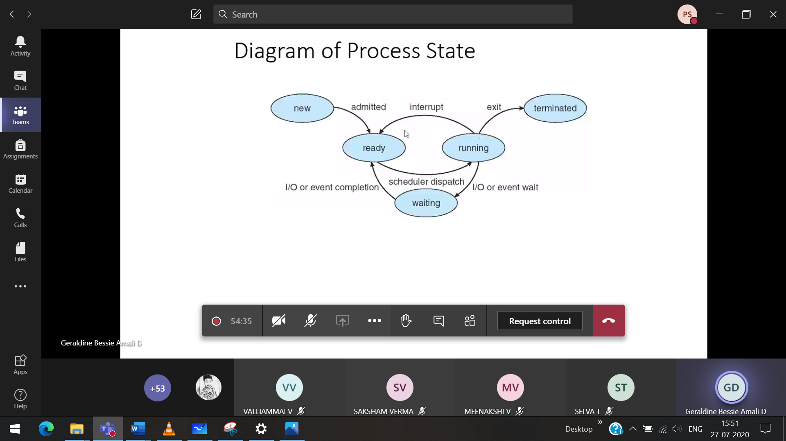

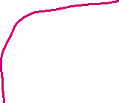

Above line 🡪 outside the

1)Ready state Interupt , here p1 stops and p3 executes

Waiting state/block state

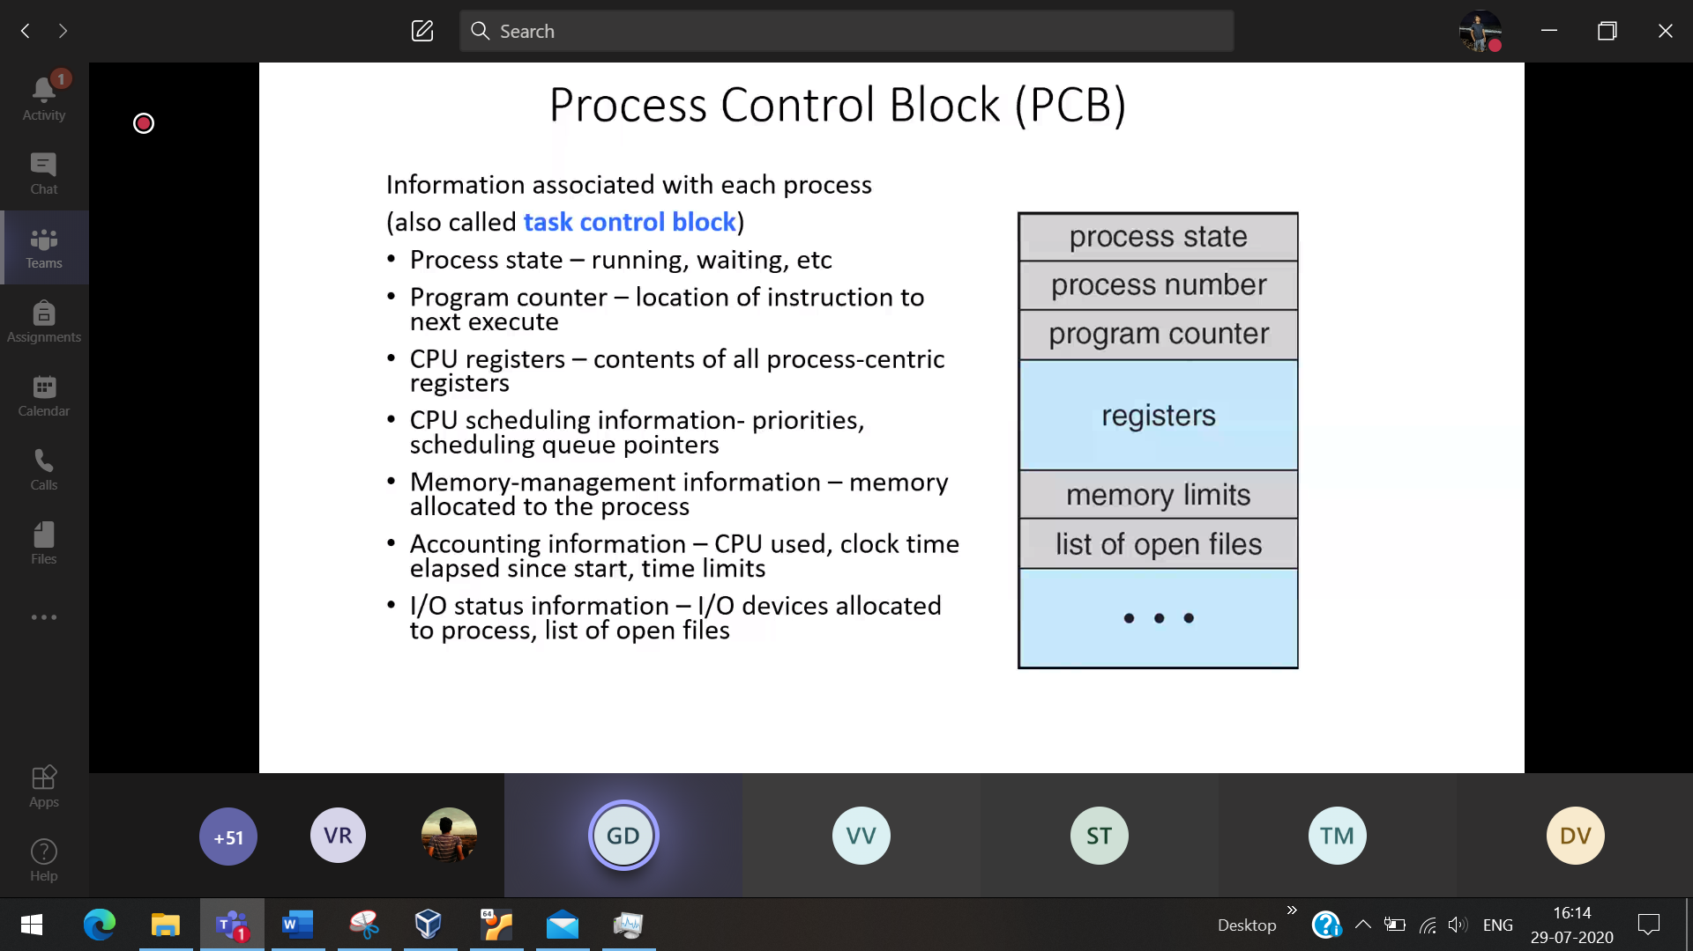

Process control block/ task control block

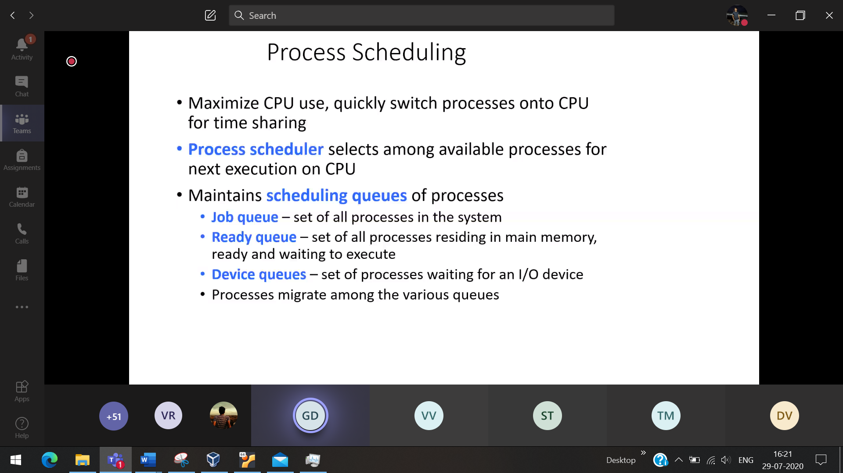

Job queue 🡪 (long term scheduling) Many jobs waiting to get into RAM  
ready queue 🡪   
devices queue 🡪

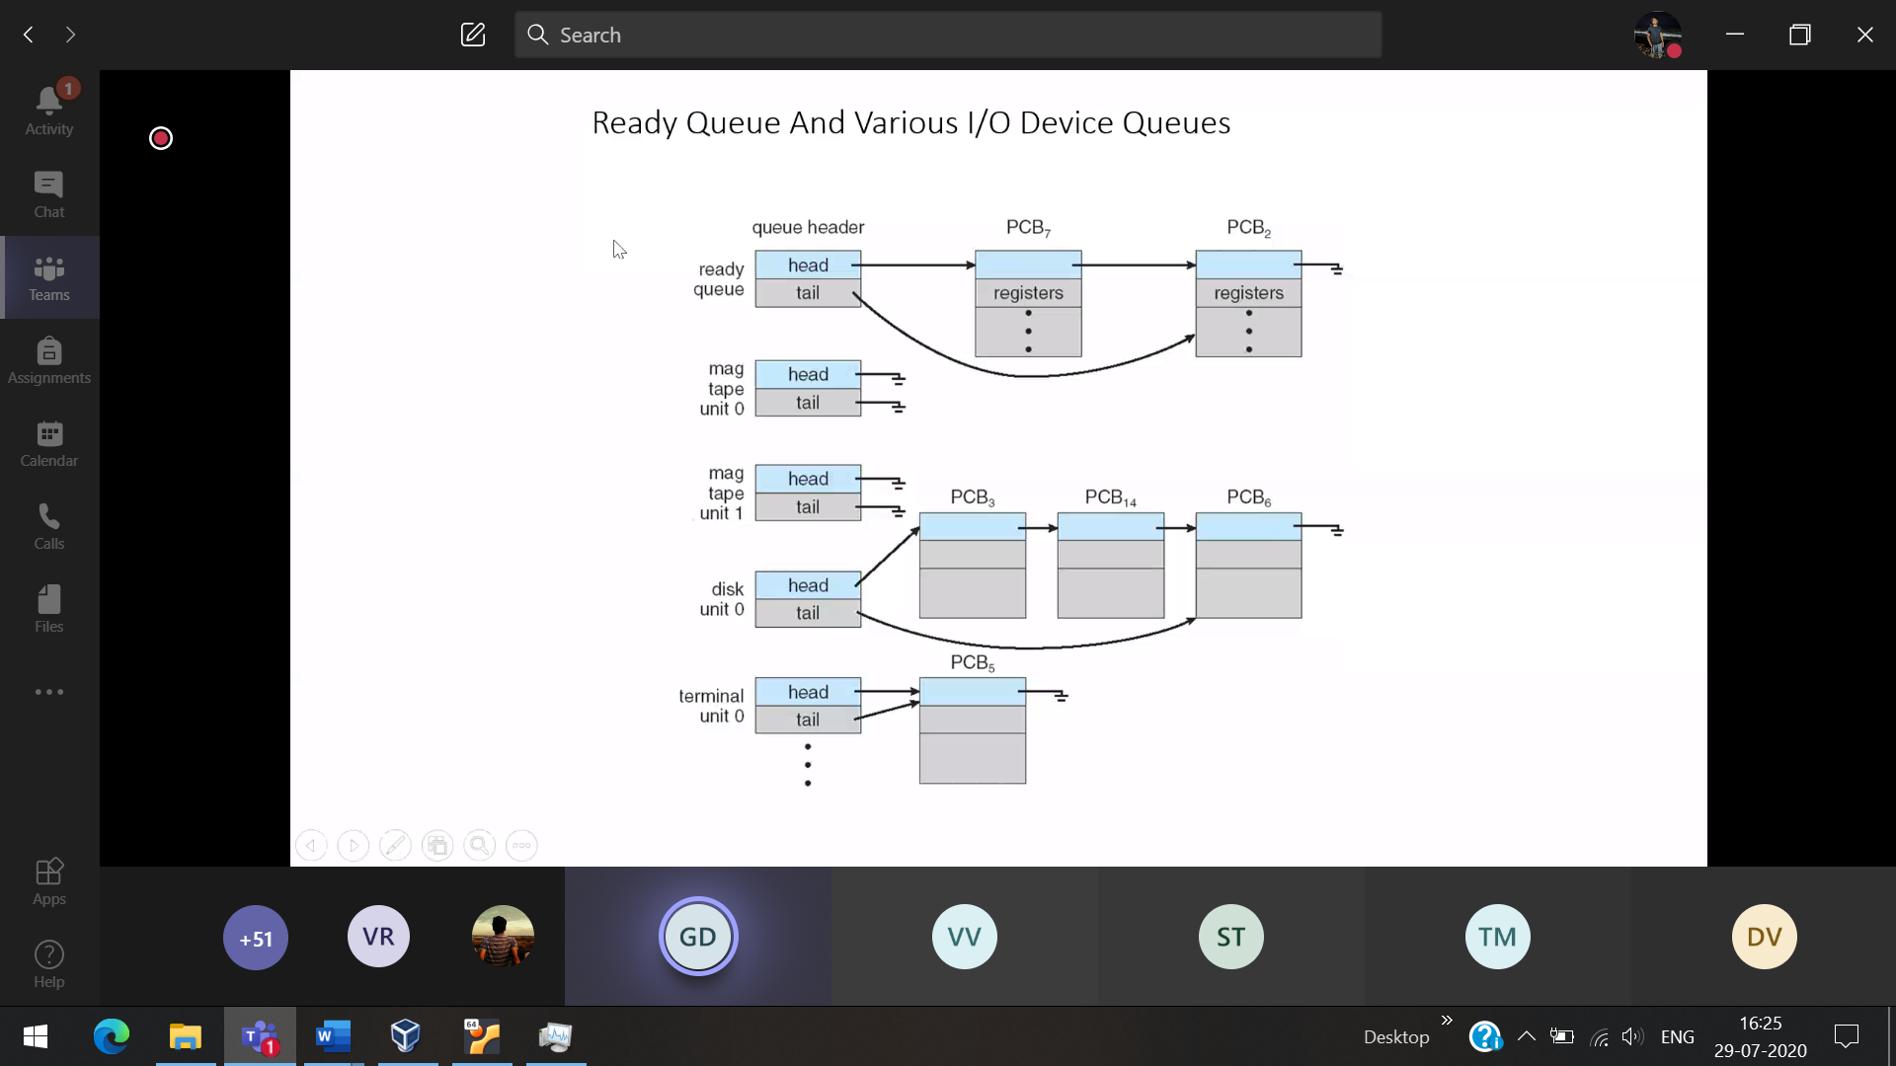

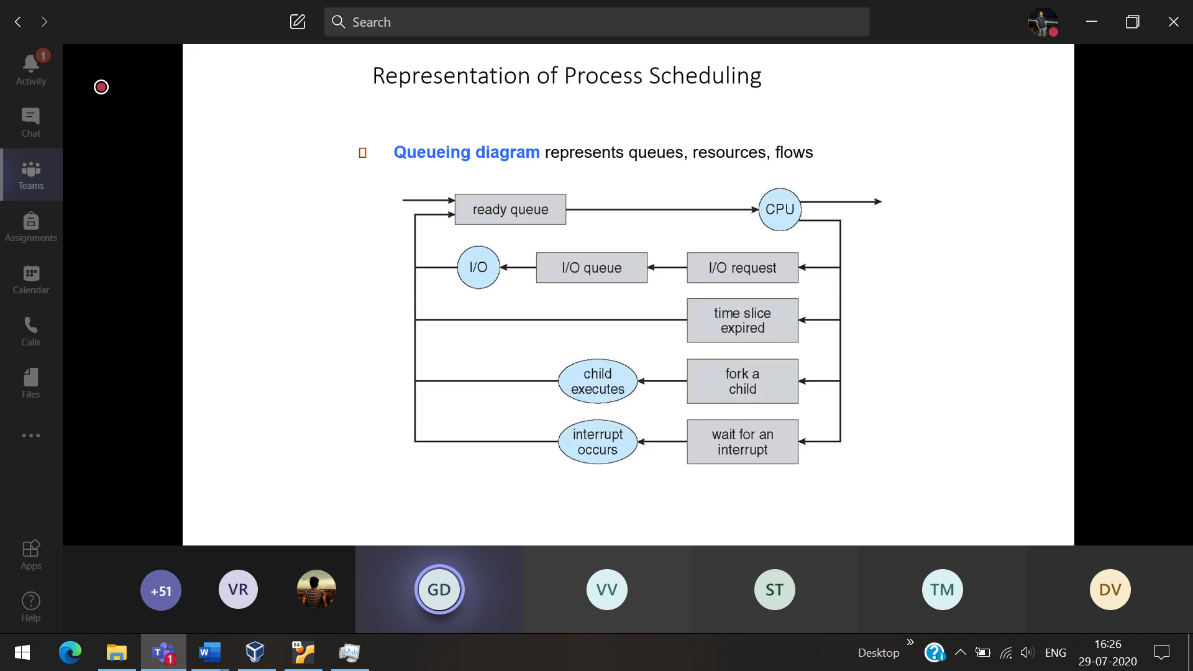

Time slice expires 🡪 Divide the time into intervals

P1,P2,P3,P4 🡪 5 min for each Whatever done in 5 min, come out and join at the back P4,P1,P2,P3

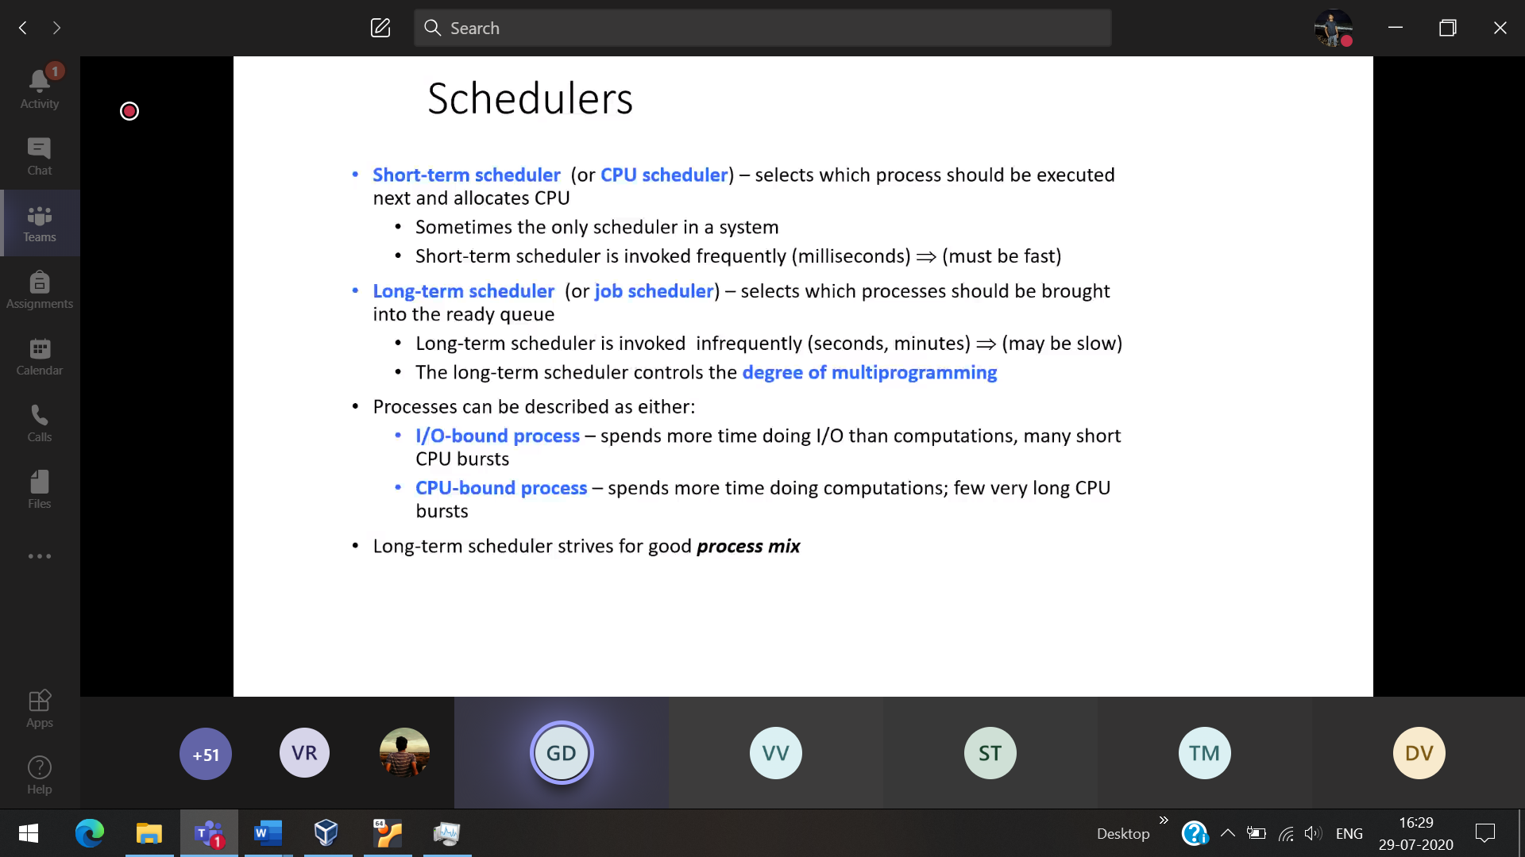

Short term RAM to CPU

Long term ROM to RAM

Dm 🡪 Number of process brings to the RAM

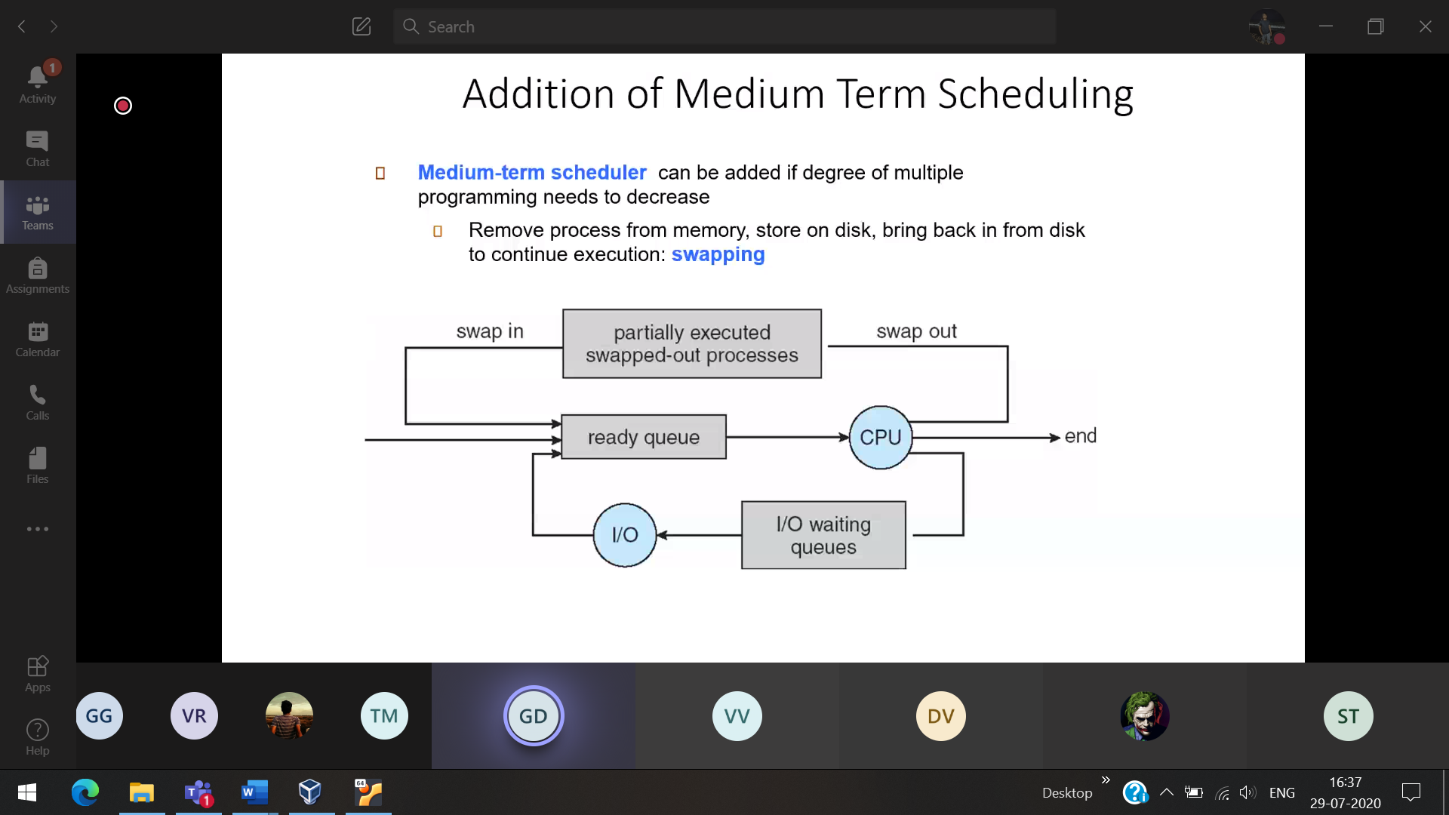

Suspended state : When the process is moved out of RAM

Ready suspended 🡪 The process is running/ready then it brings back to the RAM

Blocked suspended 🡪 The process is in waiting state and

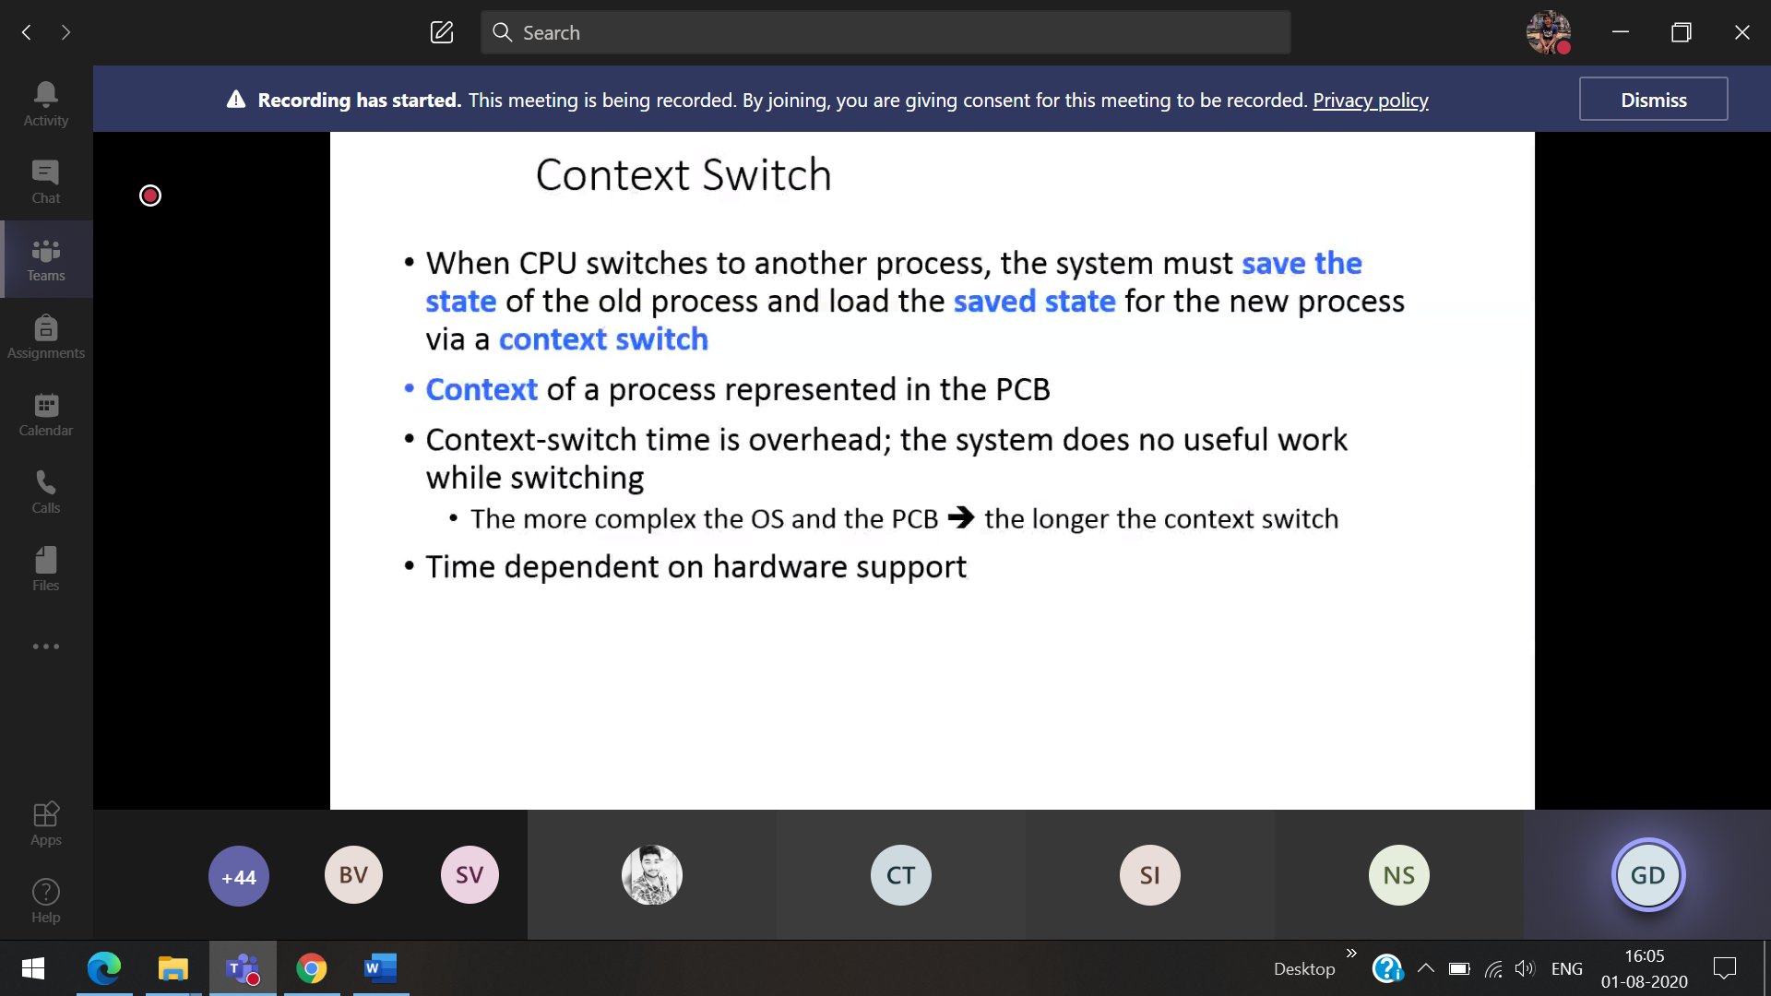

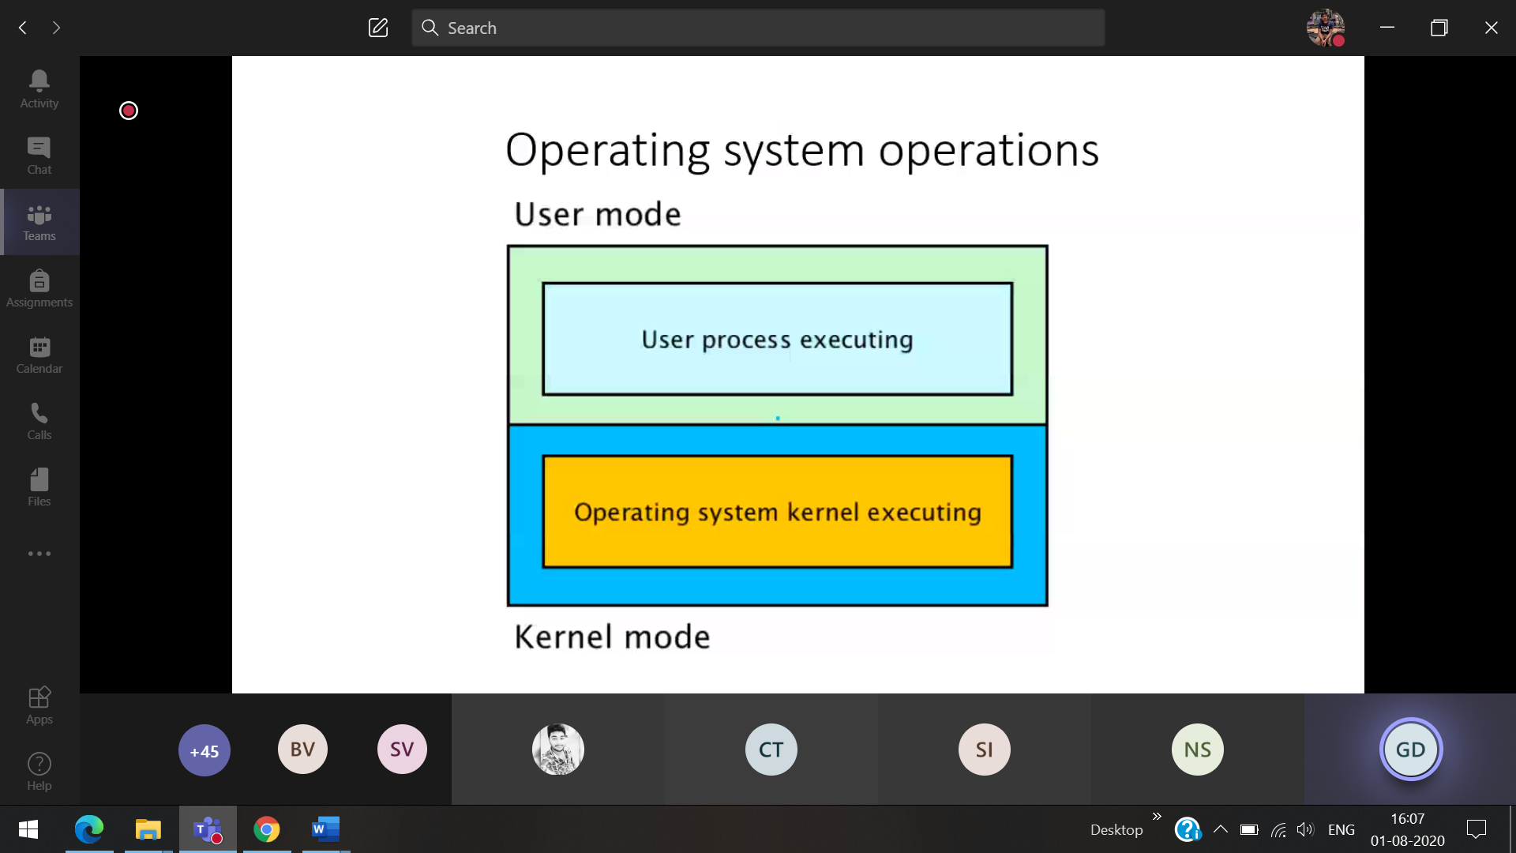

Kernel mode 🡪 hardware is directly expressed

When it will switch from user mode to kernel mode

1. **Hardware error** Interrupt from the external hardware [ While CPU is executing hardware interrupts]
2. **Software interrupt** [ While CPU is executing there will be bug,error ] (Error doing while programming infinite loop, error index out of the limit) . Creates **exception/trap**

A bit, called the **mode bit**, is added to the hardware of the computer to indicate the current mode: kernel(0) or user(1). With the mode bit, we are able to distinguish between a task that is executed on behalf of the operating system and one that is executed behalf of the user.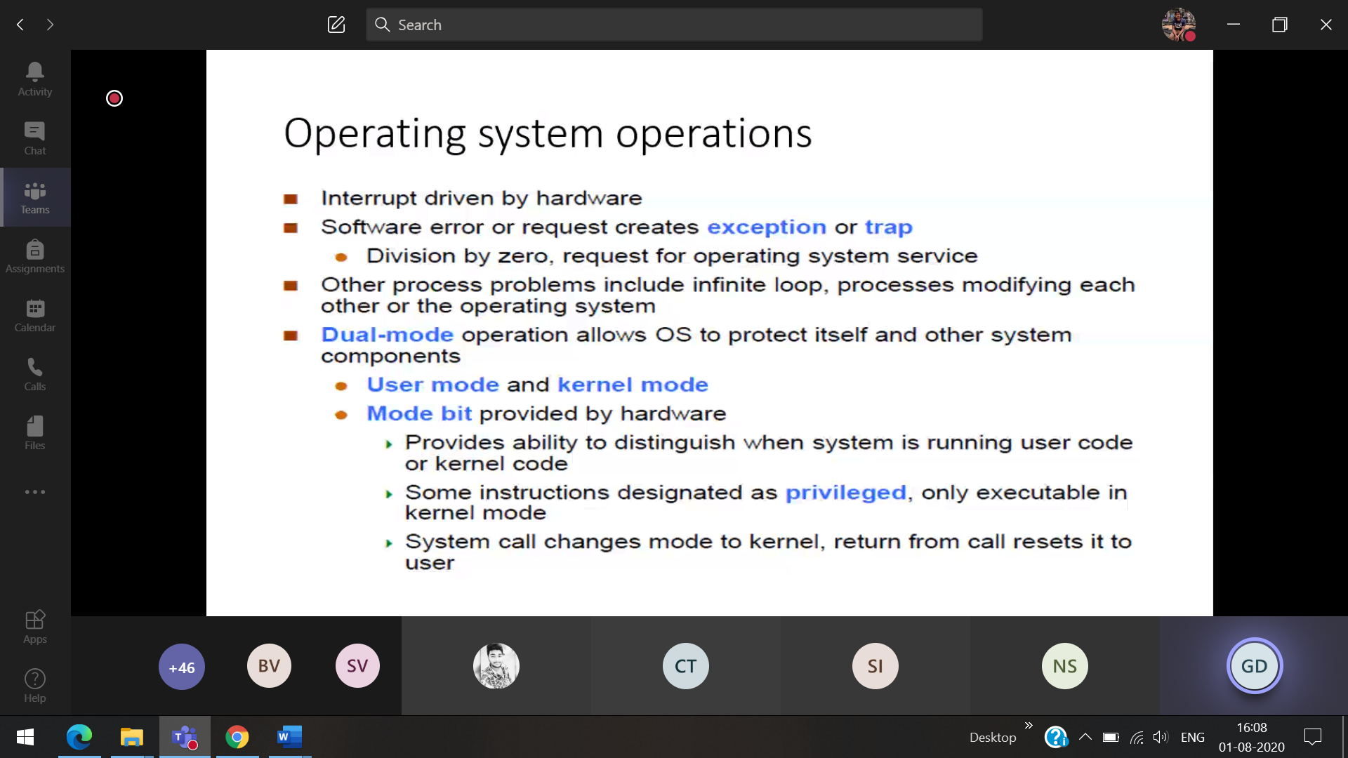

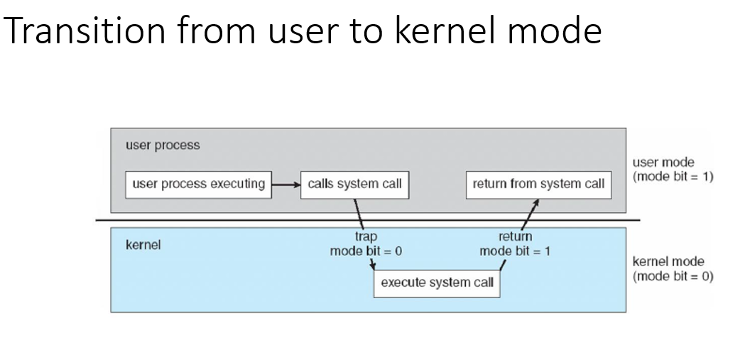



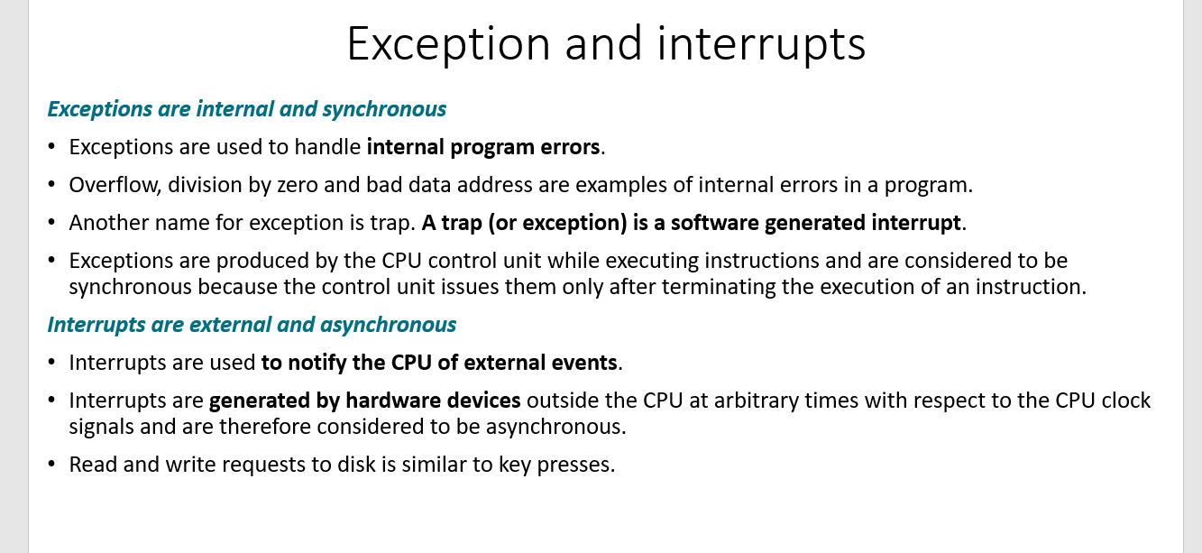



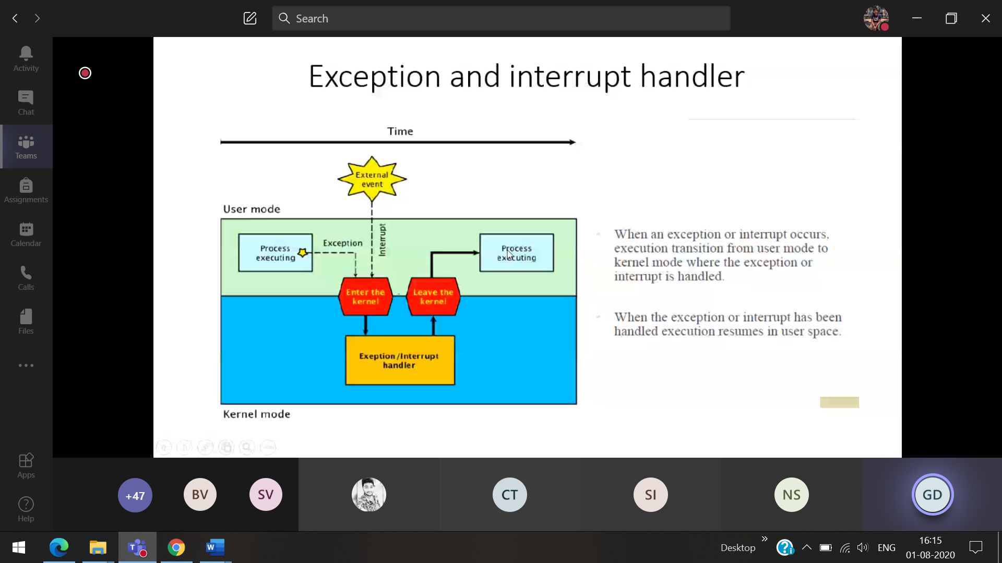

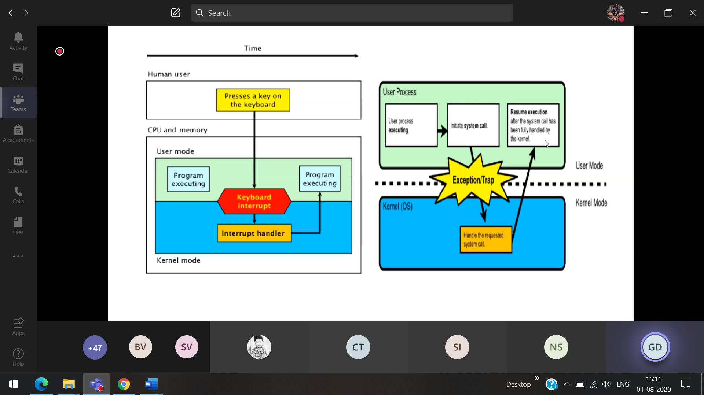

The Process which are created can create/terminate other process

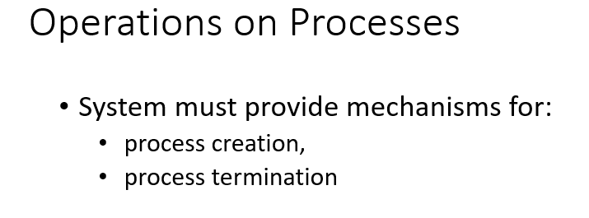



(parent process) 1 process creates another process(child process)

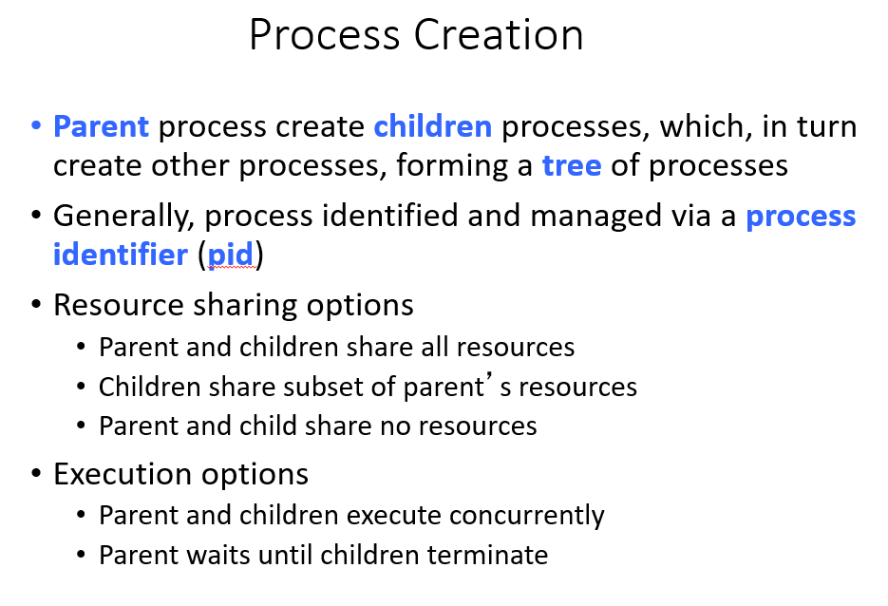

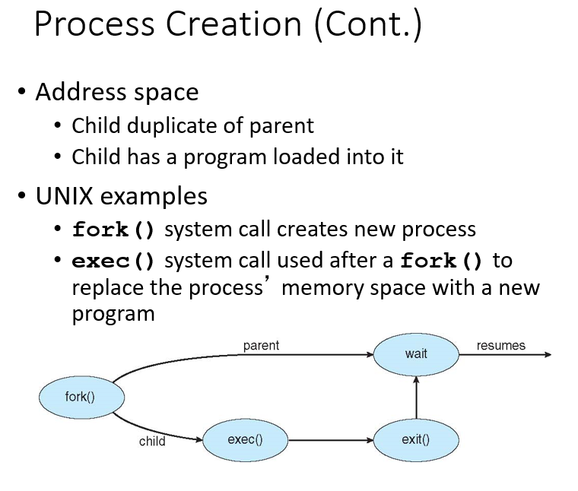



Parent executes fork() to create a child  
fork() will always return a value

If the creation of the child process is unsuccessful   
a=-1[To the parent process]

If the child process is successfully create fork() will return   
a=0 [To the child process]  
a=Process ID(child) [To the parents process]

**Note : Both the parent and child process executes the instructions after fork()**

Now child process is successfully created. So What is the value of x in Parent, child process??

Successful creation of Child process

|  |  |  |
| --- | --- | --- |
|  | **a** | **x** |
| **Parent process** | 2000(Process ID of child) | 4 |
| **Child process** | 0 | 4 |

Un-Successful creation of Child process



|  |  |  |
| --- | --- | --- |
|  | **a** | **x** |
| **Parent process** | -1 | 4 |
| **Child process** | Not created | Not created |

Child is a copy of the parent [What ever is in parent will be in child]

Exit() the parent knows the status of the child [ After child executes, it will report the status of the child to parent ] then parent executes



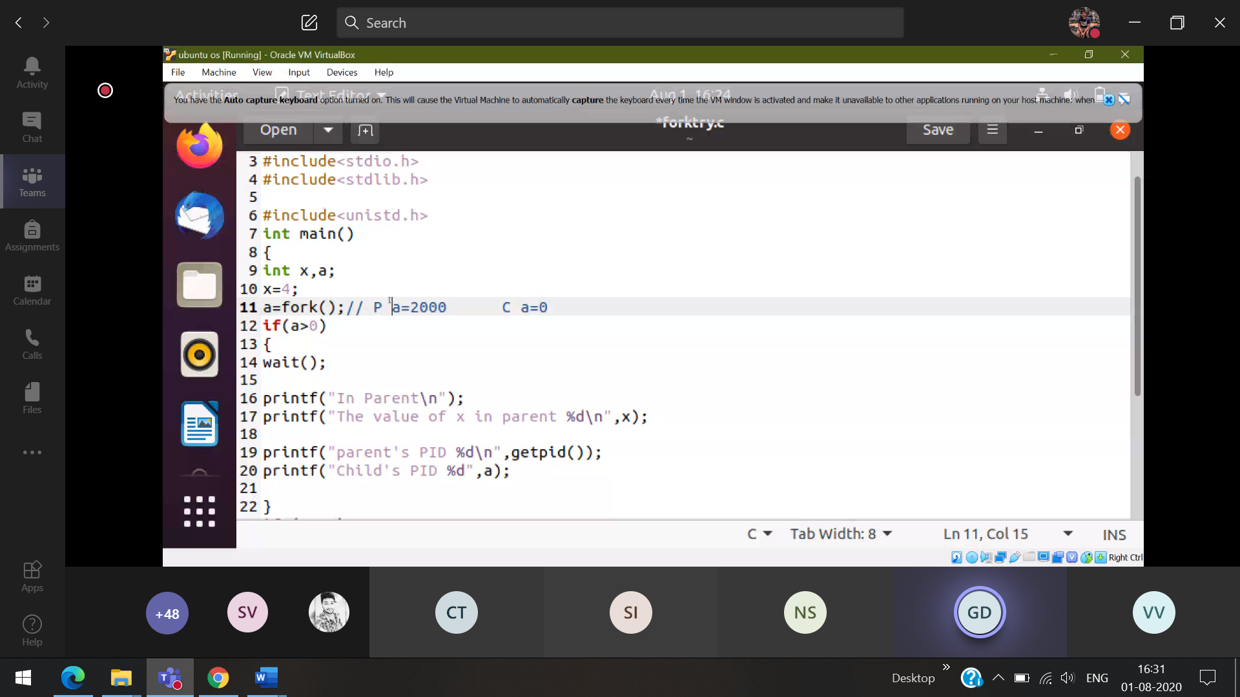

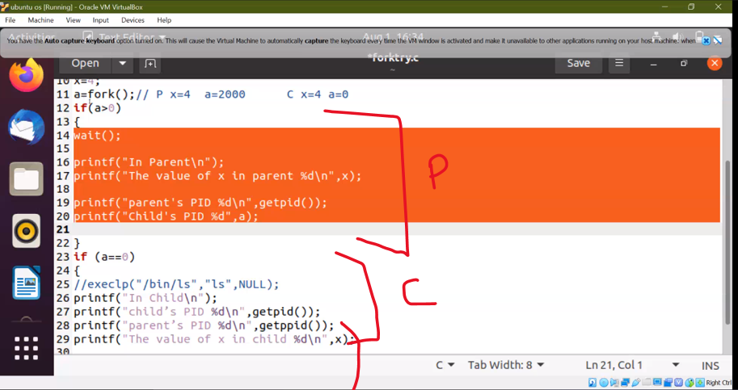



getpid-> gets the process ID of the particular process  
getppid 🡪gets the process ID of the parent (get parents pid)

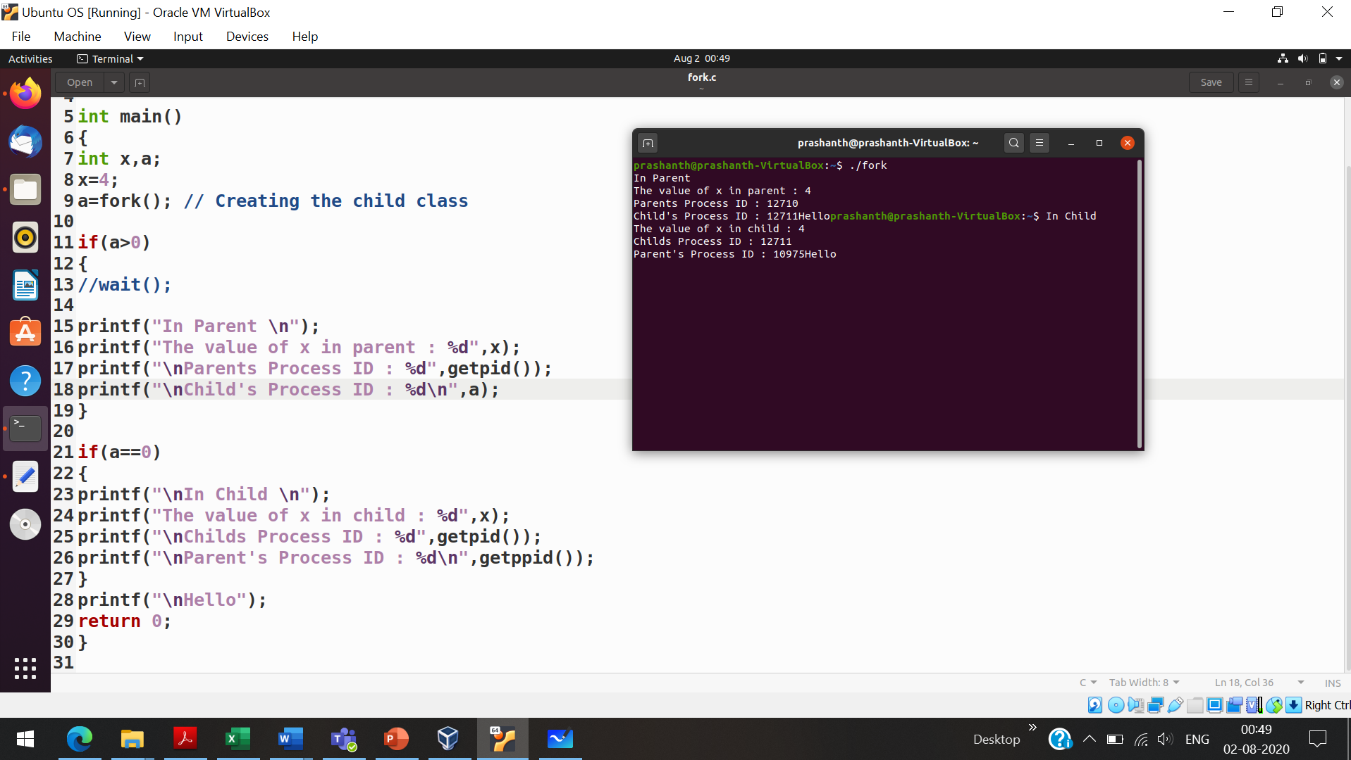

Now the child process is doing their individual process (displaying the ls of the current drive)

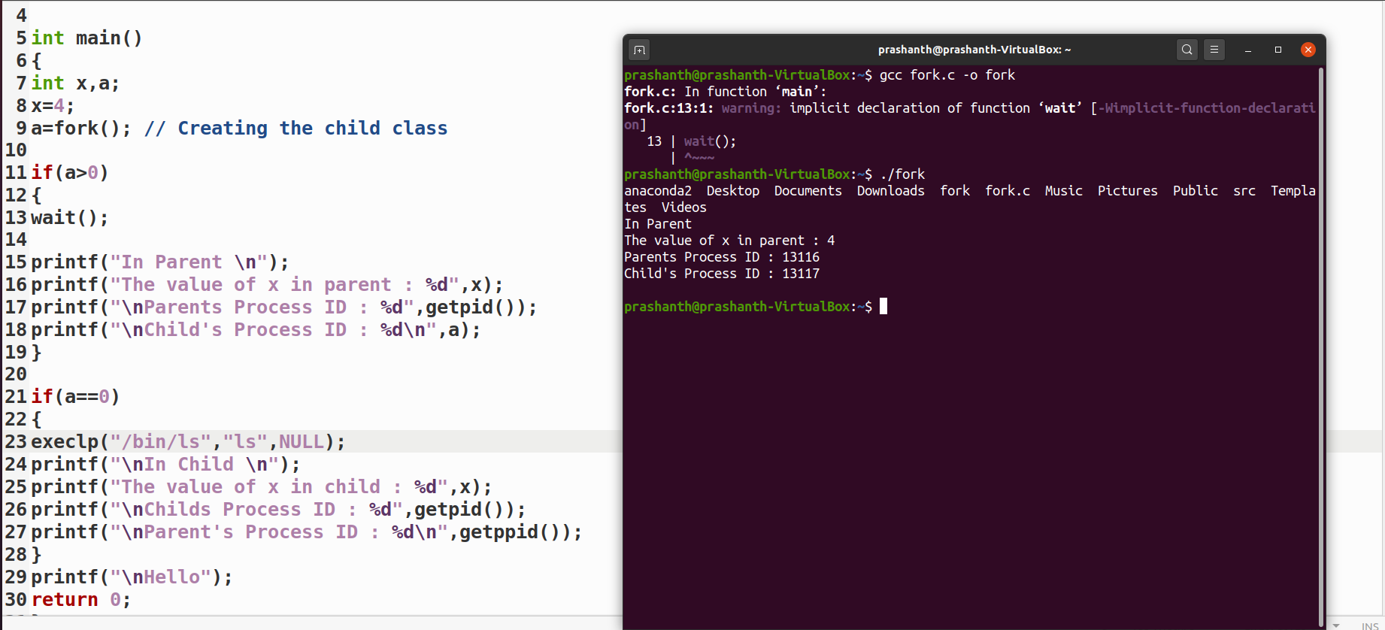

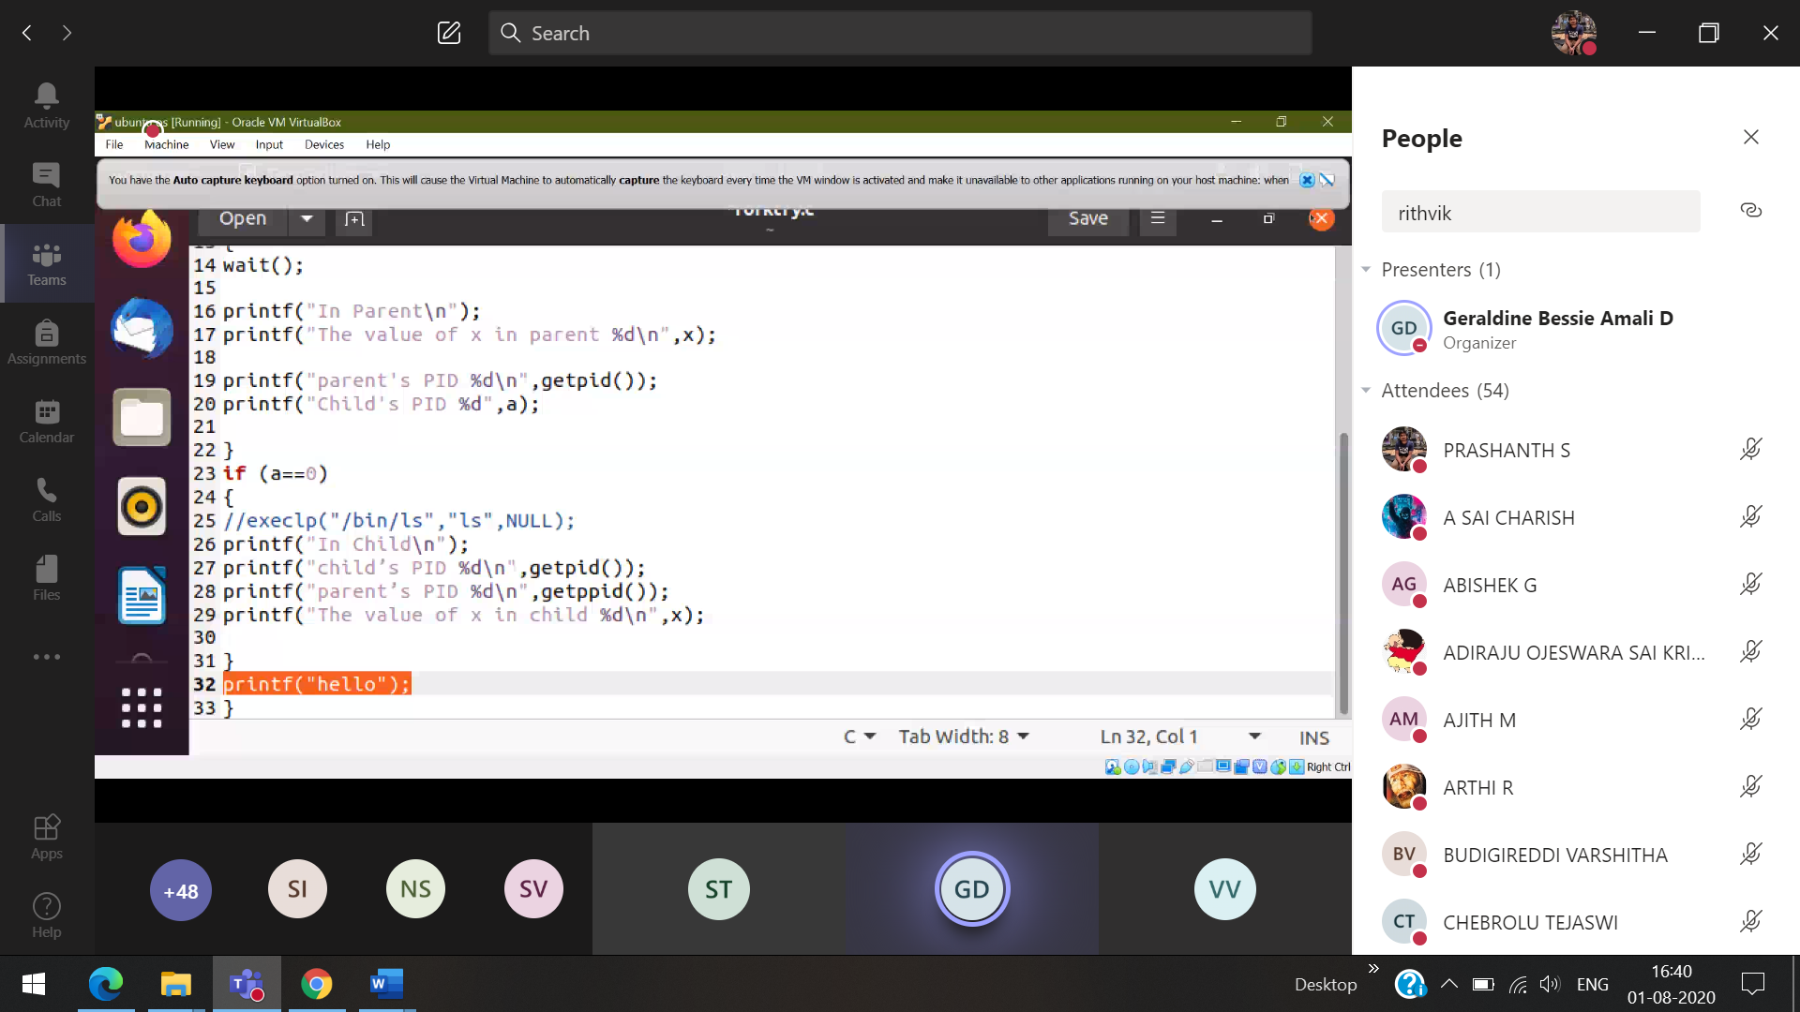 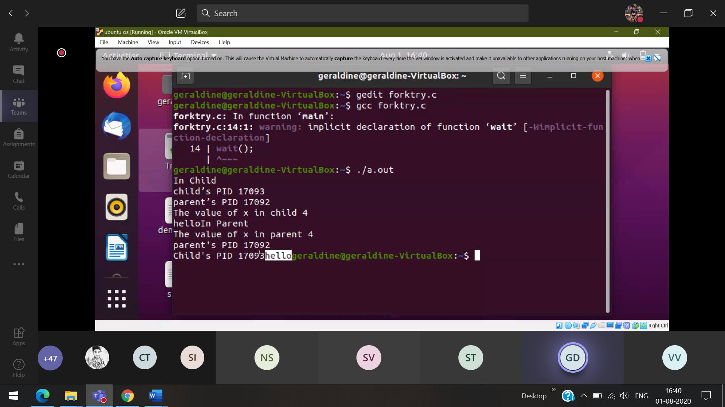



Now the child command is changed

 Overwrites the parent’s process, Now the childs job is to print the ls

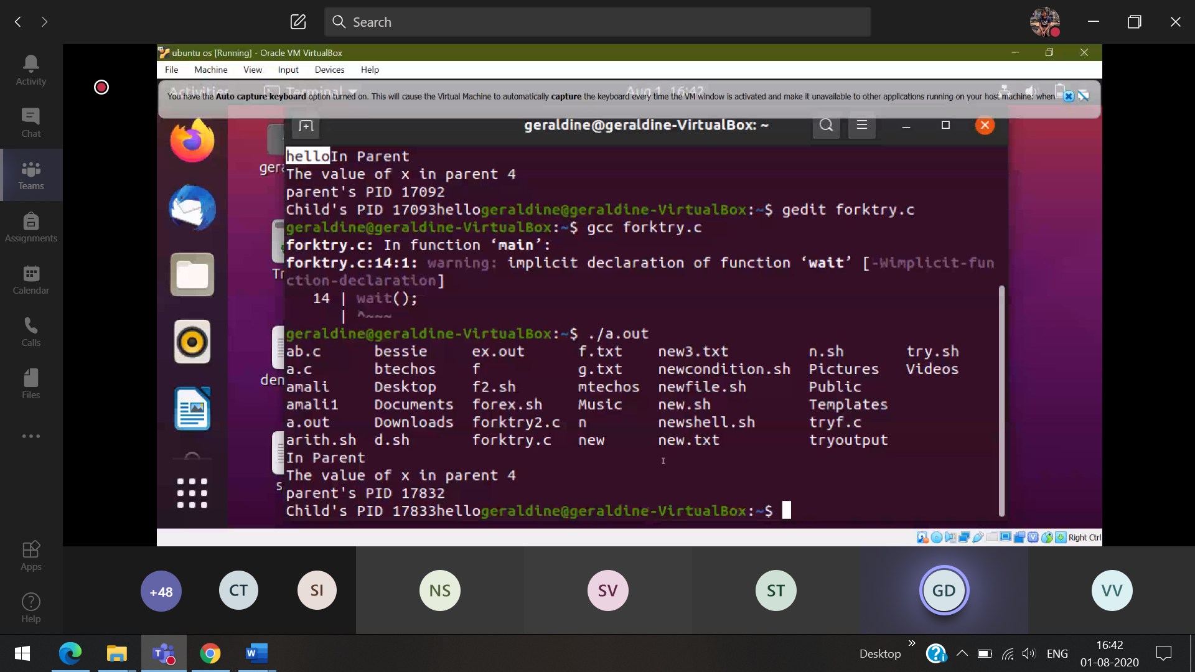

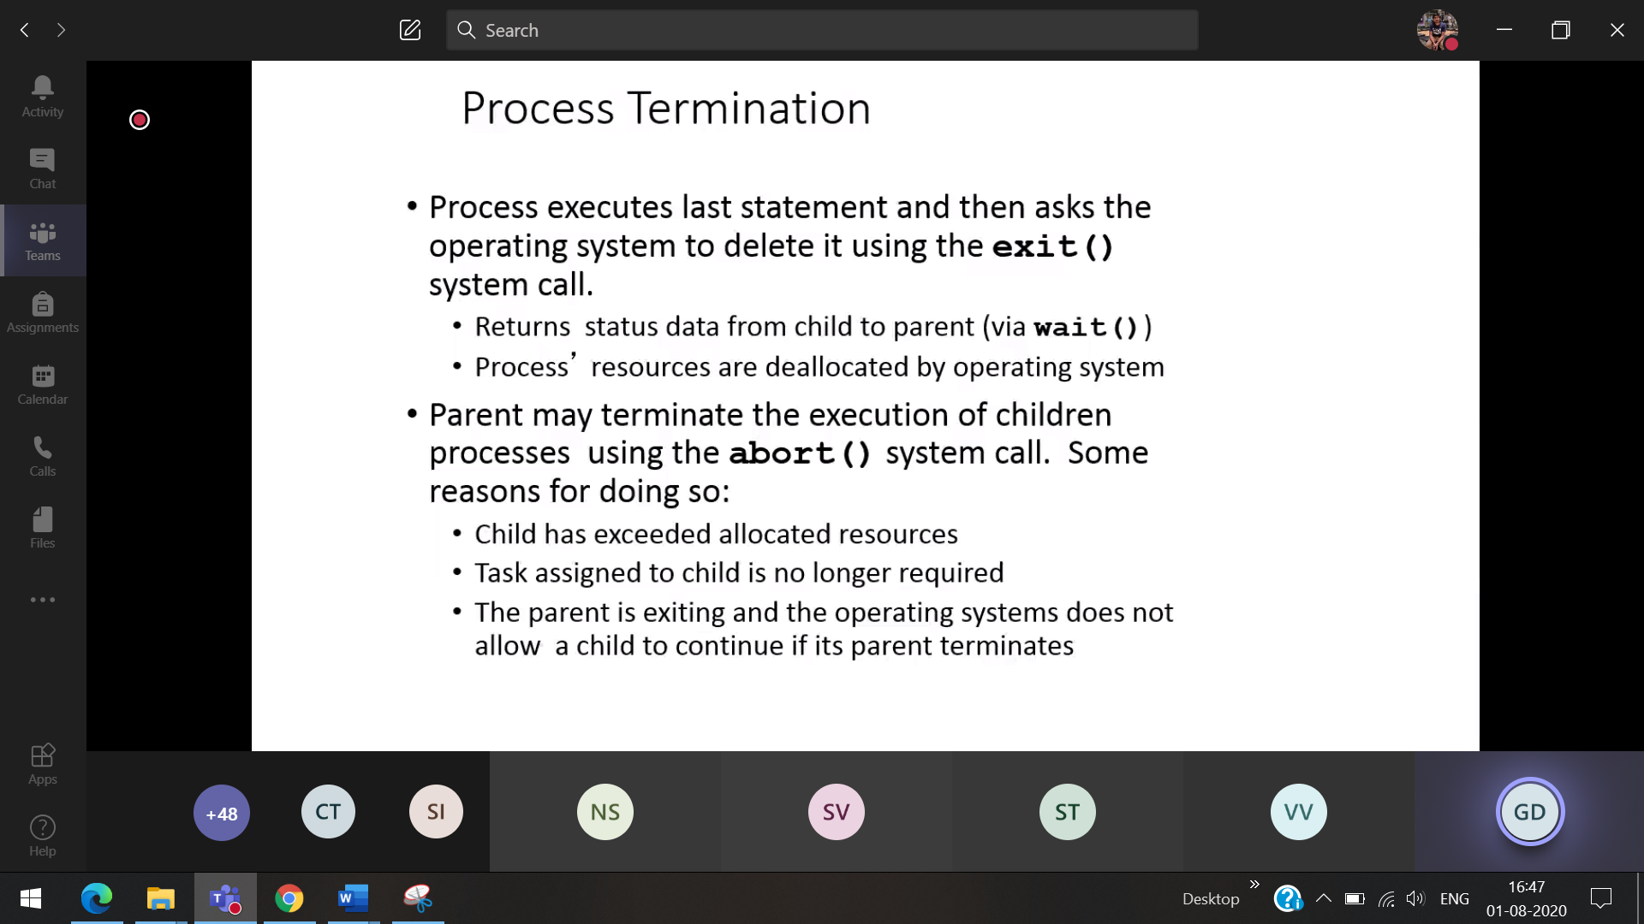

Parent and child should share the resources instead if the child uses too many resoucres , then parent will kill the child

When parent doesn’t know anything about the child [ the parent thinks that child is alive] 🡪 then child will act as zombie.

So

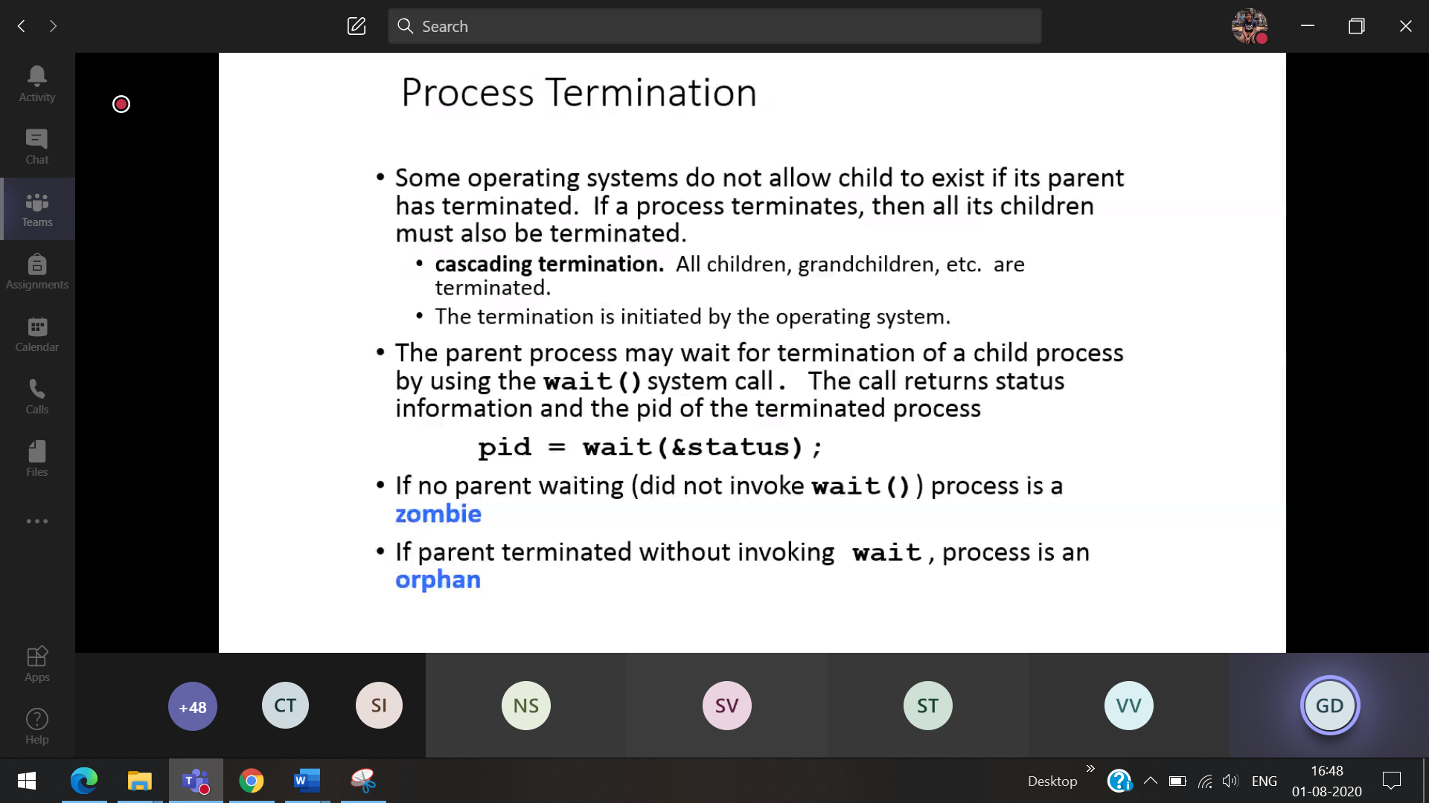

What happens when the parent terminate ??? the child becomes orphan.

1)OS deletes the process **cascade termination**

**2)**Will give the child to another parent

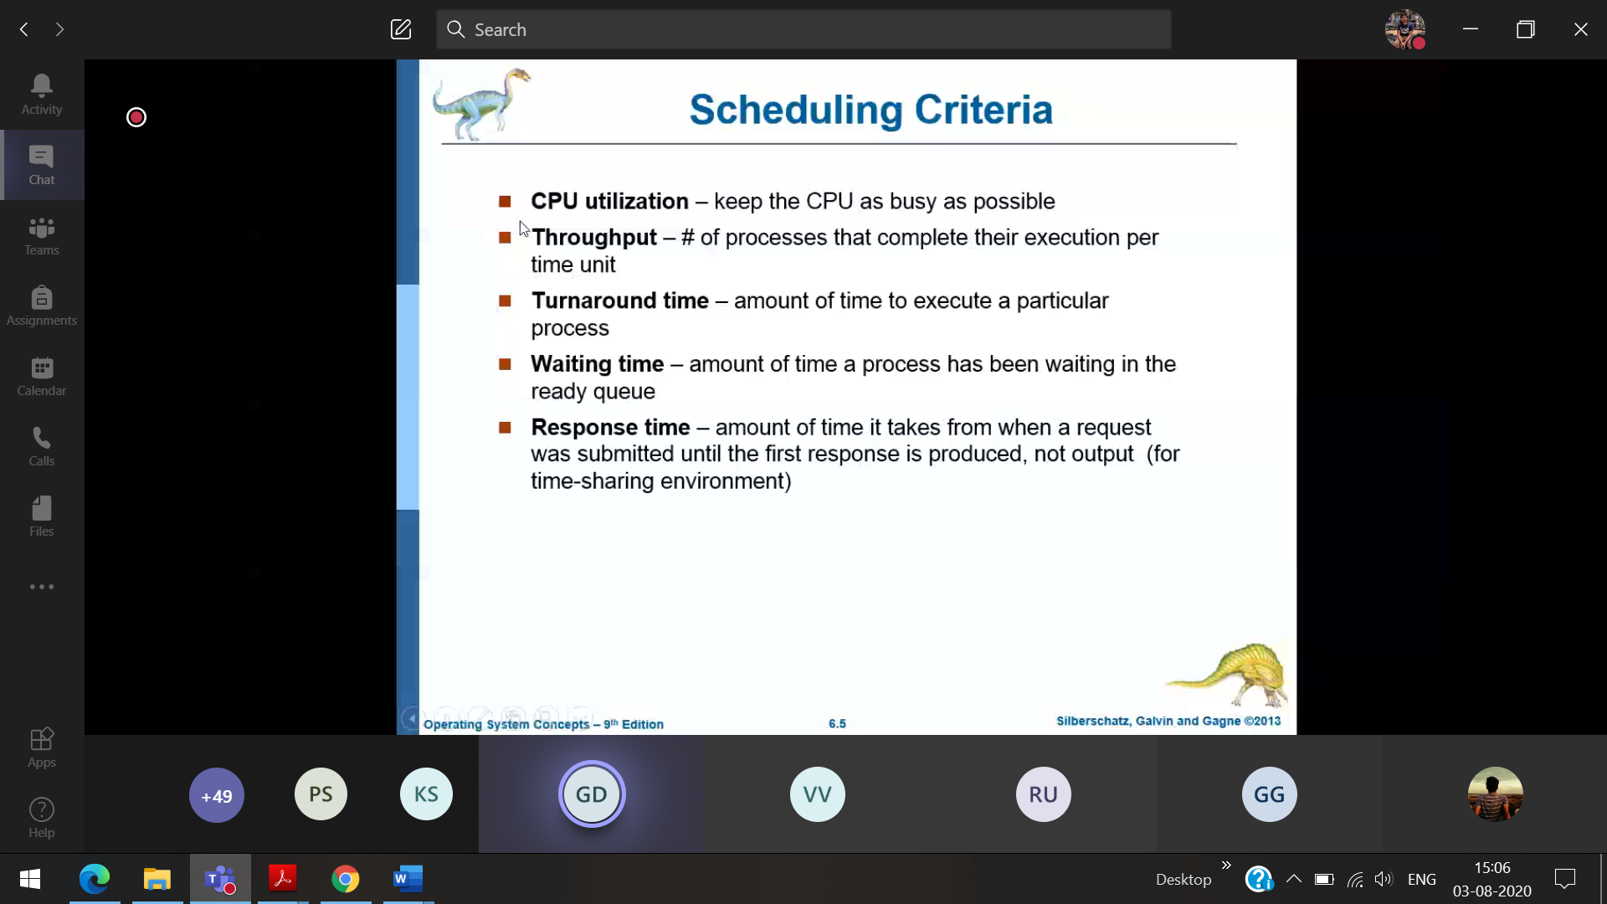

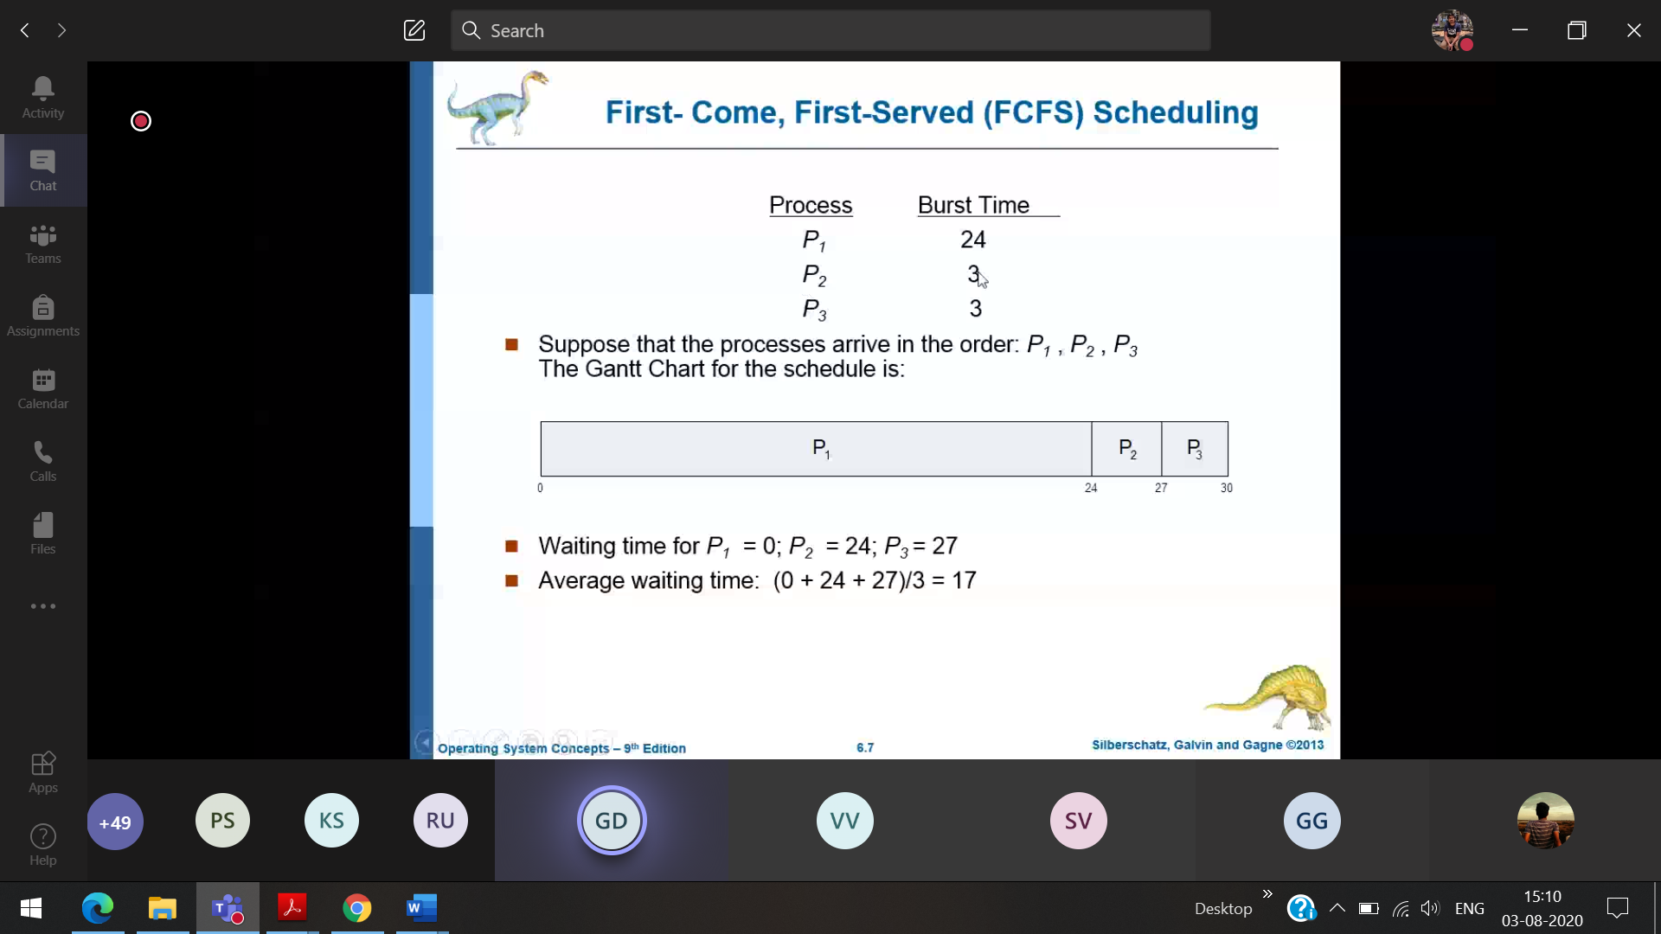

If no arrival time given, put arrival time = 0,0,0

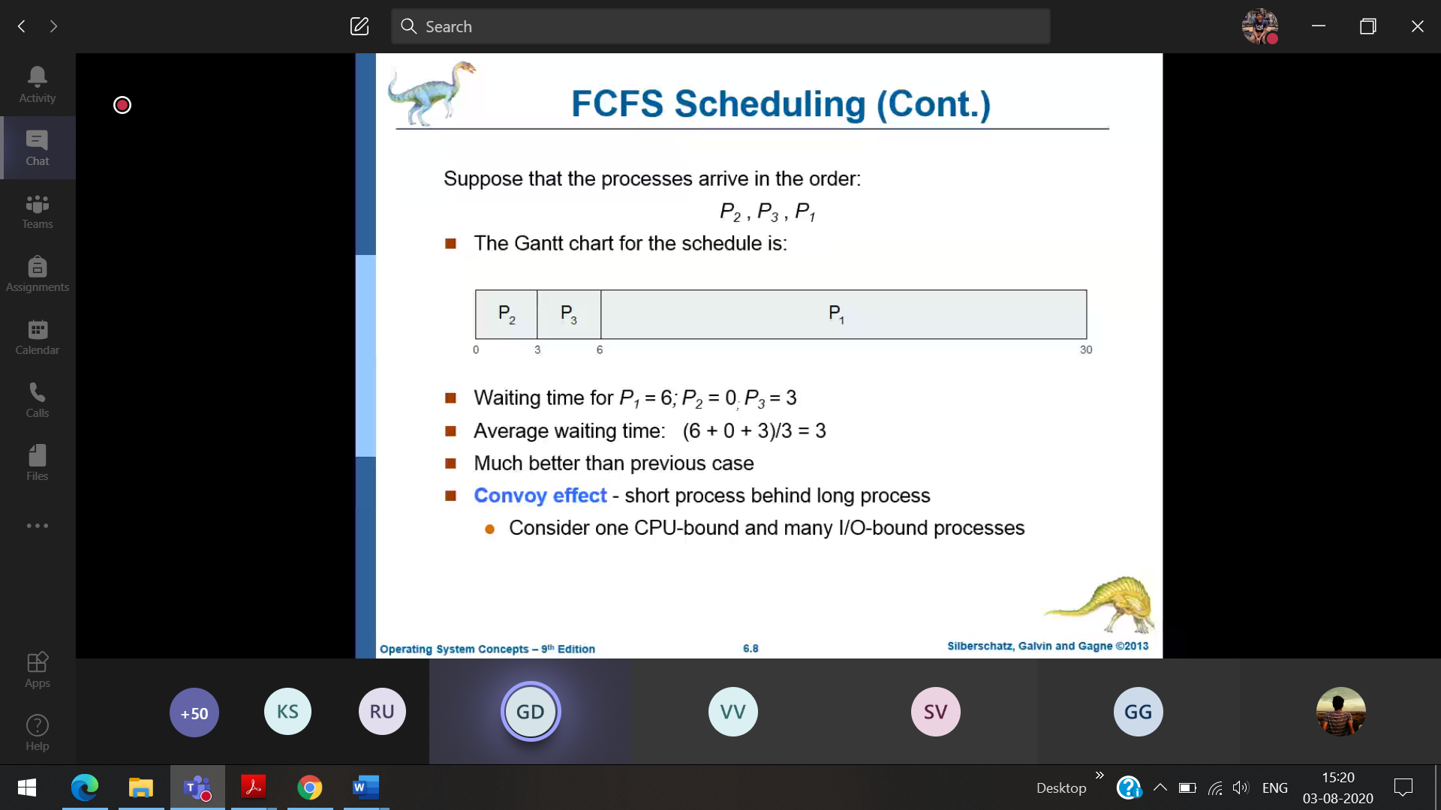

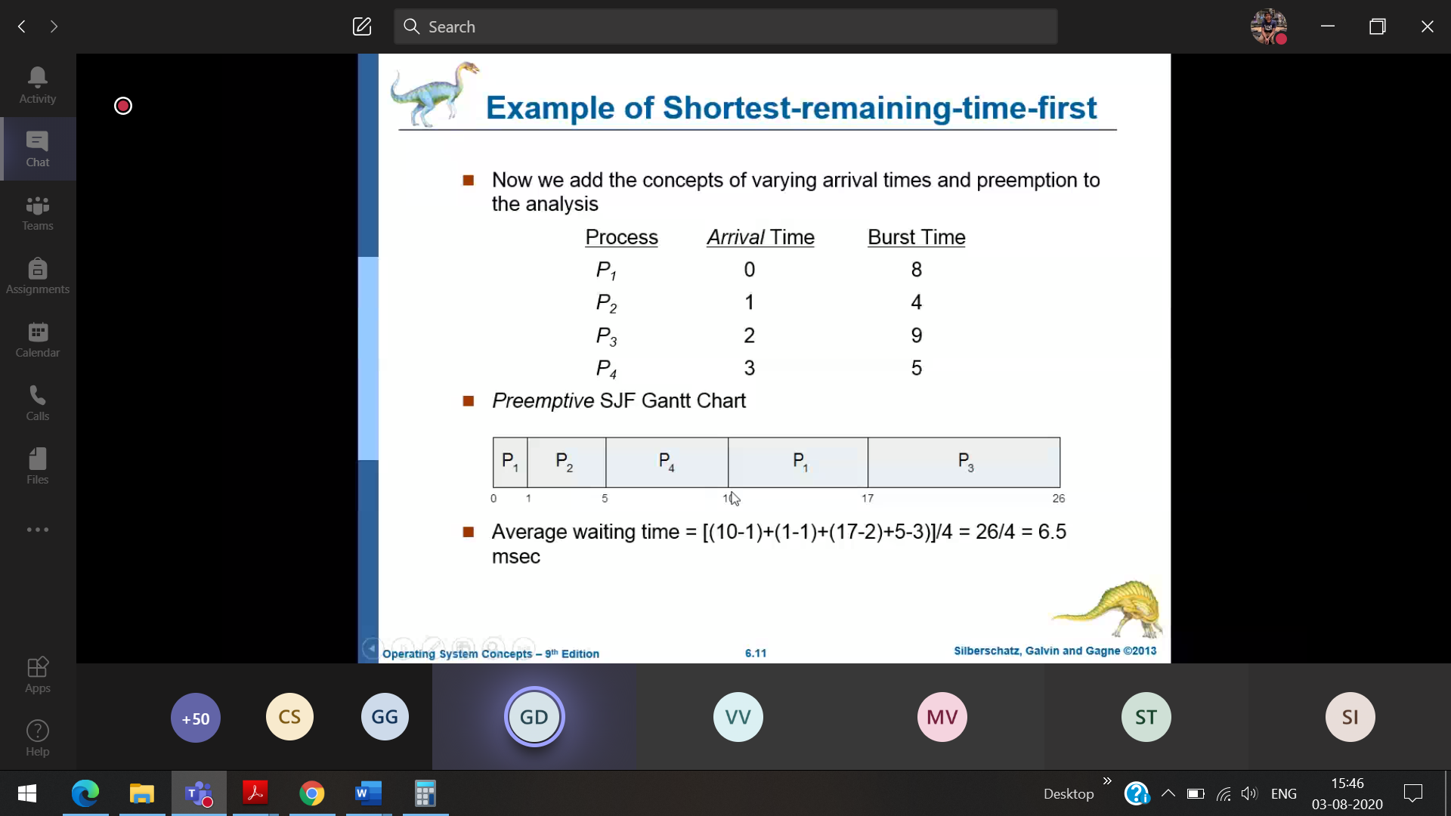

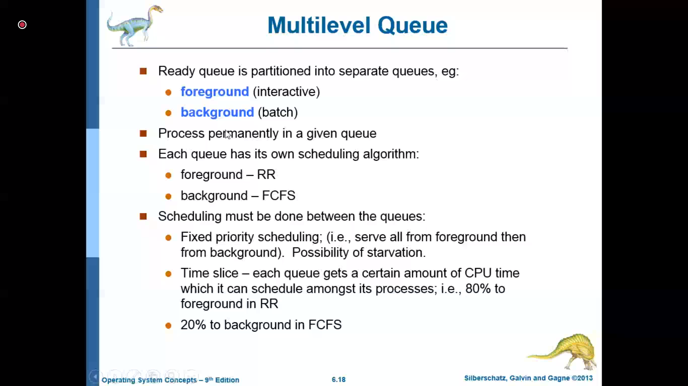

Foreground process 🡪 very less wating time (high response time) [High priority]  
background process 🡪 Not very less waiting time [Low priority]

17/08/2020

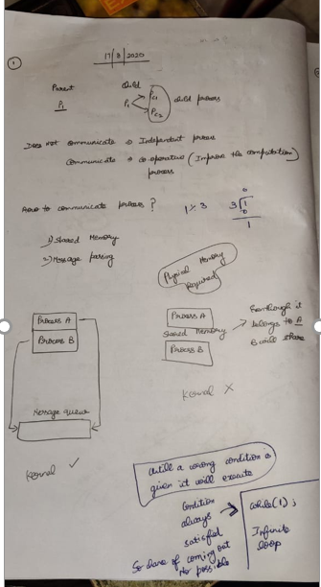

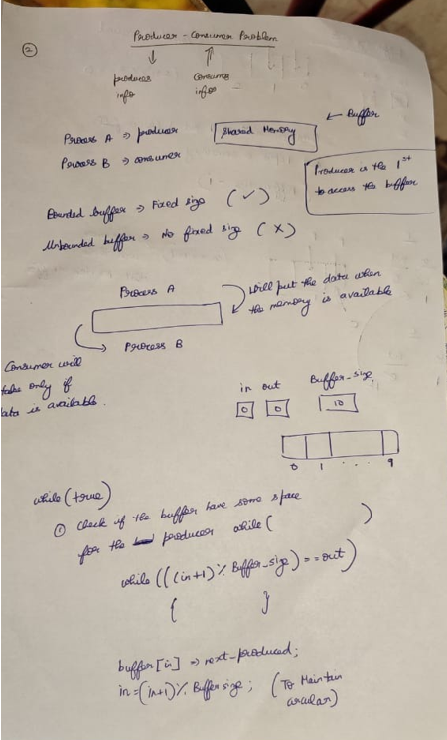

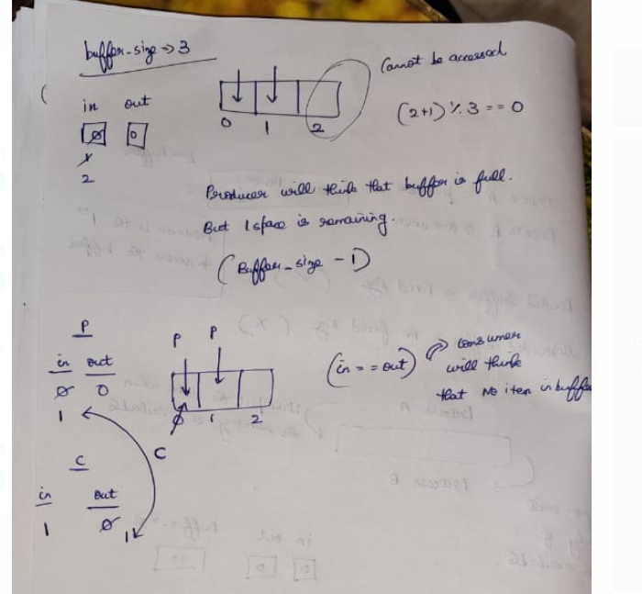

Producer will increment the value of in

Consumer will increment the value of out

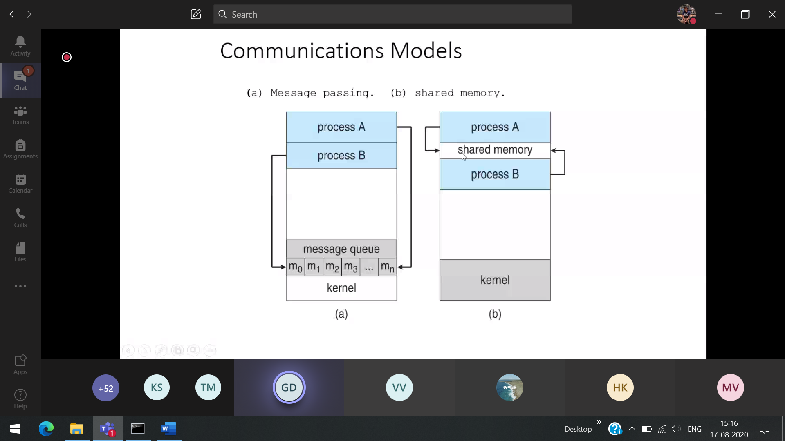

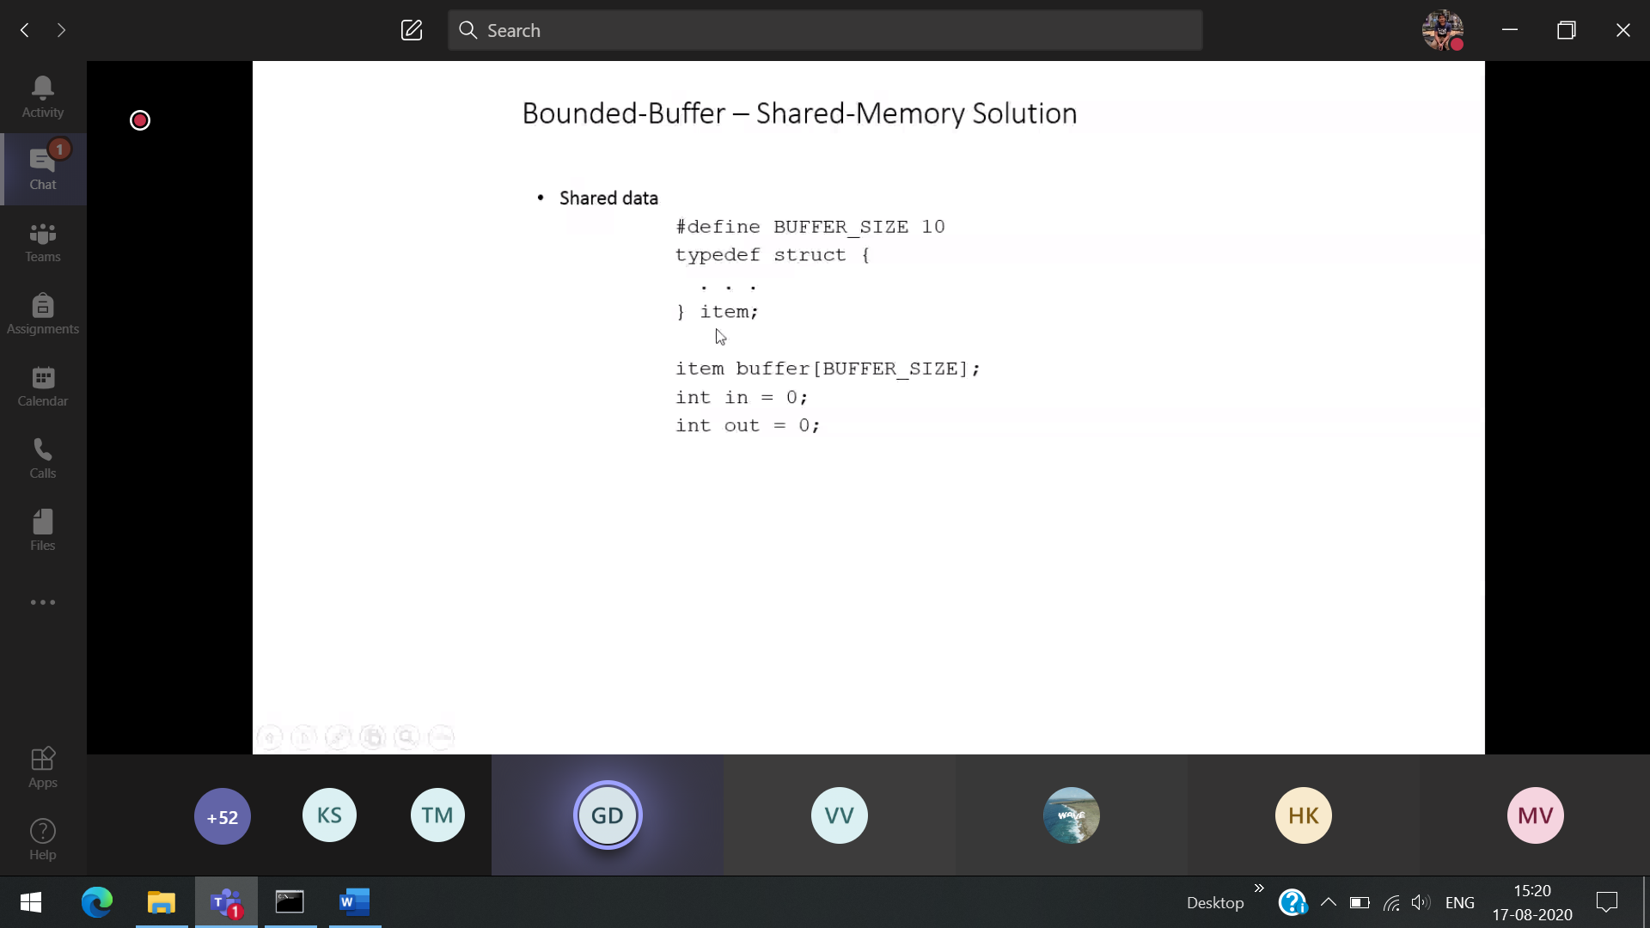

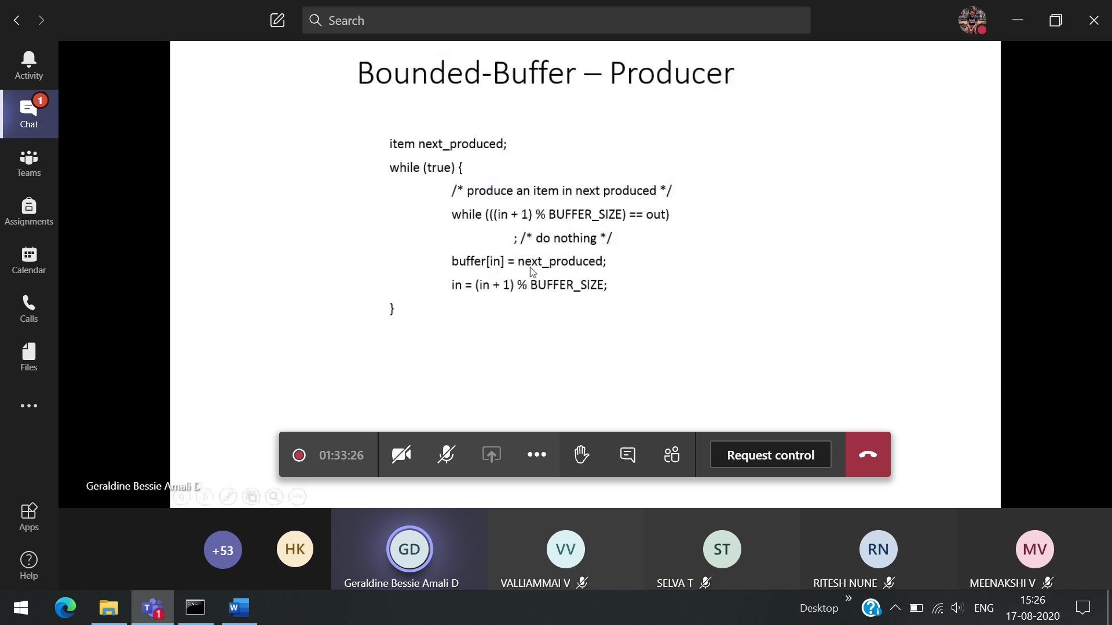

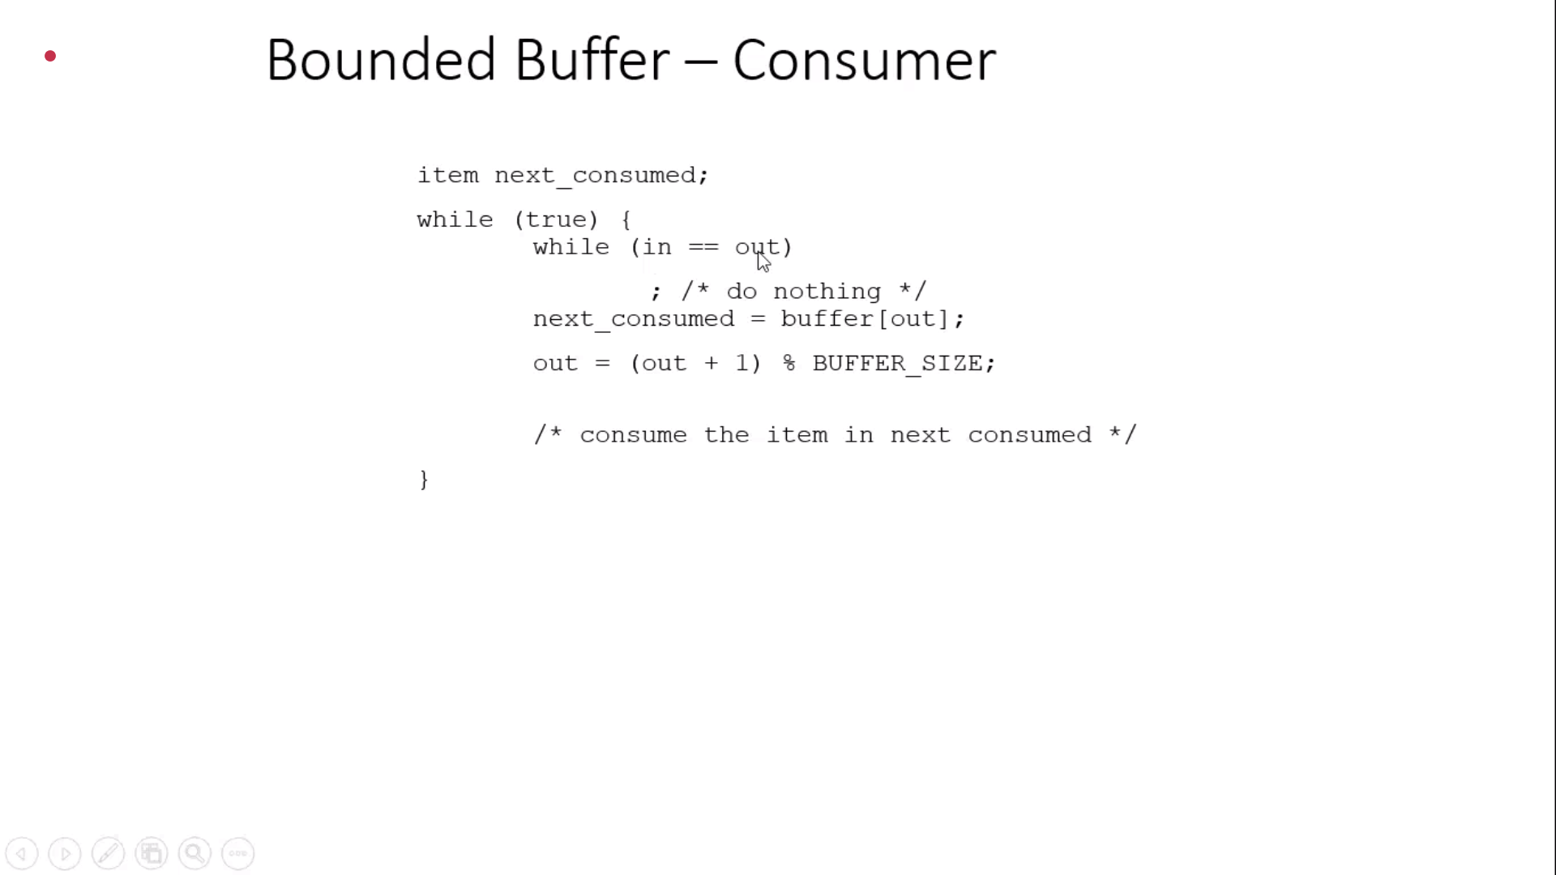

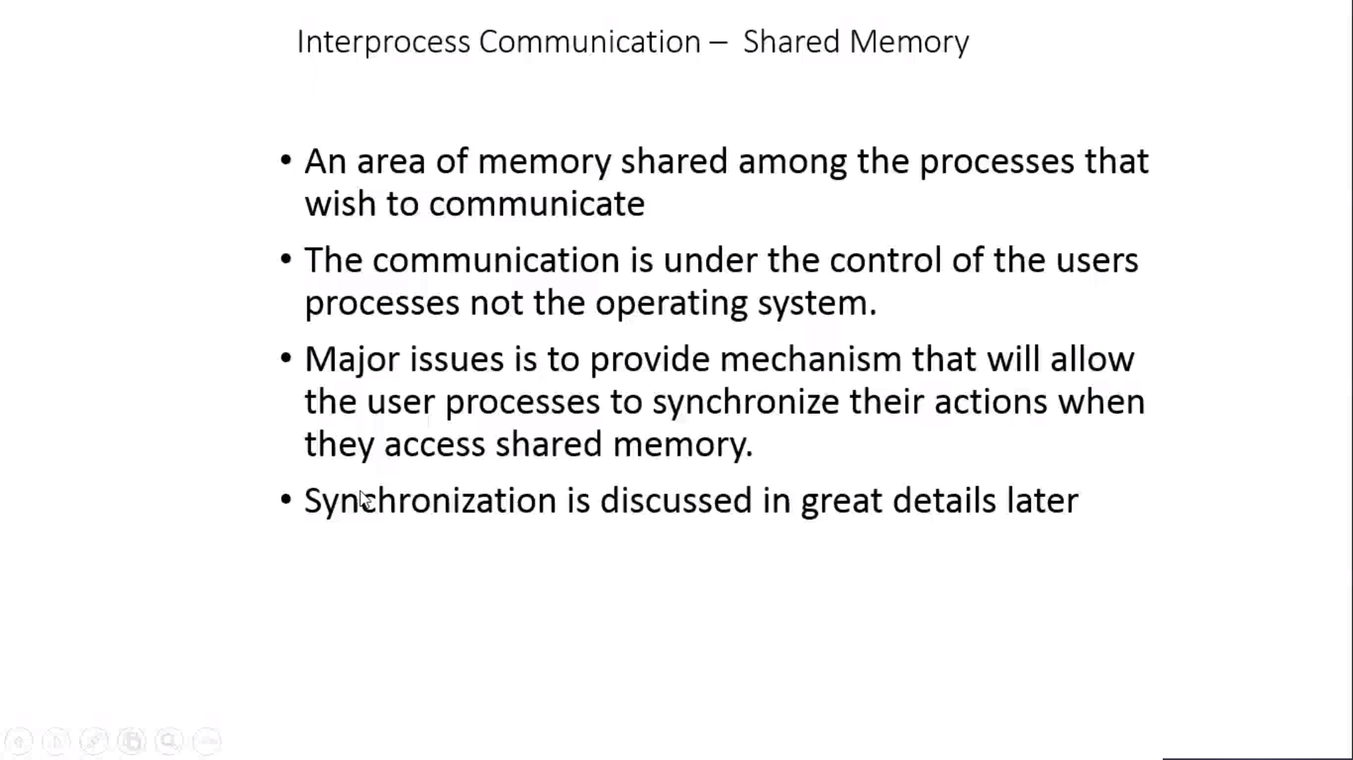

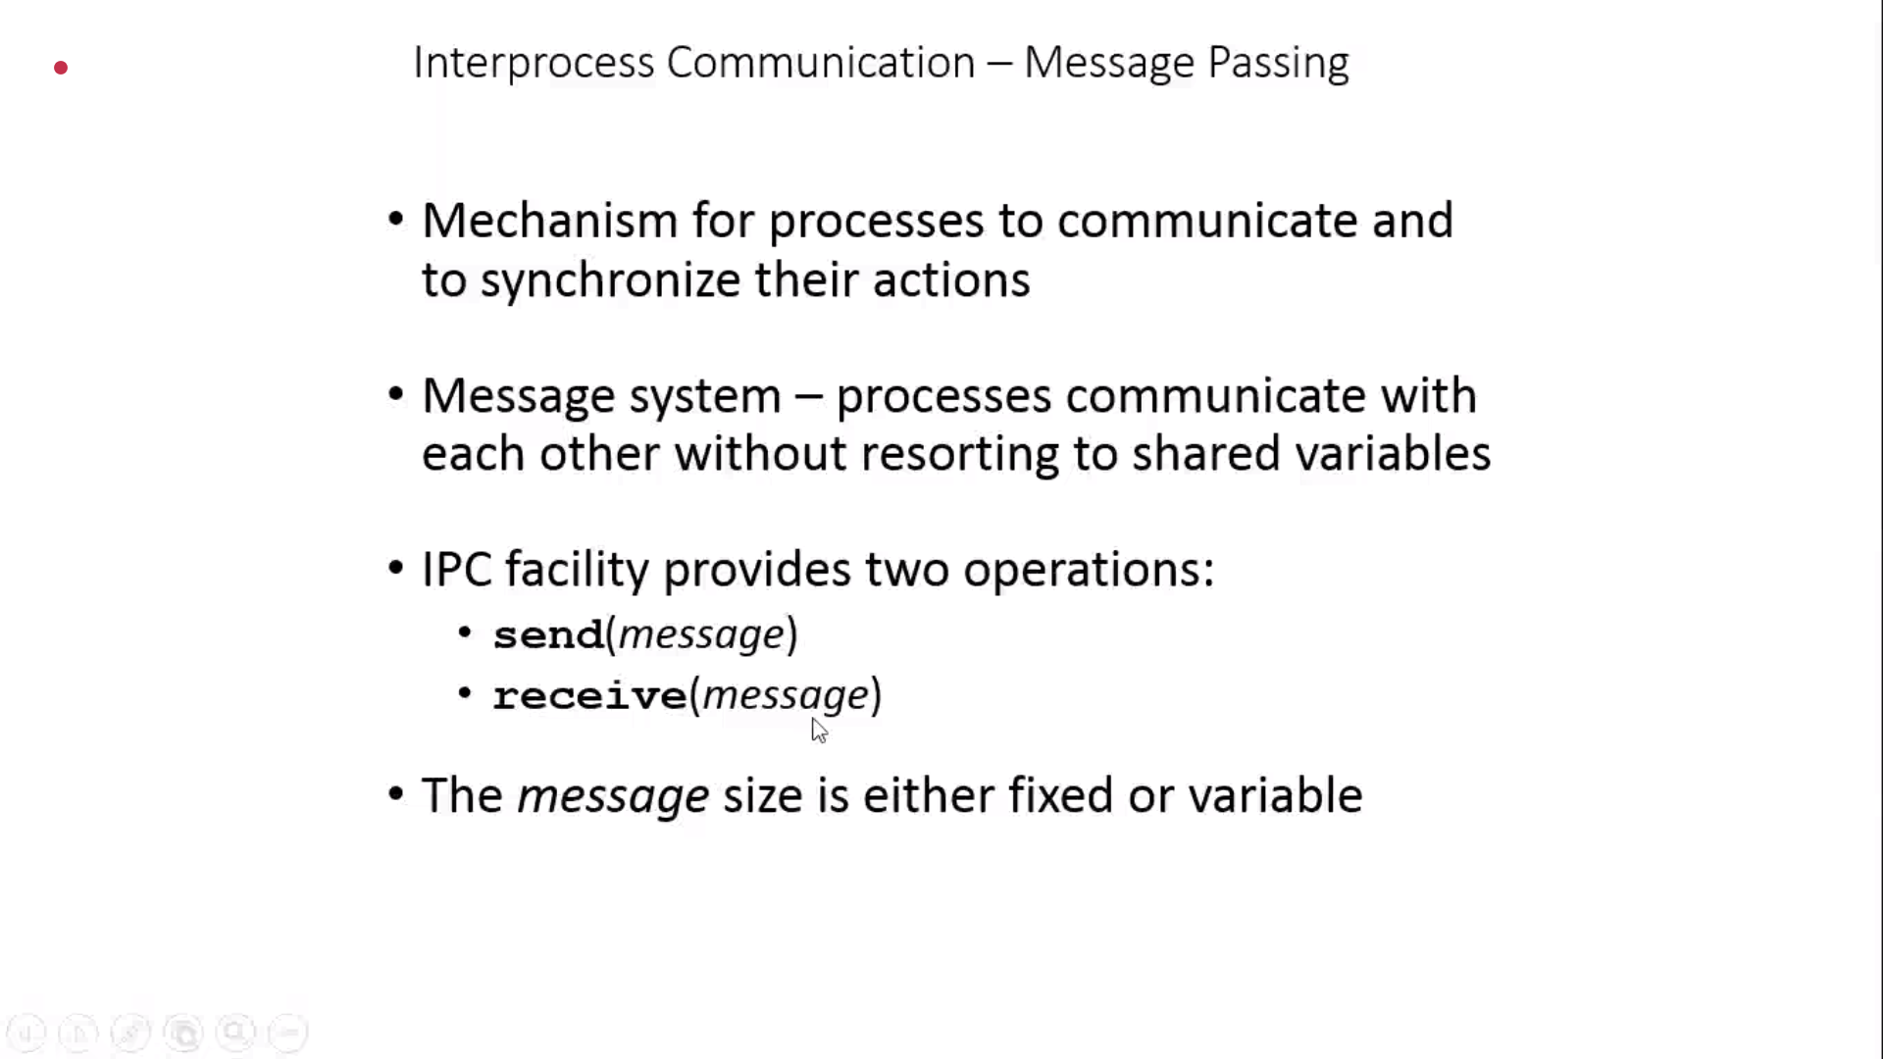

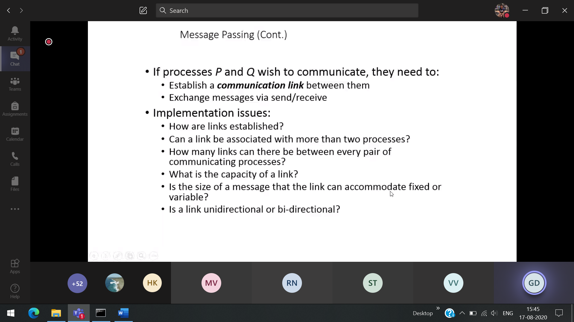

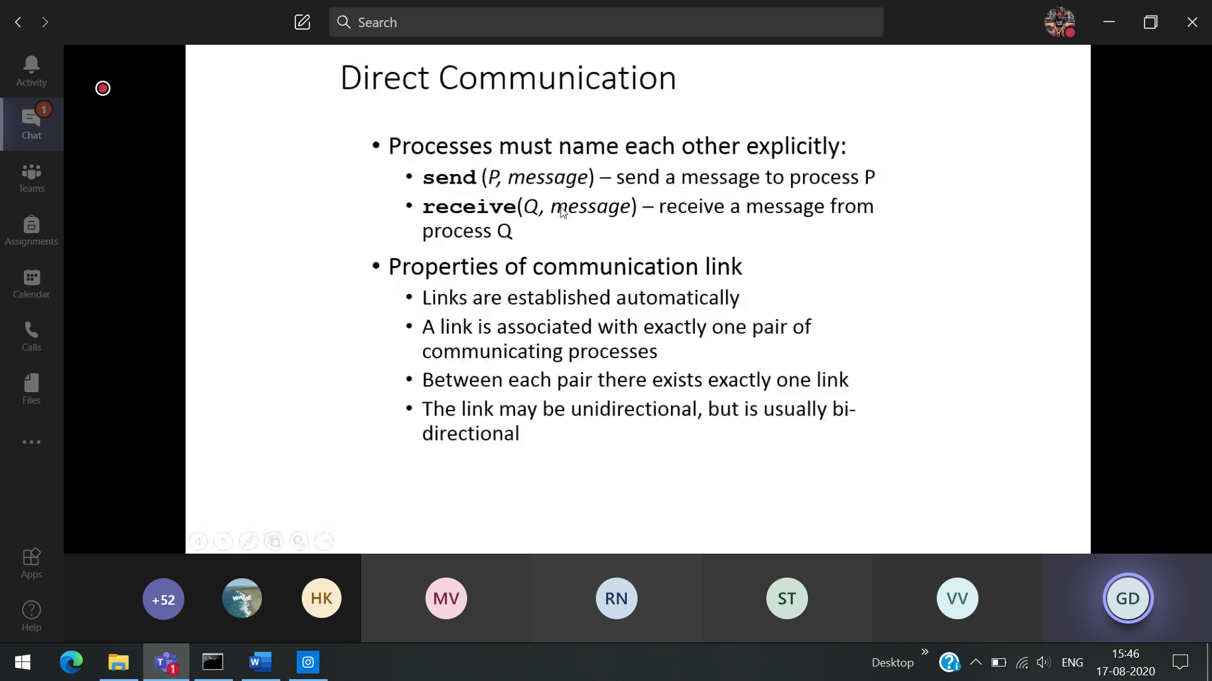

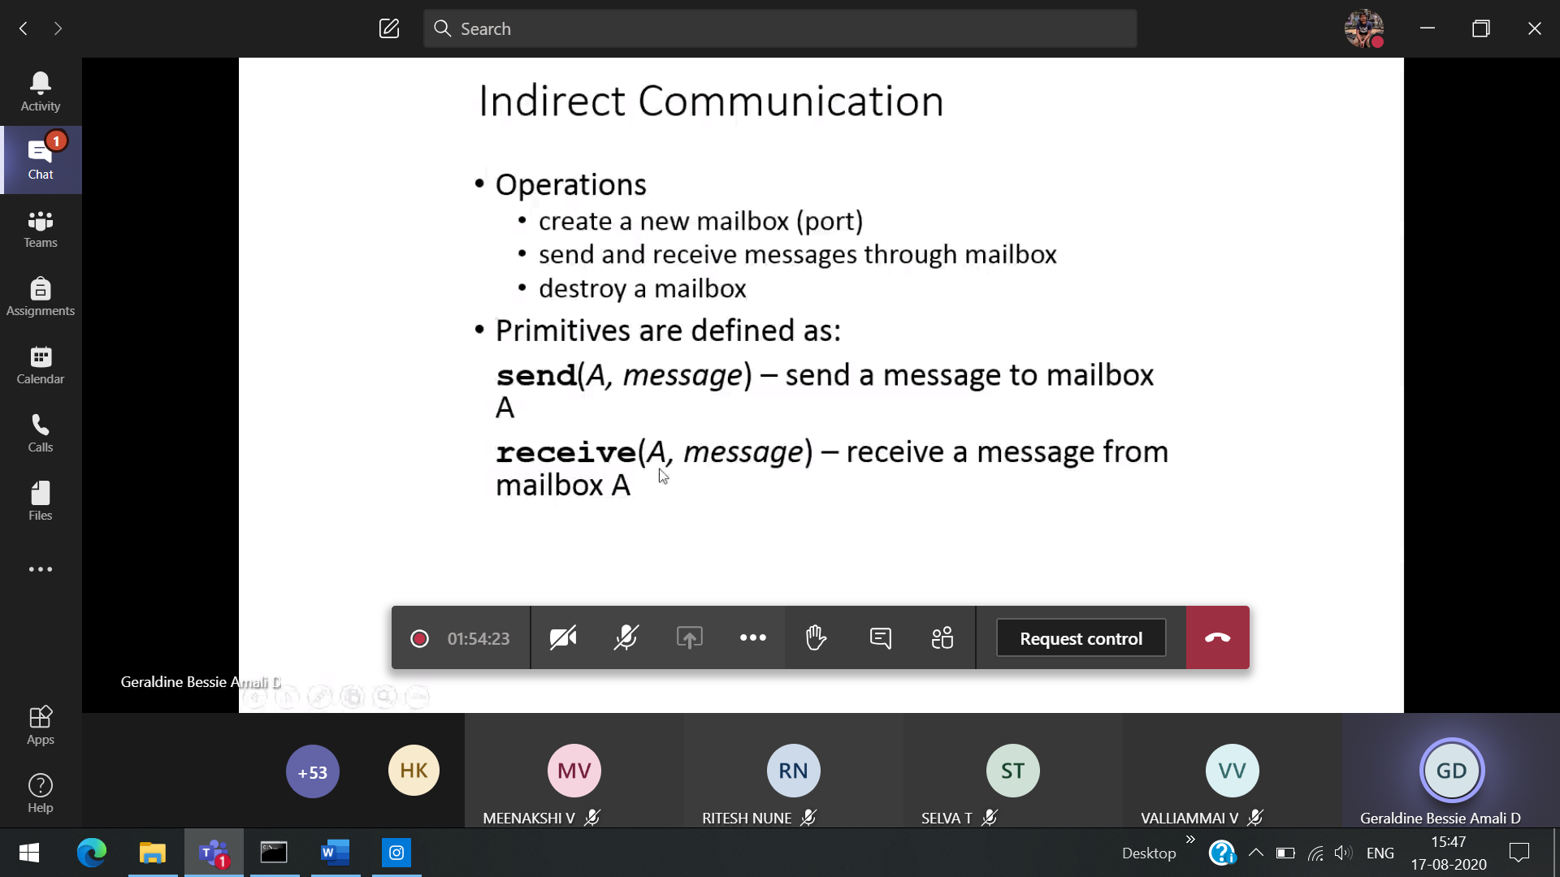

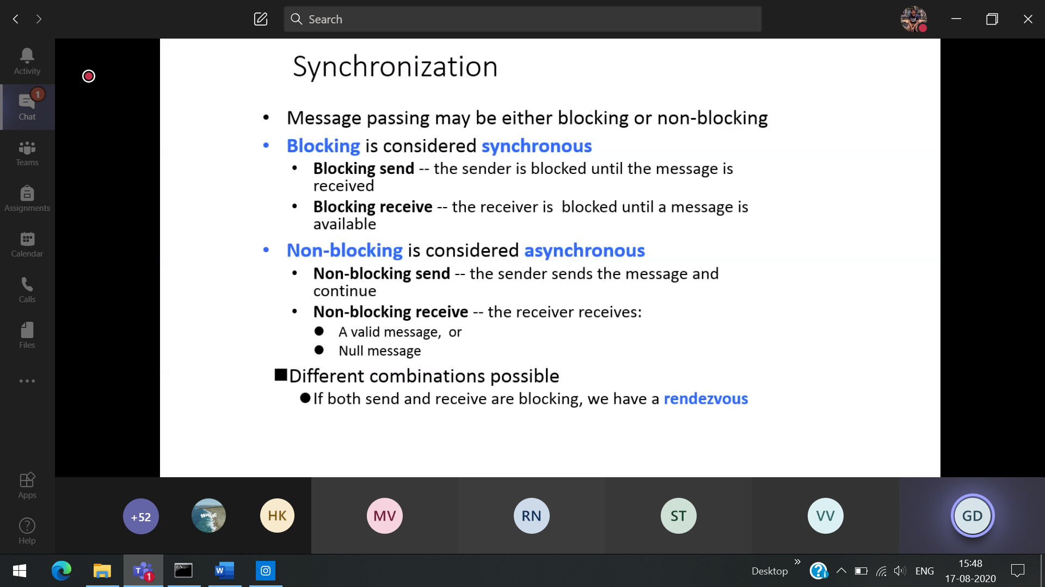rendezvous 🡪 to meet(French)

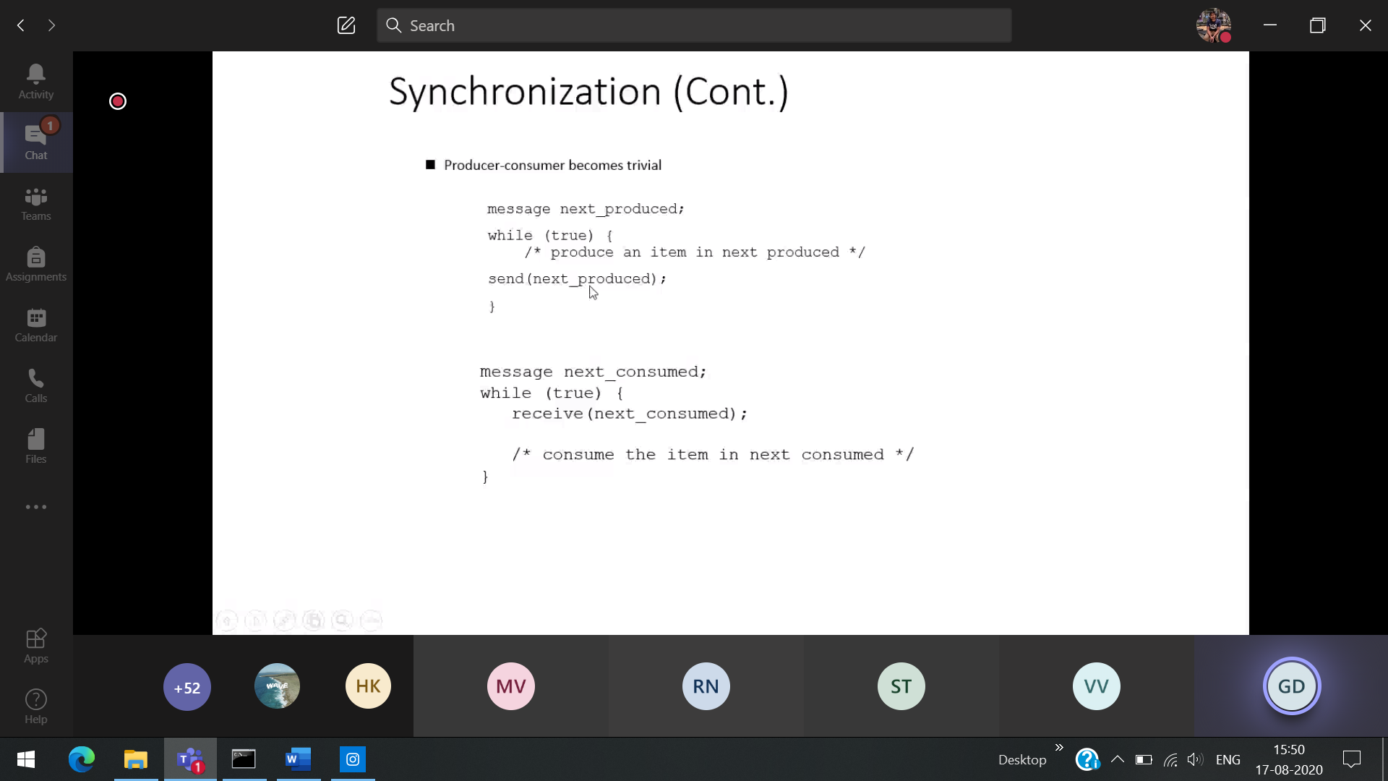 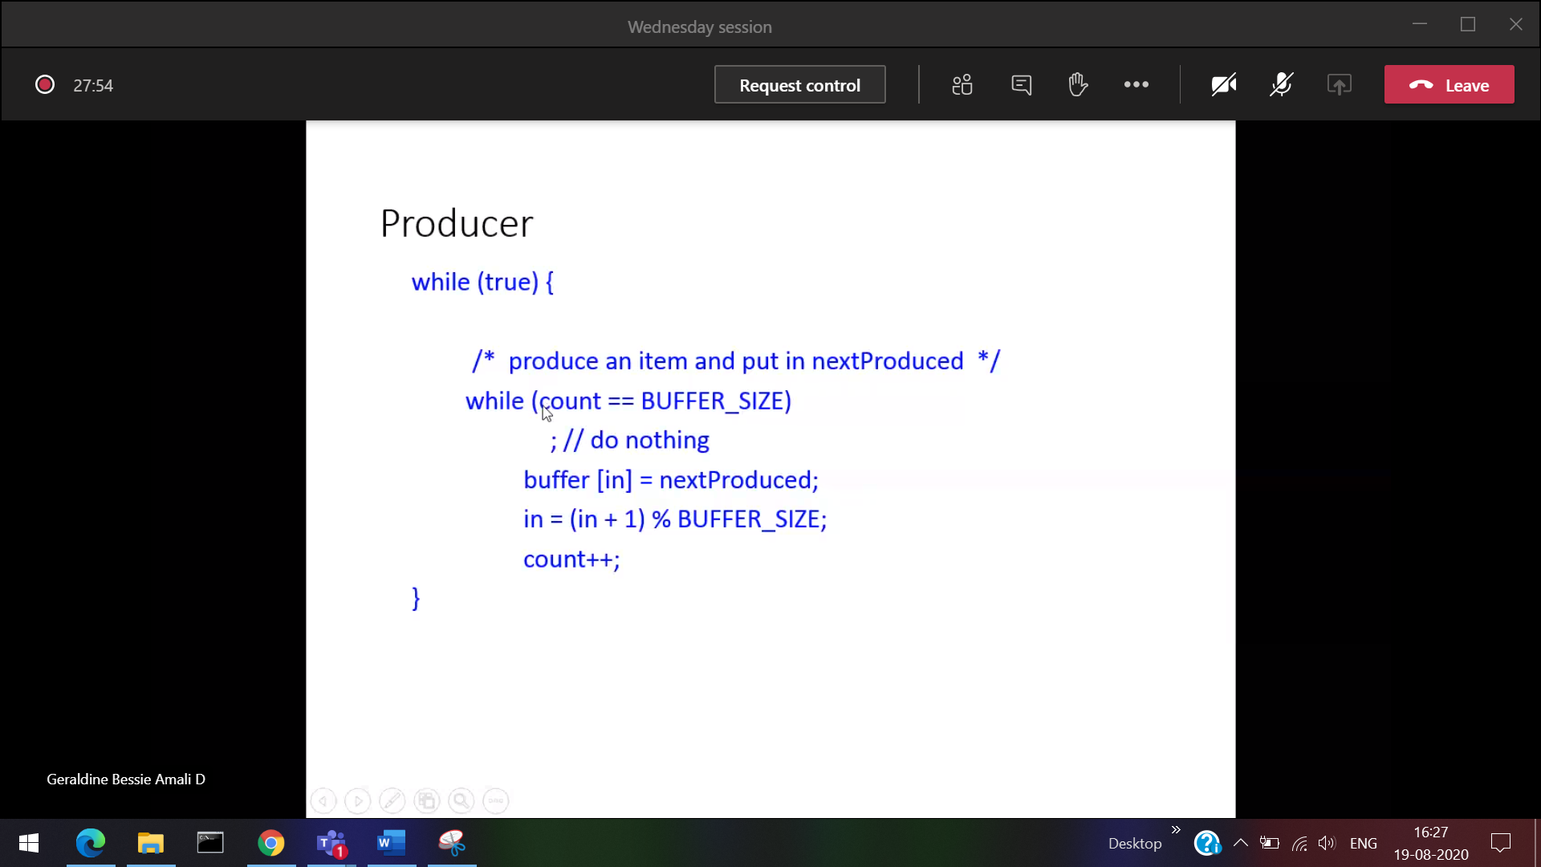



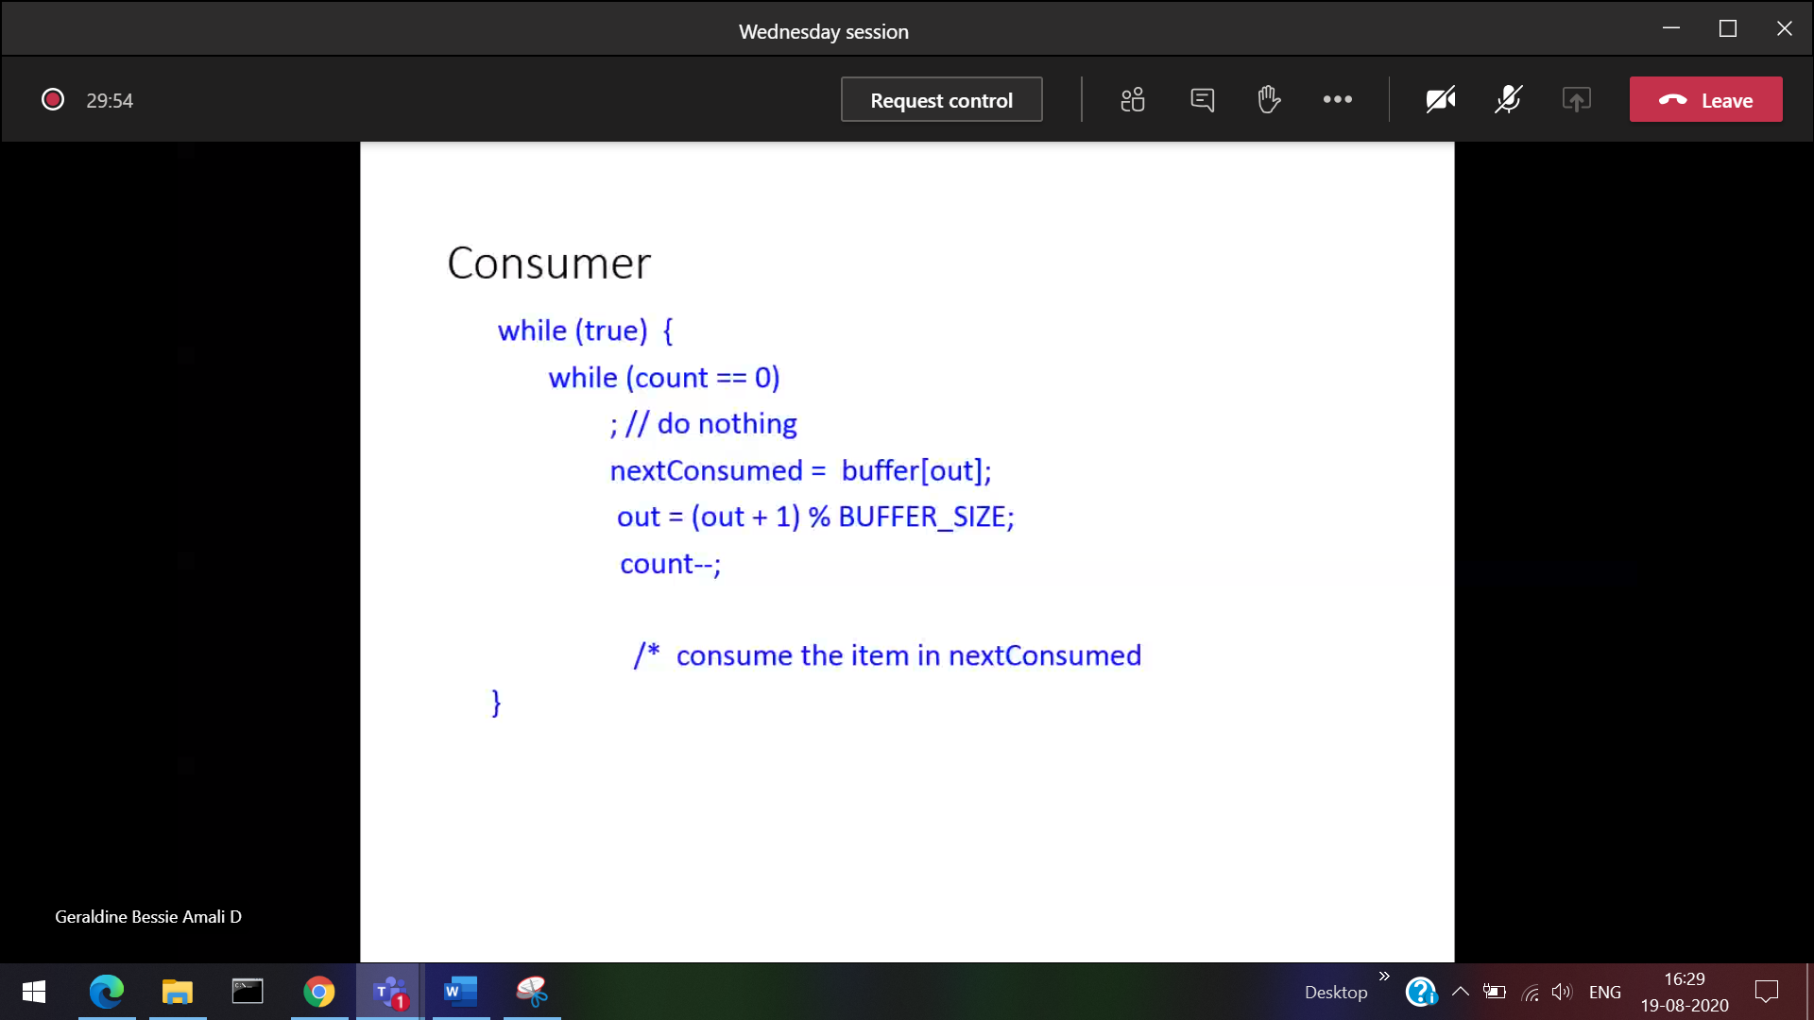

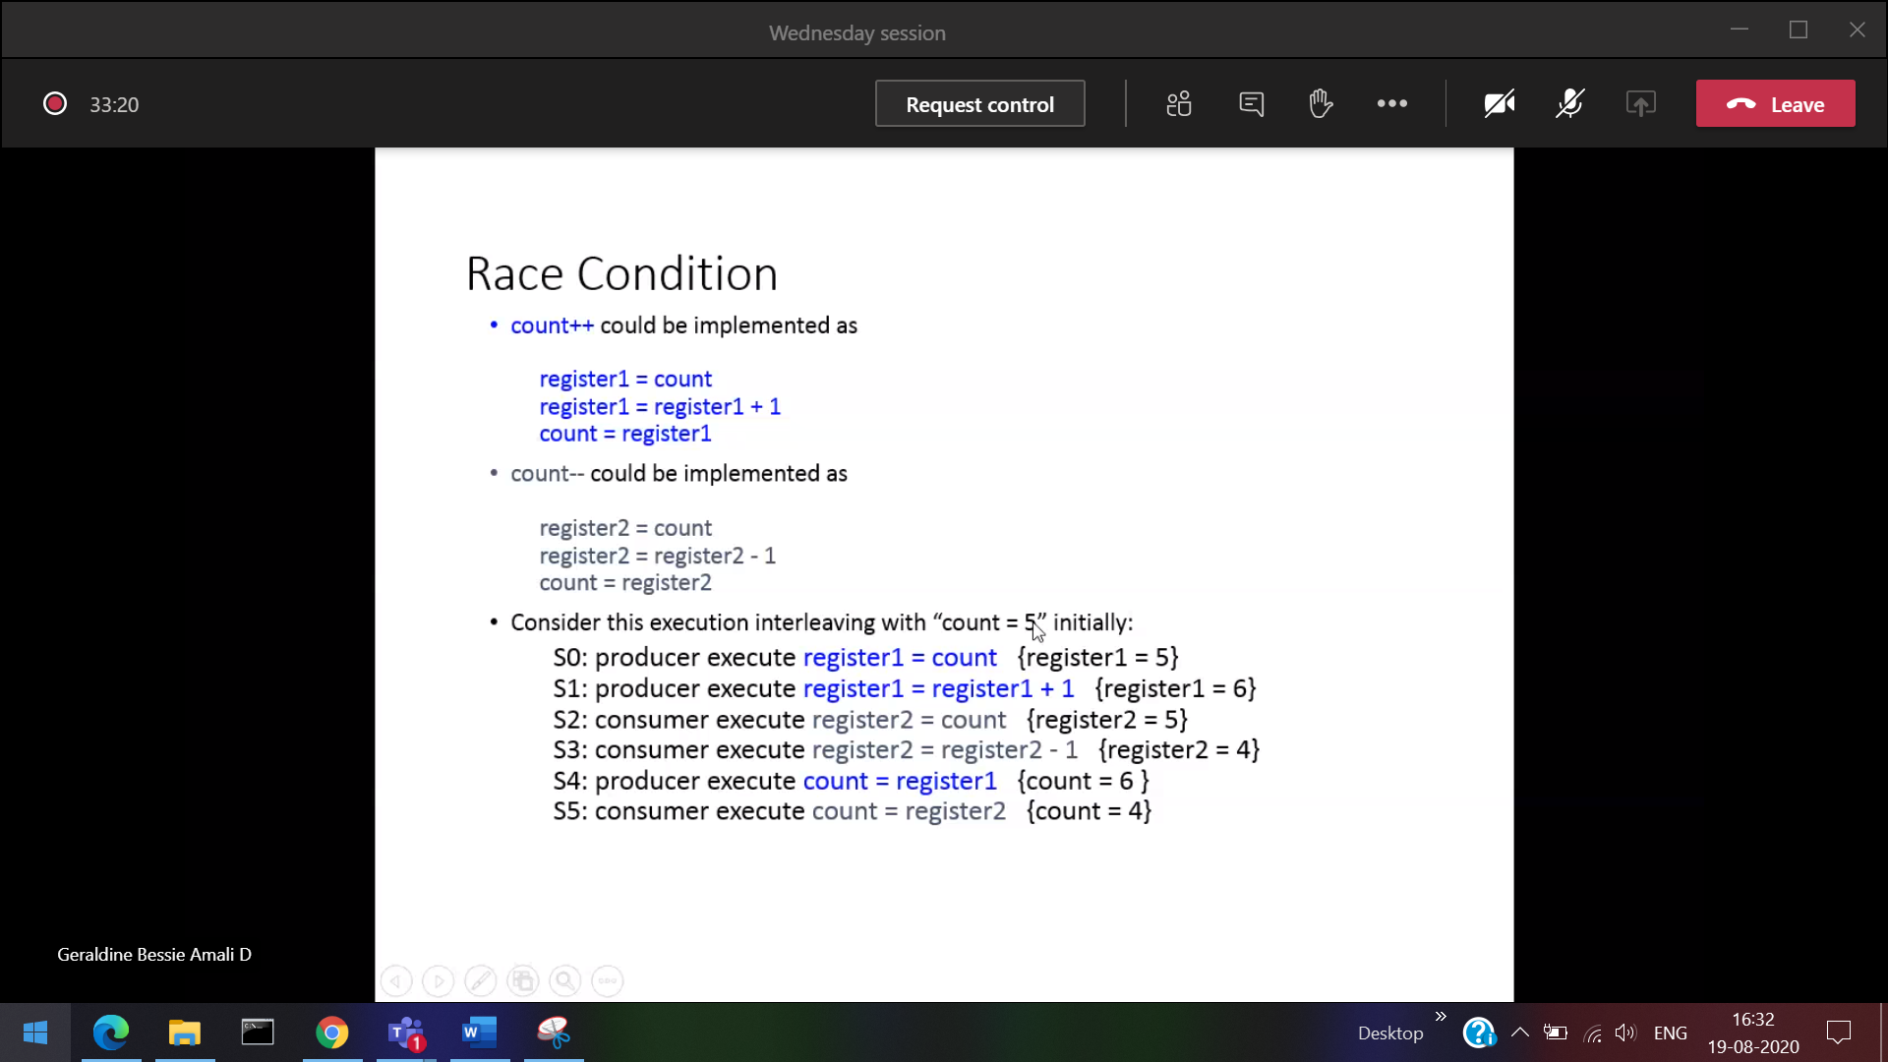

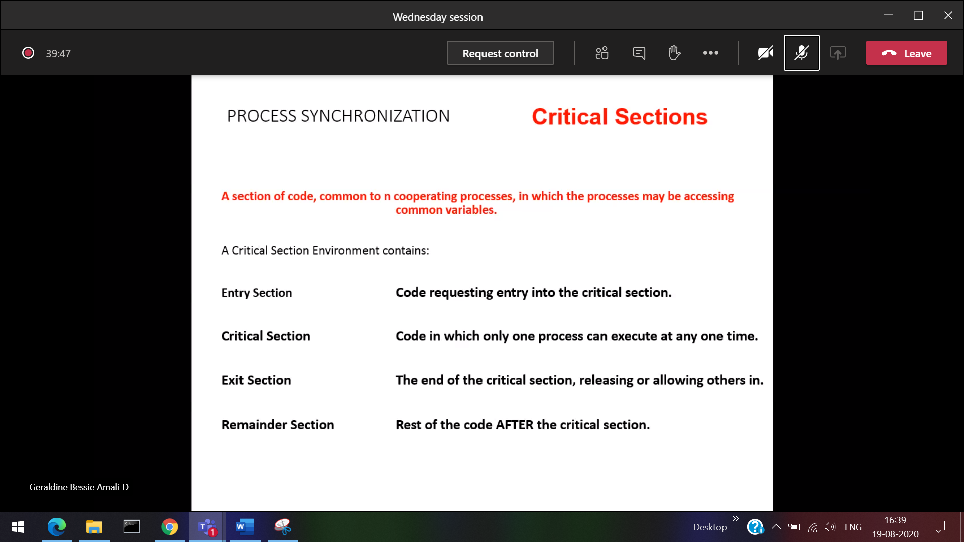

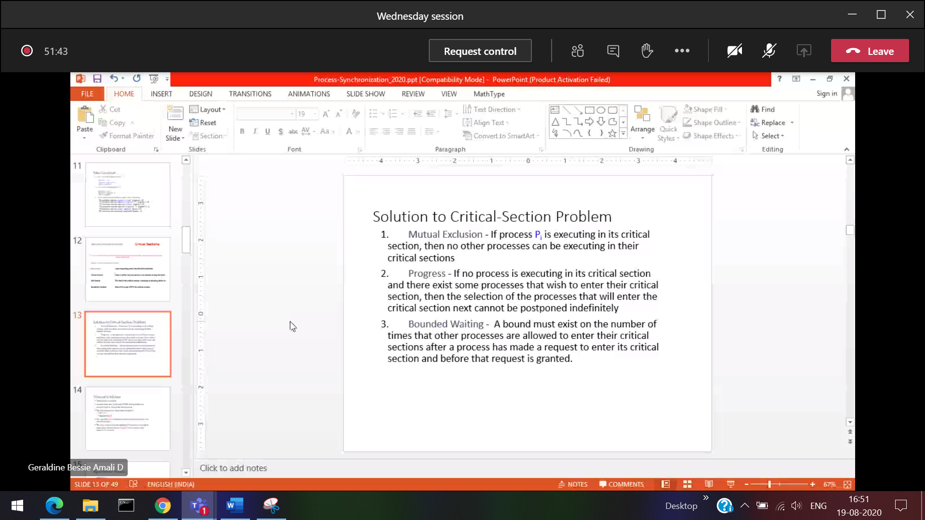

Progress 🡪 If there are N process waiting, and the critical section is now free. Then the next process to use its critical section must be assigned immediately without any delay. It can be done with the help of exit section.

When any process after using its critical section, it releases the lock and will give the key to the next process.

Bound Waiting : Maximum number of processes which can be given the key to the critical section before that particular process get its chance

Eg: b

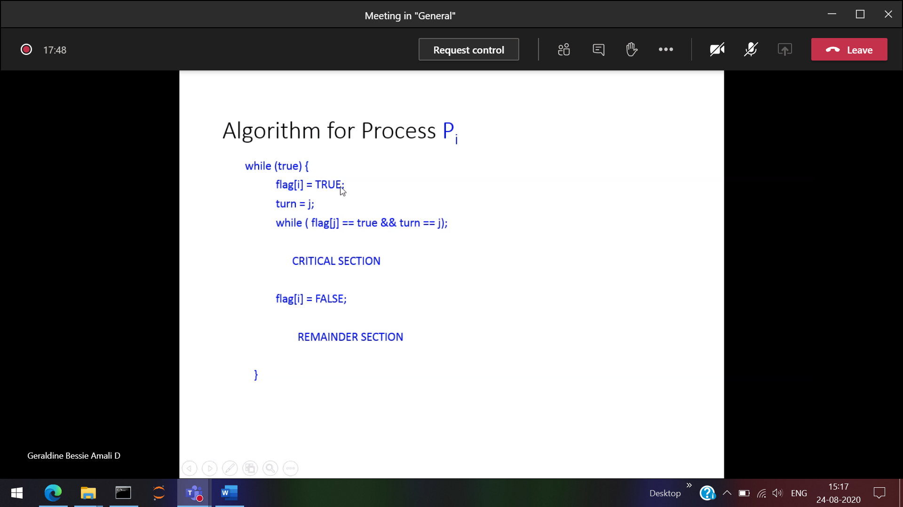

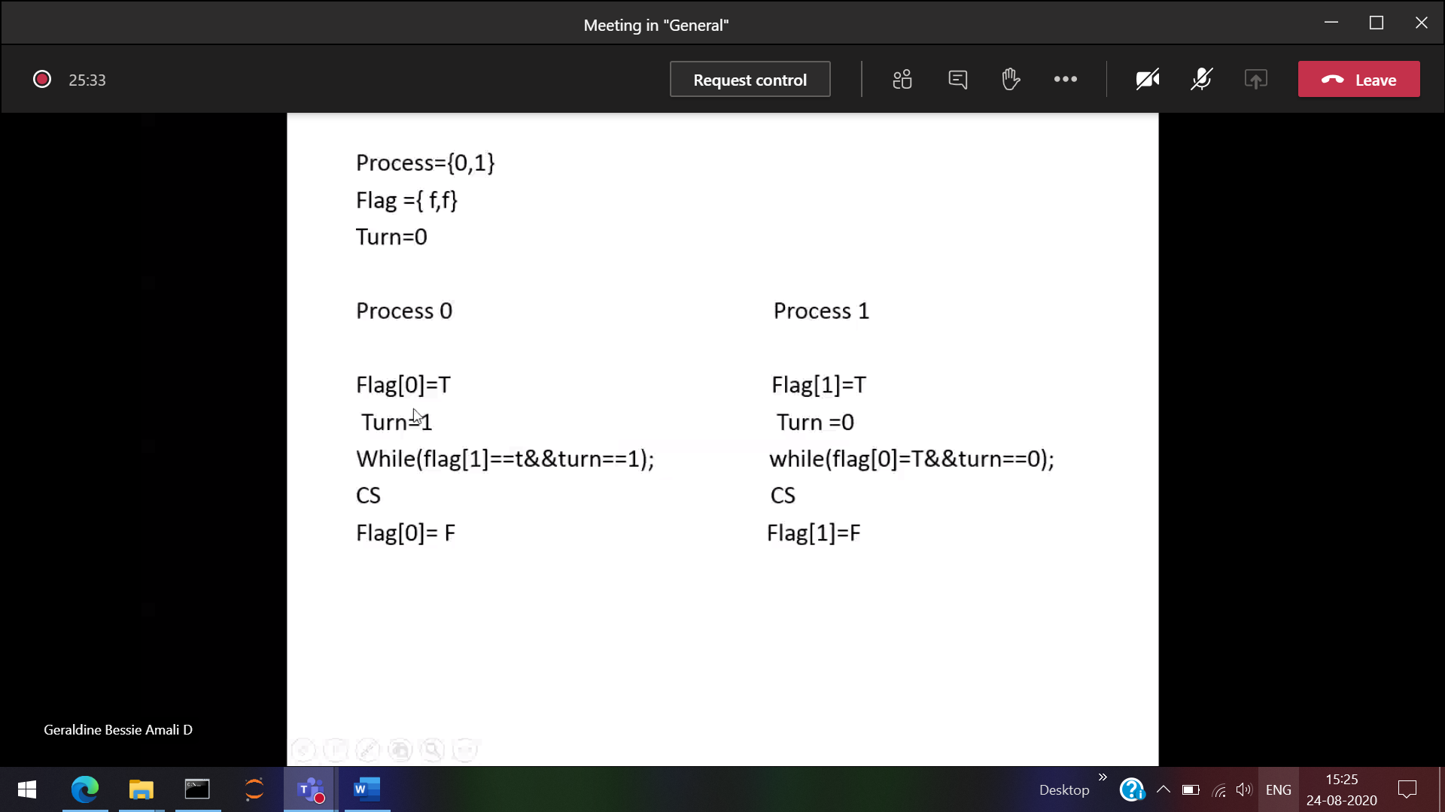

Answer

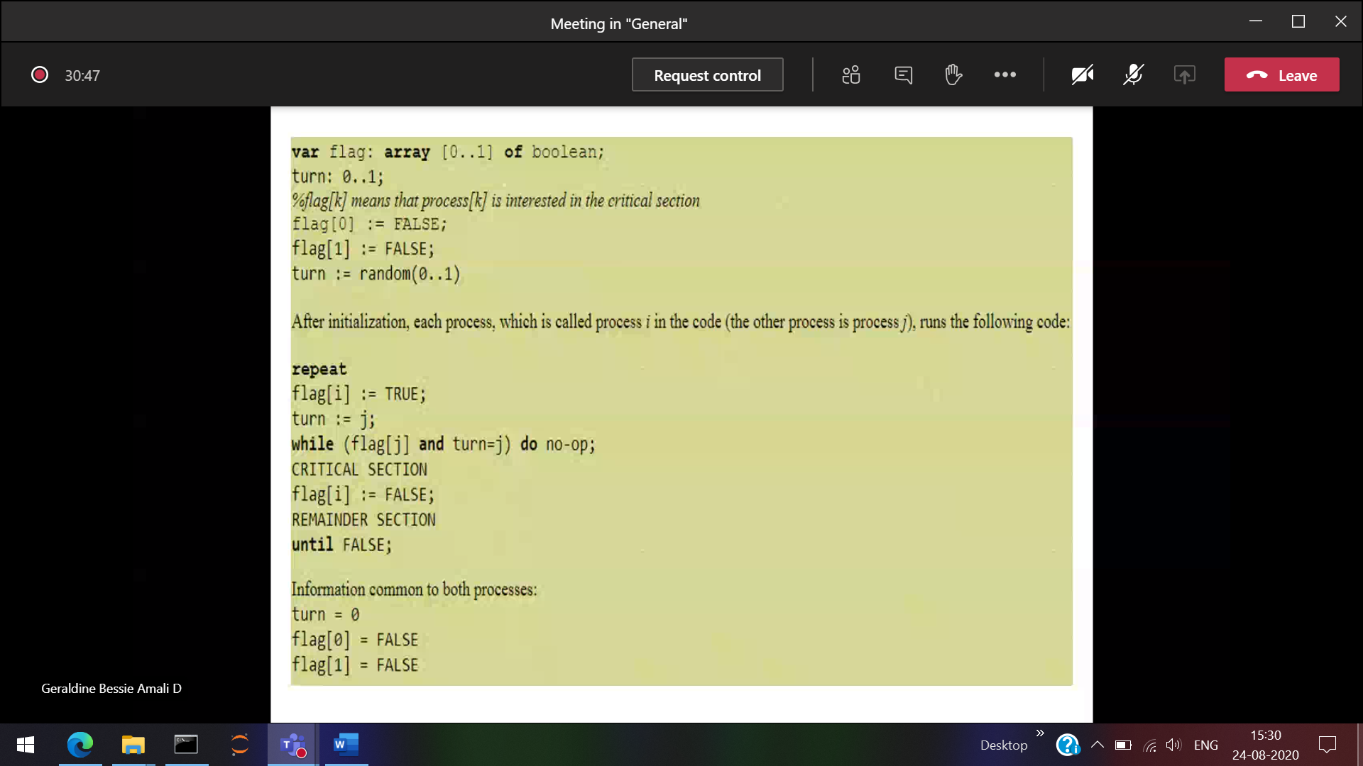

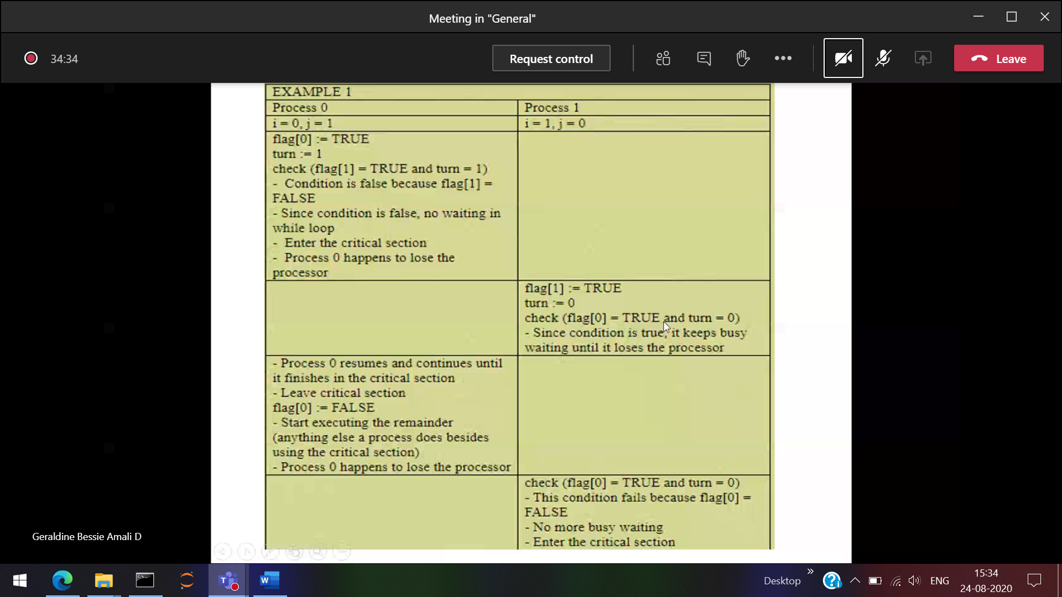

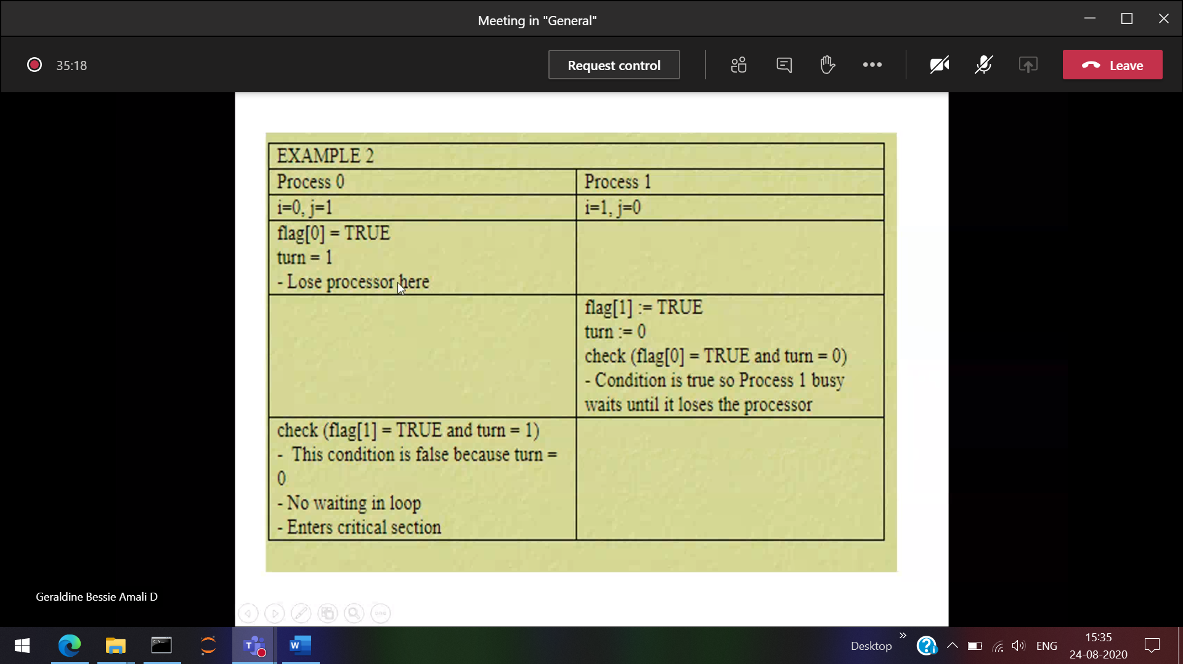



Now only turn plays a major role

Since turn=0 (while loop fails ) and hence Process 0 enters into its critical section.

P1 will go on executing in the while loop (so got trap) [Busy waiting]

3rd scenario

